Mead Street survey on emerging principles and concepts for regeneration - engagement feedback

Summary

The Mead Street engagement survey ran from 22 November to 7 January 2022. It asked for feedback on a set of guiding principles and emerging concepts to inform the regeneration of Mead Street and inform a Mead Street Development Brief.

The information below reflects the feedback from the online survey that was available via the Temple Quarter website. Two public drop-in events also took place on 22 and 23 November at LPW House which provided local businesses and residents the opportunity to discuss the emerging principles. A briefing with local community organisations also took place online.

Overall there is support for the proposals:

Principle 1 - Making it a place people want to live and work, are proud of and which is representative of the community that live there.
- Of the 132 responses to this question 68% of respondents agreed or strongly agreed with Principle 1. 26% disagreed or strongly disagreed.

Principle 2 - Providing better routes for sustainable travel
- Of the 133 responses to this question 66% of respondents agreed or strongly agreed with Principle 2. 21% disagreed or strongly disagreed

Principle 3 - Quality Places: Public Realm, Place-Making and a Sustainable and Low Carbon Neighbourhood
- Of the 131 responses to this question 81% of respondents agreed or strongly agreed with Principle 3. 10% disagreed or strongly disagreed.

Principle 4 - Quality spaces: Greenspace at the heart of the new neighbourhood and ecological enhancements
- Of the 131 responses to this question 87% of respondents agreed or strongly agreed with Principle 4. 9% disagreed or strongly disagreed

The table below summaries the level of agreement for each of the principles.

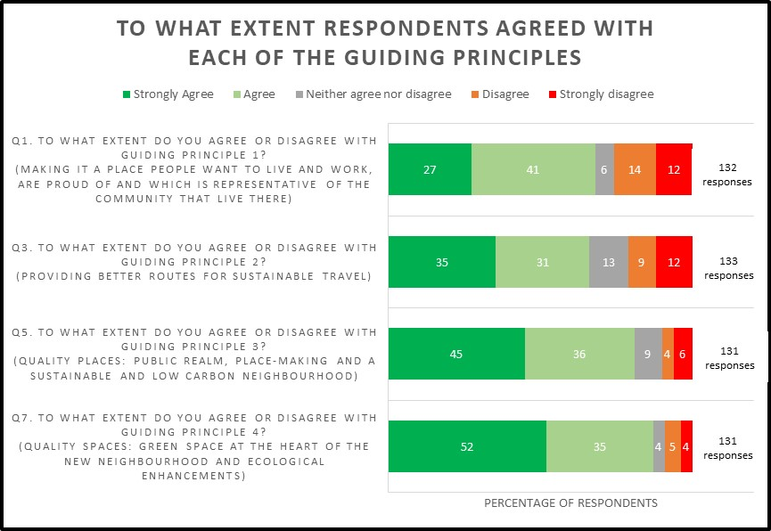

The summary report below details the feedback from the engagement on the four principles. It also includes feedback received in relation to Constraints and Opportunities and Emerging Concepts and Principles that formed part of the engagement.

Principle 1 - Making it a place people want to live and work, are proud of and which is representative of the community that live there.

Of the 132 responses to this question 68% of respondents agreed or strongly agreed with Principle 1. 26% disagreed or strongly disagreed.

Figure 1: Summary of responses to Principle 1.
To what extent do you agree or disagree with Guiding Principle 1? (Making it a place people want to live and work, are proud of and which is representative of the community that live there)
Answer Choices |  |  | Response Percent | Response Total
1 | Strongly agree |  | 27.27% | 36
2 | Agree |  | 40.91% | 54
3 | Neither agree nor disagree |  | 6.06% | 8
4 | Disagree |  | 13.64% | 18
5 | Strongly disagree |  | 12.12% | 16

89 respondents submitted comments about Principle 1. The main themes were as follows:

- There is support for regeneration of the area with many seeing the need to make changes.
- Concerns were expressed about the height and density of the development and whether sufficient community infrastructure and services needed to support an increased population were in place. Concerns were also expressed about the impact on existing businesses, increased traffic congestion and the impact on the Totterdown escarpment.
- Some comments referenced that too dense or too high buildings were detrimental to health and wellbeing or would mean that there would not be the mix of services, space, or facilities for a cohesive community.

Other comments raised in relation to Principle 1 are summarised below:

- The need for Infrastructure/local amenities/community cohesion x 29
- Don’t build too high and/or too densely x 22
- Concerns due to congestion/pollution/parking/traffic x 11
- Ensure there is enough social housing/affordable/community led x 11
- Importance of preserving the Totterdown escarpment x 8
- Comments about employment including mixed views on office space, need for retail, and employment space not just on ground level x 6
- Support for mixed use x 6
- Protect existing businesses x 6
- Greening x 5
- Examples of good schemes that would fit here x 5
- Meaning of sustainability x 4
- Comments about development in wider area x 3
- Unsuitable for housing x 3
- Density over height x 3
- Negative reaction to students/campus x 3
- Negative Health and wellbeing (linked to high rise/dense development) x 3
- Other comments x 11

The frequency of topics mentioned from comments submitted about Principle 1 are shown in figure 1 below (please note that the number of topics is more than the number of comments received as some respondents covered multiple topics in their replies).

Figure 2: Bar Chart showing number of comments by topic in relation to principle 1.

Principle 2 - Providing better routes for sustainable travel

Of the 133 responses to this question 66% of respondents agreed or strongly agreed with Principle 2. 21% disagreed or strongly disagreed.

Figure 3: Summary of responses to Principle 2.
To what extent do you agree or disagree with Guiding Principle 2? (Providing better routes for sustainable travel)
Answer Choices |  |  | Response Percent | Response Total
1 | Strongly agree |  | 35.34% | 47
2 | Agree |  | 30.83% | 41
3 | Neither agree nor disagree |  | 12.78% | 17
4 | Disagree |  | 9.02% | 12
5 | Strongly disagree |  | 12.03% | 16

83 respondents submitted comments about Principle 2. The main themes were as follows:
- Concerns were expressed that adding more residents to the area and making it a low parking neighbourhood might result in increased congestion and parking competition in surrounding areas.
- St Luke’s Road was highlighted by respondents as being dangerous for pedestrians and cyclists, particularly the tunnel section underneath the railway bridge.
- Scepticism was expressed over the effectiveness of mass transit proposals with references to other forms of mass transit other than buses. Comments related both to Mead Street and more general comments about mass transit.
- There was general support expressed for the active travel routes proposed, including for use of segregated cycle lanes in the locality.
Other comments raised in relation to Principle 2 are summarised below:

- Low parking neighbourhood proposals not supported x 19
- Improvements to St Luke's Road needed (as dangerous for pedestrians/cyclists) x 13
- Concerns about mass transit proposals x 10
- Support for segregated cycle lanes – Positive x 8
- Support for improved cycling/pedestrian facilities & active travel proposals x 9
- Proposals will increase traffic in the area x 9
- Support for low parking neighbourhood proposals x 8
- Residents Parking Zones needed to prevent overspill parking x 5
- Pedestrian and cycle access is already good along Mead Street so development won’t change that x 4
- Clarence Road & York Road should be combined to avoid duplicating traffic routes for example creating a one way system – needs a traffic strategy x 3
- Pedestrian improvements on York Road needed x 3
- Existing cycle lanes in surrounding area not being used properly x 3
- Clean Air Zone concerns around increased congestion on St Lukes Road and St Johns Lane and secondary roads x 3
- Prioritise pedestrians and crossings on St Luke's Road x 2
- Consider wheelchair users when making changes x 2
- Local car share scheme suggestion x 2
- Support for southern gateway to Temple Meads x 2
- Improved junctions/connections for cycling & walking required including on St Lukes Road x 2
- These roads are essential for businesses x 2
- Reduce/keeping housing density down. x 2
- Include safe bike storage in proposals x 2
- Not enough space to reduce the road and increase width for walking/cycling on Mead Street or widening St Lukes Road for cycling/walking x 2
- Negative towards cyclists x 2
- General comment x 12

The frequency of topics mentioned from comments submitted about Principle 2 are shown in figure 4 below (please note that the number of topics is more than the number of comments received as some respondents covered multiple topics in their replies).

Figure 4: Bar Chart showing number of comments by topic in relation to principle 2.

Principle 3 - Quality Places: Public Realm, Place-Making and a Sustainable and Low Carbon Neighbourhood

Of the 131 responses to this question 81% of respondents agreed or strongly agreed with Principle 3. 10% disagreed or strongly disagreed.

Figure 5: Summary of responses to Principle 3.
5. To what extent do you agree or disagree with Guiding Principle 3? (Quality Places: Public Realm, Place-Making and a Sustainable and Low Carbon Neighbourhood)
Answer Choices |  |  | Response Percent | Response Total
1 | Strongly agree |  | 45.04% | 59
2 | Agree |  | 35.88% | 47
3 | Neither agree nor disagree |  | 9.16% | 12
4 | Disagree |  | 3.82% | 5
5 | Strongly disagree |  | 6.11% | 8

58 respondents submitted comments about Principle 3. The main themes were as follows:
- Respondents highlighted the need to consider additional facilities and community infrastructure needed to support any future development. This included things like schools, shops, youth facilities, and surgeries that would be needed to support additional residents in the area and create a cohesive community. Freedog was highlighted as something important to the community.
- The need for more green space and to protect/plant trees was highlighted, as well as the need to plan any green space well so it is accessible and not shaded by buildings.
- Whilst respondents generally agreed with having sustainability targets, they expressed a desire for them to be more tangible and measurable to ensure a sustainable and low carbon neighbourhood is delivered.
Other comments raised in relation to Principle 3 are summarised below:

- Needs sense of community/facilities/infrastructure x 18
- Importance of green space/trees x 7
- Making commitments happen/targets needed for sustainability and public realm x 7
- Policies/actions which conflict – for example carbon neutral/heat networks whilst using building materials, low carbon vehicles vs transport hub. x 5
- Protect existing businesses x 4
- Comments on landscape/urban planning eg: planning homes back from the road, querying green space in the middle due to light, not an obvious place for families due to be surrounded by roads x 4
- Suggestions for Solar/Electric vehicle charging x 3
- Roads are currently busy and those in the development will have cars x 3
- Other more appropriate places for redevelopment than Mead Street x 3
- Make ground floor uses effective/affordable x 2
- Ensure accessibility at the site x 2
- Mead Street is a good location for regeneration x 2
- Other comments x 6

The frequency of topics mentioned from comments submitted about Principle 1 are shown in figure 6 below (please note that the number of topics is more than the number of comments received as some respondents covered multiple topics in their replies).

Figure 6: Bar Chart showing number of comments by topic in relation to principle 3.

Principle 4 - Quality spaces: Green space at the heart of the new neighbourhood and ecological enhancements

Of the 131 responses to his question 87% of respondents agreed or strongly agreed with Principle 4. 9% disagreed or strongly disagreed.

Figure 7: Summary of responses to Principle 4.
7. To what extent do you agree or disagree with Guiding Principle 4? (Quality spaces: Green space at the heart of the new neighbourhood and ecological enhancements)
Answer Choices |  |  | Response Percent | Response Total
1 | Strongly agree |  | 51.91% | 68
2 | Agree |  | 35.11% | 46
3 | Neither agree nor disagree |  | 3.82% | 5
4 | Disagree |  | 5.34% | 7
5 | Strongly disagree |  | 3.82% | 5

48 respondents submitted comments about Principle 4. The main themes were as follows:
- Comments were generally supportive of proposals to have green space at the heart of the new neighbourhood.
- A desire for proposals to be more ambitious was also expressed, particularly regarding biodiversity targets.
- Respondents highlighted that the green space at the heart of the development should be open to all in the community and serve a different purpose to Victoria Park.
Other comments raised in relation to Principle 4 are summarised below:

- Support for more green space x 10
- Proposals are not ambitious enough, particularly regarding biodiversity targets x 10
- The green space should provide wider benefits x5
- Make any green space communal/open to all x 4
- Victoria Park already provides a large open green space nearby x 4
- Green space won't work if positioned amongst tall buildings x 3
- Keep existing trees x 3
- Comments/suggests about water drainage including a soak away area and water capture x 3
- Don't limit to a green space at the centre x 3
- The maintenance of any green space/public realm needs to be considered x 3
- Provision of a roof garden would be beneficial x 2
- Tall development will damage view from Richmond Street/Totterdown x 2
- Other comments x 9

The frequency of topics mentioned from comments submitted about Principle 4 are shown in figure 8 below (please note that the number of topics is more than the number of comments received as some respondents covered multiple topics in their replies).

Figure 8: Bar Chart showing number of comments by topic in relation to principle 4.

Constraint and opportunities map and emerging concepts and principles plans

Respondents were also asked to comment on two plans – one detailing constraints and opportunities and the other showing emerging concepts and principles.

Constraints and Opportunities

92 respondents submitted comments. The main themes were as follows:
- Many respondents to this question expressed concerns associated with the height of any proposed development and the impact tall buildings would have on important city views, particularly the Totterdown escarpment.
- Opportunities to improve Langton Bridge to make it more accessible were highlighted.
- Other comments raised in relation to Constraints and Opportunities are summarised below:

- Building height should be restricted/is a risk to important city views x 41
- Improvements to St Luke's Road are required x 10
- Improvements to Langton Bridge improvement are required x 10
- Clean Air Zone implications including access to development, impact on roads, charging local residents, possible inclusion within the CAZ x 9
- Not supportive of the regeneration proposals for Mead Street x 5
- Improvements to York Road are required x 4
- lack of local amenities to support the regeneration and increased population x 4
- Support for green space within the development x 4
- Support high rise/high density building here x 3
- Need for parking controls if development goes ahead x 3
- Voicing support for existing businesses x 3
- Need for parking controls in the surrounding area if development goes ahead x 3
- Support for the Whitehouse Street/Mead Street active travel route x 2
- Big green space in middle of development is not needed x 2
- Other comments x 17
The frequency of topics mentioned from comments submitted about constraints and opportunities plan are shown in figure 9 below (please note that the number of topics is more than the number of comments received as some respondents covered multiple topics in their replies).

Figure 9: Summary of responses to the constraints and opportunities plan.

Emerging concepts and principles

67 respondents submitted comments about plan showing emerging concepts and principles. The main themes were as follows:
- Concerns raised in relating to the emerging concepts and principles plan were broadly similar to those highlighted in other questions and detailed earlier in this report, including the need to consider appropriate community infrastructure/facilities, concerns about building heights, and a desire for more green space.
- Comments also reflected concerns about noise pollution within the current site and the proposed development.

Comments also reflected concerns about what will happen to existing businesses that use the site.

Other comments raised in relation to the emerging principles and concepts plan are summarised below:

- Community infrastructure/community facilities/community cohesion needed x 17
- Travel/transport to other areas/York Road needs improving x 6
- Industrial/pollution/noise concerns x 6
- More green space needed x 5
- Consider existing businesses – the employment and value they currently bring to the area x 5
- Mass transit – needs more detail to comment and concern over compatibilityx 4
- Don’t do/ not suitable location x4
- No need for workspaces x3
- St Lukes Road improvements requiredx 3
- Concerns over height/density x 3
- Travel and movement including making it better for those in wheelchairs or with limited mobility, how the number of cars can be reduced and no need for more crossings x 5
- Ground floor frontage suggestions, for example having community facility on York Road, public realm connection on Bath Road, and think carefully about interface of private and public realm x 2
- Protecting the escarpment is important x 2
- Other comments x 15

The frequency of topics mentioned from comments submitted about emerging principles and concepts plan are shown in figure 10 below (please note that the number of topics is more than the number of comments received as some respondents covered multiple topics in their replies).

Figure 10: Summary of responses to the emerging principles and concepts plan.

Next Steps
The results from the engagement have been used to help inform the draft Mead Street Development Brief. This will go out to consultation in May/June 2022.

