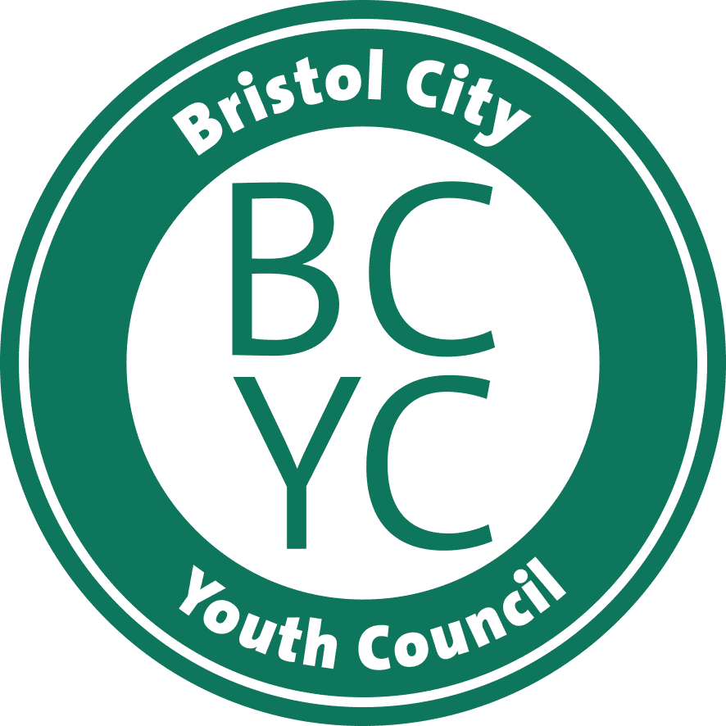

 |  | Reply to | Participation Team
 |  | Telephone
 |  | Mobil | 07780486367
 |  | E-mail | ywparticipation@bristol.gov.uk
 |  | Our ref | BYE 2026
 |  | Your ref
 |  | Date | 11th September 2025

Dear Teacher / Youth Worker

Bristol Youth Elections 2026 – Polling Station Registration

We are writing to ask your School, College or Youth Project to sign up as a polling station for the Bristol Youth Elections 2026.The voting period runs from 19th to 30th January 2026.

Young people in Bristol will elect representatives (aged 11-18 on the day of the election) to the Bristol City Youth Council (BCYC) and UK Youth Parliament (UKYP). We have enclosed the ‘Election Guidelines’ which explains how to run the election, and a ‘Polling station Participation Form’ (next page) for you to return to us by Monday 3rd November 2025 to register.

As a reminder you will have received another email to ask for your help in promoting the Bristol Youth Elections nominations to young people aged 11 to 18. You will have received a poster and application forms in the email however you can also download all the information documents at Bristol City Youth Council election

The Participation team would like to offer support to promote nominations either through an assembly, workshop or visit with information stand. Please contact us to make a request. The deadline for young people to nominate themselves as a candidate is Friday 31st October 2025.

We would also like to offer support with any information or support needed to sign up to be a polling station.

Please do not hesitate to contact us if you have any questions or requests.
Yours sincerely
Claire Corrigan

Bristol Youth Elections 2026
Polling Station participation form

Please return this form to the address below by Monday 3rd November 2025
or if it is more convenient, please email your responses to ywparticipation@bristol.gov.uk.

Name of School/College/Youth Project

Name of key contact person
Job Title

Telephone Number

Email Address
We would like our School / College / Youth Project to act as a polling station  (Please tick as appropriate) | Yes | No
Number of students at your School/ Youth Group
This will enable us to provide you with the right amount of ballot papers
Additional notes / questions / support required

Thank you!

Participation and Involvement Team
Families in Focus North
40 – 44 Ridingleaze
Lawrence Weston
Bristol, BS11 0QE

