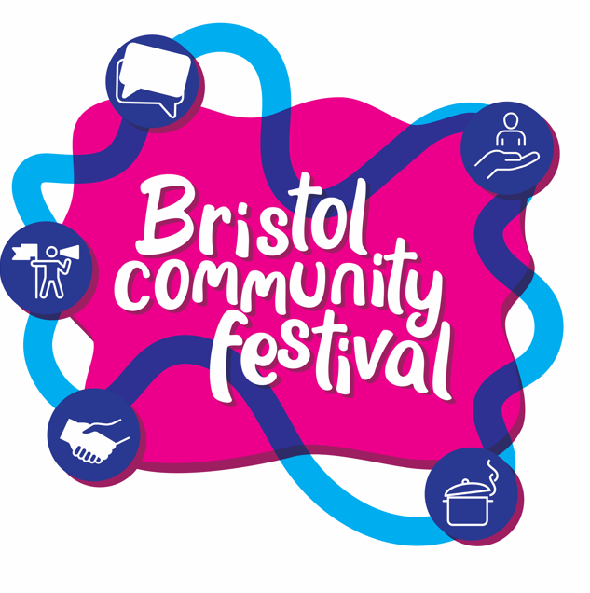

Bristol Community Festival – Self Funded Events Application Form

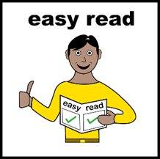
This is a plain English information and application form to run a self-funded event at Bristol Community Festival.
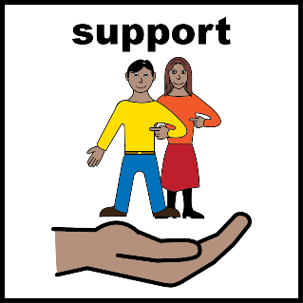
You may need support with reading and completing this form. You can ask someone you know to help you.
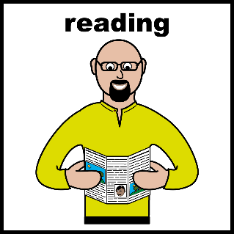
Please make sure that you have read all the information before you answer the questions below.

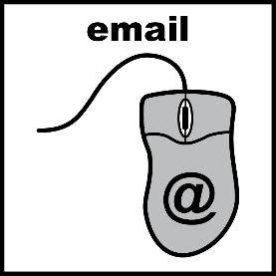
When you have answered all the questions below, email this document to investmentandgrants@bristol.gov.uk.
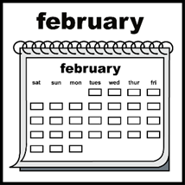
You must complete and send the form by Sunday 3rd May 2026

Please email investmentandgrants@bristol.gov.uk or call 07778 732452 if you have any questions.

Information about this form

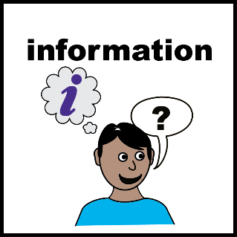
Bristol City Council are inviting community groups to organise events as part of Bristol Community Festival from 6th – 12th June 2026.
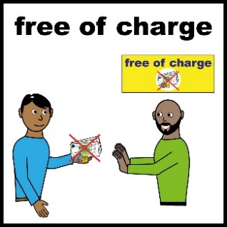
This form is for community groups who would like to organise an event and do not need funding or are not based or works in the top 30% most deprived areas in Bristol.

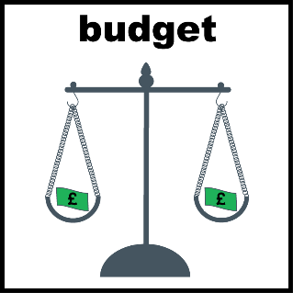
If you do need money to organise your event or do work in an eligible area, please complete the Bristol Community Festival – events grants application form. You can find this form on our website.

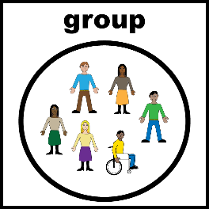
You can apply if you are based in Bristol and are:
- a voluntary sector organisation or
- part of a group or
- an individual

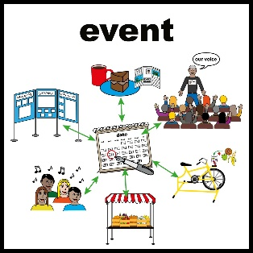
Events must do one of these things:

- Celebrate activities and projects created by ordinary people to make change in their community.

- Share stories of people making their voices heard.

- Help people to feel like they belong in their community.

- Connect people with opportunities to make a difference in their community.

- Inspire people to get involved in things that are important to them.
Events could be things like:
- Awards ceremonies
- Celebrations of culture
- Taster activities
- Talks and workshops

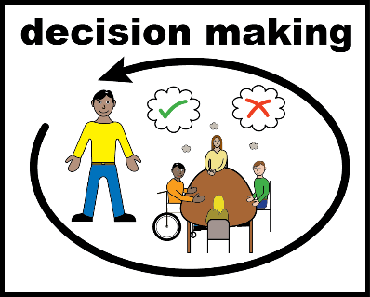
After the deadline we will assess your application and let you know if you have been successful.

Application form
Please write your answers in the boxes below.
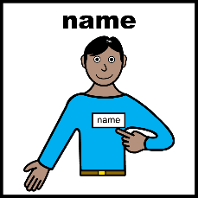
What is the name of your organisation?
What is your name and email address?
What type of group/organisation are you? Please tick one.

Resident-led group (You can be volunteers).

Unincorporated association

Community Interest Company (CIC) limited by
guarantee

Community Interest Company (CIC) limited by share
(schedule 2 with 100% asset lock)

Company limited by guarantee

Charitable Incorporated Organisation (CIO)
Community benefit company registered as an

Industrial and Provident Society
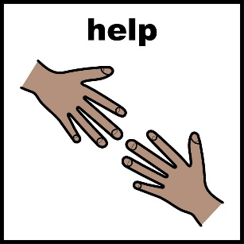
Do you have any access or communication needs? Please tell us about them. For example, you need a BSL translator or documents in large print.

What will your event be called?
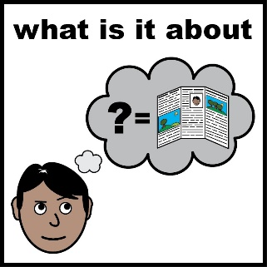
Tell us about your event idea (no more than 200 words).

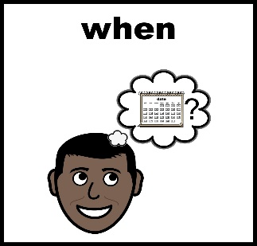
When will your event be held? For example, on a weekday, weekend, evening or daytime.
It should be between Saturday 6th June and Friday 12th June 2026

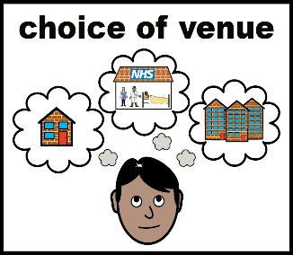
Where will your event take place? For example, Easton, Hartcliffe. If you already have a venue idea, please let us know. If you want to hold your event outside, please read the guide to holding events outside and Community Events in Parks guide.

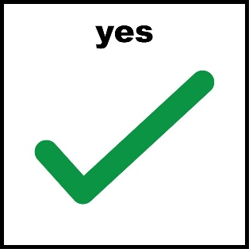
Please tick which of these things your event will do (you can tick more than one).

Celebrate activities and projects created by ordinary
people to make change in their community.

Share stories of people making their voices
heard.

Help people feel like they belong in their community

Connect people with opportunities to make a
difference in their community.

Inspire people to get involved in things that are

important to them.

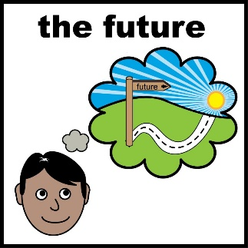
What will happen after your event? (200 word limit) For example, people will meet others from their area or community, people will know what’s happening in their community.

Health and Safety
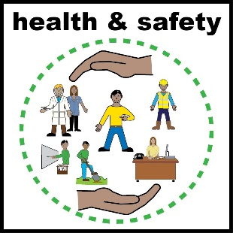
We want to make sure that everyone is safe while attending the festival, and you are protected if anyone is injured or harmed at your event.
If you are organising an event, you must have Public Liability insurance.
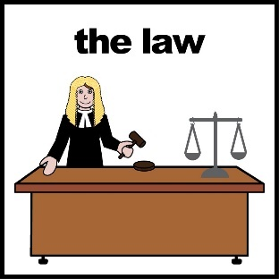
Bristol City Council will not be held responsible for any accident, injury or loss occurring at events associated with Bristol Community Festival.
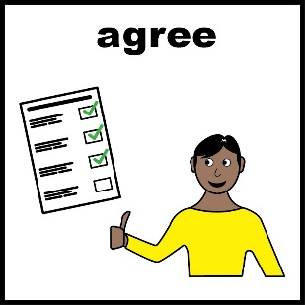
Please put a tick in the box if you agree to:

I confirm that my event will be covered by Public Liability Insurance and that I take responsibility for ensuring the health and safety of those who take part.

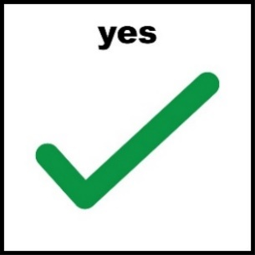
Tick here:

Accessibility
All venues used for events must have...

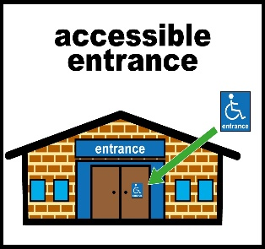
an accessible entrance, parking space…

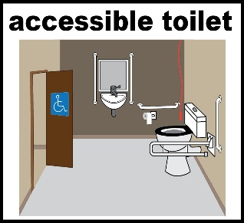
and an accessible toilet.

We can help you with finding an accessible venue for your event.

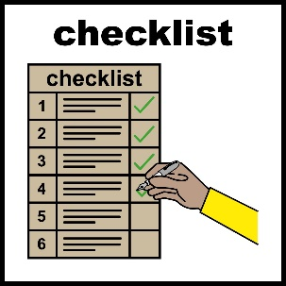
You will need to complete a Self-Assessment Access Audit Checklist to help you make sure your venue is accessible.

You can ask someone you know to help you to complete this.

Please email this to us in the Bristol City Council Community Resources team at investmentandgrants@bristol.gov.uk
Sunday 3rd May 2026.
Applications received after this time will not be considered.

