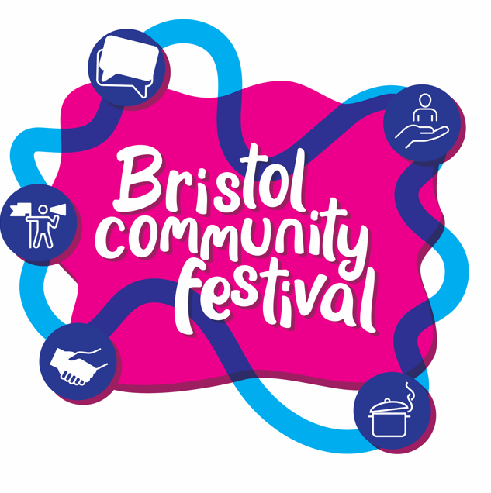

Bristol Community Festival – Event Grant application form


This is a plain English information and application form to run an event at Bristol Community Festival.
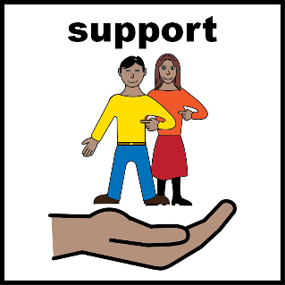
You may need support with reading and completing this form. You can ask someone you know to help you.
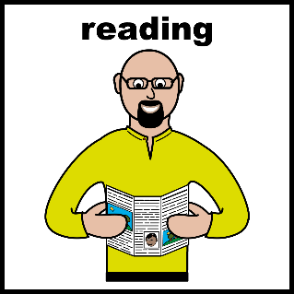
Please make sure that you have read all the information before you answer the questions below.

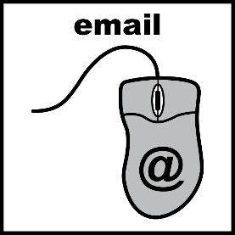
When you have answered all the questions below, email this document to investmentandgrants@bristol.gov.uk.

You must complete and send the form by 9am on Monday 23rd February 2026.

Please email investmentandgrants@bristol.gov.uk or call 07778 732452 if you have any questions.

Information about the grants


Bristol City Council would like to give community groups money to organise events as part of Bristol Community Festival from 6 – 12 June 2026.
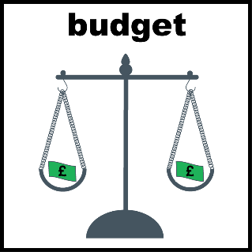
You can apply for £500 and an extra £150 to fund accessibility related costs.

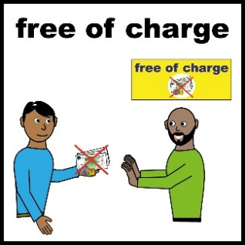
If you do not need money to organise your event or do not work in an eligible area, please complete this form instead.

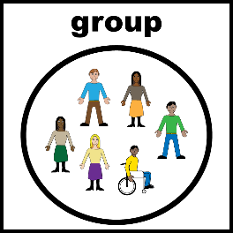
You can apply if you are:
- a voluntary sector organisation or
- part of a group (of at least 3 residents)
- someone who is based in Bristol or works in the city

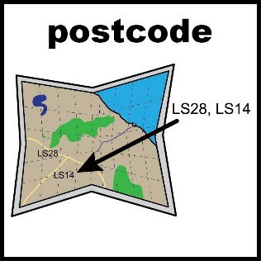
…that work in areas highlighted on this map or

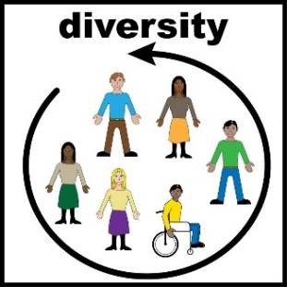
…led by/work with people from these groups of people:

- Black & Minoritised communities
- Older people
- Young People (age 16 – 25)
- LGB (Lesbian, Gay, Bisexual) people
- Disabled people
- Women
- Transgender people
- Gypsy Roma traveller people

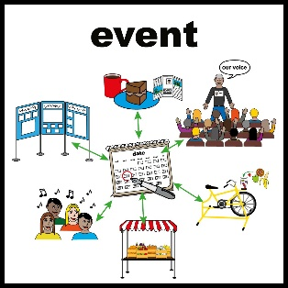
Events must do one of these things:

- Celebrate activities and projects created by ordinary people to make change in their community.

- Share stories of people making their voices heard.

- Help people to feel like they belong in their community.

- Connect people with opportunities to make a difference in their community.

- Inspire people to get involved in things that are important to them.
Events could be things like:
- Awards ceremonies
- Celebrations of culture
- Taster activities
- Talks and workshops

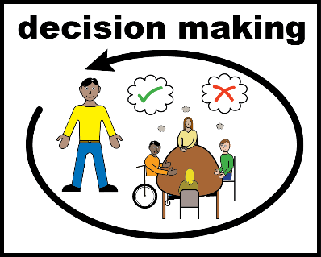
After the deadline 9am Monday 23rd February 2026 we will assess your application and let you know if you have been successful.

If you are successful and you are part of a resident group, you will be paid through an online system called Open Collective.
Open Collective is a website where you can receive money into your bank account.

Application form
Please write your answers in the boxes below.
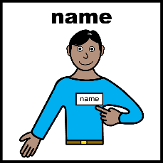
What is the name of your group/organisation?
What is your name and email address?
What type of group/organisation are you? Please tick one. If you’re not sure, email investmentandgrants@bristol.gov.uk and we can help.

Resident-led group (at least three residents must
make up your group. You can be volunteers).

Unincorporated association

Community Interest Company (CIC) limited by
guarantee

Community Interest Company (CIC) limited by share
(schedule 2 with 100% asset lock)

Company limited by guarantee

Charitable Incorporated Organisation (CIO)

Community benefit company registered as an
Industrial and Provident Society
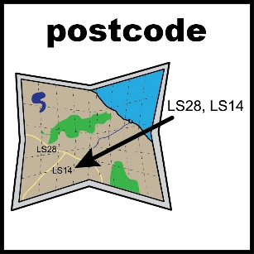
Which area are you based/do you work in? Check this map.
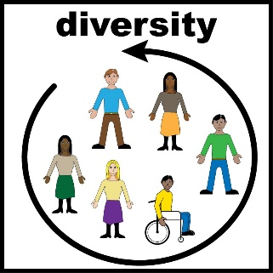
Which equalities groups are you led by/do you work with (if any)?
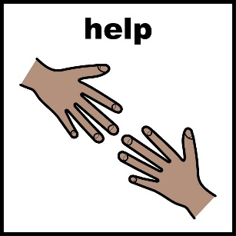
Do you have any access or communication needs? Please tell us about them. For example, you need a BSL translator or documents in large print.

What will your event be called?
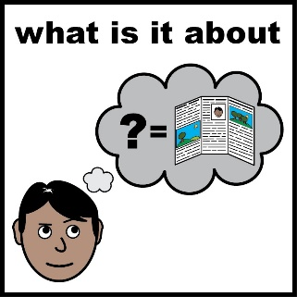
Tell us about your event idea (no more than 200 words).

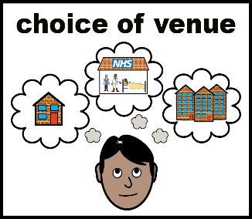
Where will your event take place? For example, Easton, Hartcliffe. If you already have a venue idea, please let us know. If you want to hold your event outside, please read the guide to holding events outside and Community Events in Parks guide.

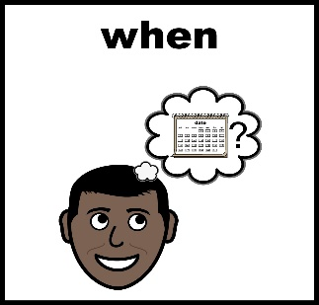
When will your event be held? For example, on a weekday, weekend, evening or daytime.
It should be between 6 - 12 June 2026.

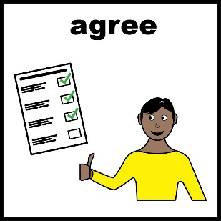
Please put a tick in the box if you agree to:
I agree to that my organisation/group, or a representative from my organisation/group, will attend the final celebration event on Saturday 13th June if my application is successful.
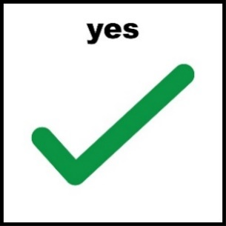
Tick here:

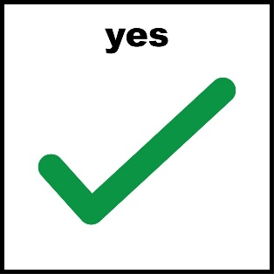
Please tick which of these things your event will do (you can tick more than one).

Celebrate activities and projects created by ordinary
people to make change in their community.

Share stories of people making their voices
heard.

Help people feel like they belong in their community

Connect people with opportunities to make a

difference in their community.

Inspire people to get involved in things that are

important to them.


What will happen after your event? (200 word limit) For example, people will meet others from their area or community, people will know what’s happening in their community.

Accessibility
All venues used for events must have...

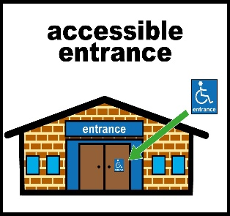
an accessible entrance, parking space…

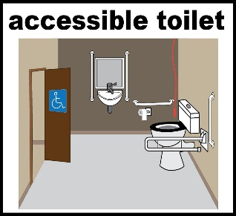
and an accessible toilet.

We can help you with finding an accessible venue for your event.

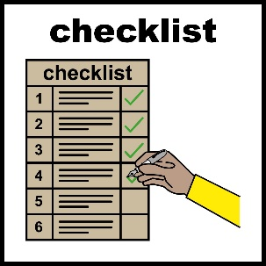
If you receive money for your event, you will need to complete a Self-Assessment Access Audit Checklist to help you make sure your venue is accessible.

You can ask someone you know to help you to complete this.

Please put a tick in the box if you agree to:

host my event in an accessible building and complete a Self-Assessment Access Audit Checklist if my application is successful.
Tick here:

Please tell us how your event will be accessible and inclusive (100 words limit).

To make events accessible you can apply for £150 on top of your £500 grant, this can be used towards anything from this list: Access Support.

If you are applying for this extra £150, please complete the table below with what you plan to spend it on.

Access support item | Cost
e.g. BSL interpreter for 3 hours | e.g. £144
Total | £

Event costs
Please complete the below table with your event costs. These can be estimated. All events must be covered by Public Liability Insurance. This cost can be covered by the grant if you cannot use the insurance of the venue you are using. Please include this in your event costs if needed.

Item | Cost
e.g. venue hire | e.g. £300
e.g. equipment hire | e.g. £100
e.g. public liability insurance | e.g. £100
Total | £

Event Risk Assessment
What are the risks of your event and how will you avoid them? Do you need any permissions for your event? For example, permission to hold an event in a park, road closure etc. Please make sure you have looked into what is needed and allowed time to get permissions before your event.
Please complete the below table.
Project risk | Impact of risk | Severity of Impact (Red, Amber, Green with Red being severe impact and green being minimal impact) | Likelihood of Risk (1-5 with 1 being very unlikely and 5 being very likely) | Mitigation
e.g. Attendees with food allergy eats food containing an allergen and has a reaction | e.g. Attendee has a negative experience, becomes unwell and does not want to engage in future activities | Amber | 2 | e.g. Food is clearly labelled with allergens. First aider will be on site.
e.g. venue is not fully accessible | e.g. wheelchair users cannot access event | Red | 3 | e.g. source alternative venue to accommodate needs of attendees
Project risk | Impact of risk | Severity of Impact (Red, Amber, Green with Red being severe impact and green being minimal impact) | Likelihood of Risk (1-5 with 1 being very unlikely and 5 being very likely) | Mitigation

Please email this to the Bristol City Council Community Resources team at investmentandgrants@bristol.gov.uk.
9am Monday 23rd February 2026.
Applications received after this time will not be considered.

