
Working with Hazardous Plants
Bristol Parks and Green Spaces Volunteer Programme

Activity: Working with hazardous plants Date: September 2026
If hazardous plants are present on your site they should be identified on your site risk assessment.
These hazards must be reassessed before an activity take place. This is not an exclusive list of hazardous plants but includes plants with a higher risk of harm that you might come across when volunteering

Hazard | Possible Outcome | Who is at risk? | Control measures | Risk rating | Person responsible
Giant Hogweed  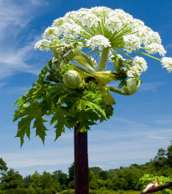 | Contact with sap causing severe burns, blistering and painful dermatitis. Blisters can develop into purplish or blackened scars. | Volunteers and staff | Giant Hogweed should not be touched or dealt with. If you identify Giant Hogweed, stay away, and keep others away. Report to BCC via fixmystreet with a location (preferably What3words). A trained officer will safely remove it. If skins makes contact with sap, wash affected area immediately. | M | Health and safety lead
Common Hogweed  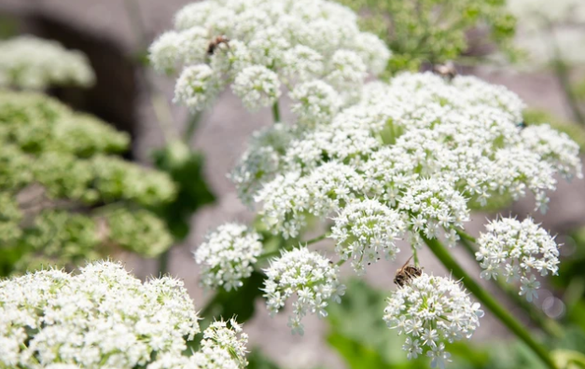 | Contact with sap cause irritation and skin blisters and burns | Volunteers and staff | Wear gloves, long sleeves and trousers. Provide hand wash. | L | Health and Safety lead
Hemlock  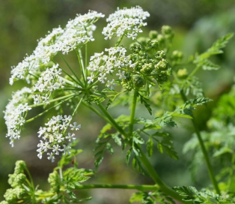 | Touching the plant can generate a painful rash, or painful burning on the eyes.  Accidental poisoning from ingesting the plant - Both growing and cut, dried plant are poisonous if ingested. | Volunteers and staff | If working where Hemlock may be present wear gloves, long sleeves and trousers.  Hemlock can be fatal if ingested – ingestion can be avoided with a mask over your mouth. Be aware of symptoms - Hemlock poisoning will display symptoms after 30 minutes to three hours depending on amount ingested.  If removing Hemlock, dig deep to take out the taproot. Waste should be bagged and put in general waste. Wash your hands thoroughly with soap after. Useful advice: Hemlock advice | Hemlock advice | Norwich City Council | M | Health and safety lead
Wild Parsnip and Wild Angelica  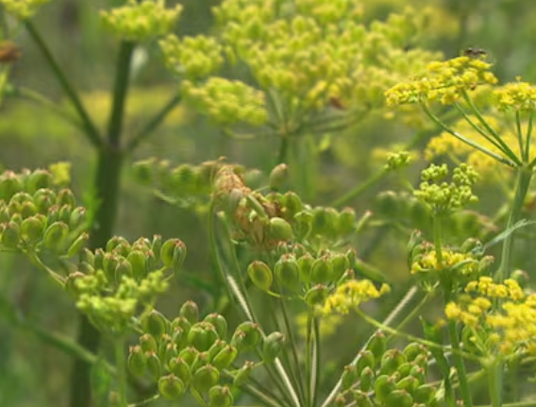  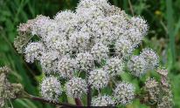 | Sap can cause burns to the skin. If the plant juices makes contact with skin in the presence of sunlight, a rash and/or blistering can occur. Skin discoloration that may last several months | Volunteers and staff | Wear gloves, long sleeves, provide hand wash | M | Health and safety lead
Bracken  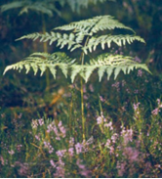 | Inhalation of toxic bracken spores and / or fungi spores associated with bracken causing harm  Higher risk if bracken cut late in the summer after warm, wet weather, when spores are released. | Volunteers and staff | If you have bracken on your site, contact your Area Coordinator to arrange safe methods of management. Protect skin with gloves and long sleeved clothing.  Avoid prolonged working in bracken particularly during the late summer season from August to September. | M | Health and safety lea
Thorns and brambles | Can cause cuts and abrasions that can become infected. Blackthorn thorns are prone to carry infectious material. Each thorn has a rough texture and can easily break under the skin. | Volunteers and staff | Wear gloves and appropriate footwear if working with thorny plants. Deal with splinters promptly. Go and see a doctor immediately if there is any serious pain or swelling | M | Health and safety lead
Blue green algae (in water)  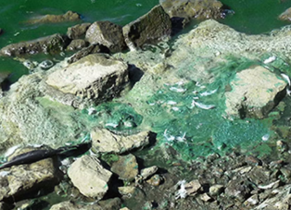 | Contact with algal blooms causing blisters | Volunteers and staff | Avoid close working with algal blooms. Wash them off immediately if they contact skin. If contact cannot be avoided ensure protective clothing is worn and hand washing facilities are close by. | M | Health and safety lead
Hemlock water dropwort  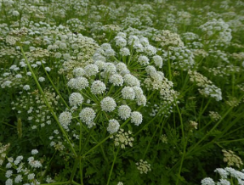  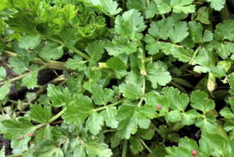 | Hemlock Water Dropwort enters digestive system and causes illness or fatality. All parts of the plant are poisonous if eaten. | Volunteers | Wear gloves. Wash hands when gloves removed. Do not put the plant in or near your mouth. | L | Health and safety lead
Foraging and misidentification of toxic plants | Incorrect identification and eating poisonous plants leading to illness - potentially fatal | Volunteers and public | Volunteer leads are not authorised to lead foraging walks. Leads should not pick or hand out plants to others to eat | L | Health and Safety lead

