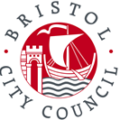
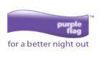

DBS Update Service
What is it?
The Disclosure and Barring Service (DBS) update service lets applicants keep their DBS certificates up to date online and allows related organisations to check a certificate online. This form allows us to check your DBS certificate status online. You must maintain a subscription to the DBS Update Service at all times you hold a Hackney Carriage or Private Hire Driver licence.
What do you need to do?
- You can register with the DBS as soon as you have your application form reference number on the DBS website or you can wait and register with your certificate number when you receive your DBS certificate. If so, you must do so within 30 days of the date of issue displayed on the certificate.
- If you don’t sign up in this time frame you will have to complete a new DBS Check to sign up to the DBS Update Service.
- Once you have registered and received your certificate provide us with your details below and return via the contact form. Registration lasts for 1 year and costs £13 per year. You can find further information on signing up to the DBS Update Service and renewing your subscription here.
DBS Update Service Details:
Name (eg. John Smith)
Gender: (eg. Female, Male)
Date of Birth:(eg. 06/12/1968)
Email address: (eg.test@test.com)
Certificate number: (see example below)
Signature:
Date:
☐ I confirm that I have signed up to the DBS update service, and understand I am giving permission for Bristol City Council to check my DBS status as necessary.

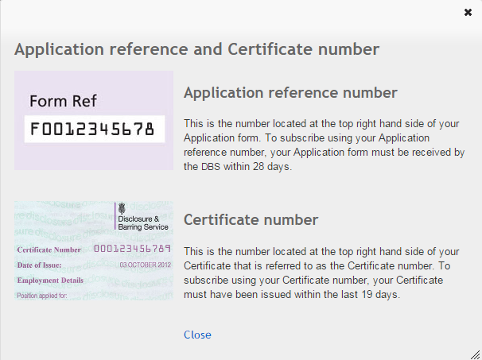
If you wish to withdraw your consent in the future you must notify the Licensing Team in writing via the contact forms.

