EFFECTIVE OCTOBER 2017
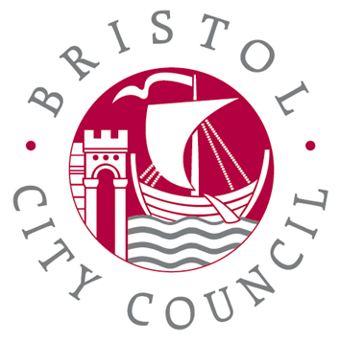
BCC Translation & Interpreting Service
100 Temple street, Bristol. BS3 9FS.
Tel: 0117 90 36400
Email: tis@bristol.gov.uk
Tel: Translation & Interpreting: 0117 90 36400

TRANSLATION / QUOTATION REQUEST FORM.

Please provide information about yourself and the document you would like to translate or to have a quotation on.
Today’s date
Organisation name
Department / division
Section / team / school
Your full name
Full postal address (including postcode)
Telephone number
Email address
What type of document is it?
e.g. letter, birth/marriage certificate, etc.
Translate from (which language)
Translate into (which language)
Cost Centre Code / purchase order Number (BCC customers MUST fill this in)
Is the translation urgent? | Yes No (delete as appropriate)  Standard service: 4 working days  Urgent service: 2 working days
Do you require a quote before we proceed? | Yes please send me a quote before proceeding  No a please action the work now
Charges: £30 for most languages up to 150 words; £15 per 100 words over the initial 150 words. Some languages may be charged at a higher rate – please check with us when booking. VAT will be added for non-Bristol City Council organisations. 50% surcharge for urgent work. Formatting surcharges may apply for complex documents – please check when booking.

