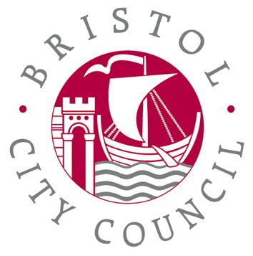

Bristol City Council

Bristol Impact Fund: Growing the Power of Communities

Small grants

Application Guidance Notes

Deadline for applications:
12:00 noon Friday 8th April 2022

Contents

 | Page number
The Bristol Impact Fund: Growing the Power of Communities | 3
Eligibility criteria check lists and guidance | 4
What we won’t fund | 6
Small Grants | 7
Collaborative working | 7
Organisations previously funded in the first BIF | 7
How to submit your application | 7
Support and Advice | 8
How to complete the application | 8
Small Grants Assessment | 16
Small Grants Allocation Decisions | 20
Grants timetable and process | 21
Supporting documents | 21
Checklist (documents that must be submitted) | 21

Bristol Impact Fund: Growing the Power of Communities experiencing the greatest inequality

These guidance notes will help you to apply for the Bristol Impact Fund Small grants.

We suggest you read the Bristol Impact Fund: Overview to fully understand what we want to fund with the second Bristol Impact Fund. For the first time, the council will work with a number of other funders to share the applications we receive for BIF Small Grants which we hope will result in more organisations receiving funding, whether from BIF Small Grants or from other funders.

The Bristol Impact Fund has a budget of £1.45m in year 1 and then £1.65m for years 2, 3 and 4 each, totalling £6,400,000. The Fund will operate across the following years:

Year 1 | Year 2 | Year 3 | Year 4
October 2021 – September 2022 | October 2022 – September 2023 | October 2023 – September 2024 | October 2024 – September 2025

The Bristol Impact Fund: Overview is included in your application pack. If you need the document in plain text please contact the Investment and Grants Team:
investmentandgrants@bristol.gov.uk

Applications to the Bristol Impact Fund 2 Small Grants should be sent to the investmentandgrants@bristol.gov.uk

The table below tells you what the application form asks you to fill in and how each section is scored:

Section | Questions addressed | Scoring
Section A- Name and address of organisation | Name and address of organisation. Details of key contact | Not scored
Section B- Eligibility | Is your organisation eligible for a grant? | Gateway questions
Section C- Funding priorities | Are you small organisation, where are you going to work, who are you going to work with, are you an organisation of your community? | Weighted scoring
Section D- Quality | How much grant are you asking for, what will you do? What is your Community Identified Priority? What work will you do and how will you work to bring people together and build skills confidence and stronger relationships between people | 1-4 scoring  Scoring 1 for any question means the proposal is un fundable.
Section E – Impact | What difference will your work make? What positive difference will the grant make to your organisation. Set your outcomes and indicators for your community identified priority.  Populate the pre-set indicators for your Community Building priority (you must address this). | 1-4 scoring  Scoring 1
Section F Baseline Standards | Can you meet our baseline standards. Safeguarding policy (if relevant). Commit to using accessible venues and minimising environmental impact. Confirm you’ll have insurances in place at start of grant. | Gateway questions
Section G Supporting Documents | Checklist of additional documents to send with application. | Not scored.

Eligibility Criteria Checklist

Section B

The Bristol Impact Fund is open to applications from voluntary, community and social enterprise (VCSE) organisations which meet the specified criteria.
Before you start to complete the application you should use this checklist to ensure that all the statements below apply to your organisation.

Yes/No
- Is your organisation based in Bristol or delivering services in Bristol?
- Does the organisation have a set of rules that tells you how the organisation is run – (for example, a constitution)
Please submit this with your application
- Does your organisation have at least 3 trustees or directors?
Please provide us with a list of all your trustees, their names and their addresses.
- Is there a bank account in your organisation’s name?
- If you have answered no to question d. is there an Accountable Body who has agreed to hold the funds for your organisation? Enter the name and address of the Accountable Body organisation below:
- Do payments have to be authorised by two people (who are not related or living together)?
- Send us a copy of your most recent accounts
B1 Help:
Trustees: You should have at least 3 trustees in the Bristol area (see Guidance document for map)
Accountable body is a body that can meet the criteria above and agrees to hold your grant funding in their bank account.

The Bristol Impact Fund is open to applications from voluntary and community sector and Social Enterprise organisations that have one or more of the following structures or forms. Before you start to complete the application you should use this checklist to ensure that at least one of the structures below applies to your organisation.

Is your organisation a - | Yes/No | Tick for the accountable body: Yes/No
Unincorporated association
Registered charity
Community Interest Company (CIC) limited by guarantee
Community Interest Company (CIC) limited by share (schedule 2 with 100% asset lock)
Company limited by guarantee
Charitable Incorporated Organisation (CIO)
Community benefit company registered as an Industrial and Provident Society
Other (please tell us below)

If you are unable to answer “Yes” to all the above statements, your organisation is unfortunately ineligible for a grant from the Bristol Impact Fund.

Local Priority

We will prioritise local organisations (organisations that are registered in Bristol – by which we mean that their main base or headquarters are in Bristol - and have at least 3 trustees who are residents of the Bristol area – see page 16) but we will consider applications from non-local organisations which meet the eligibility criteria and which bring specialist expertise to the city.

Eligibility Criteria Guidance Notes

Constituted
Your organisation must have a constitution (a set of rules) or Memorandum and Articles of Association that allows it to undertake the activities in your application. If your constitution does not currently allow your organisation to undertake the activities you are proposing then we will require a letter signed by your Chair setting out what changes to your constitution are proposed and when the amendments or new constitution will be adopted.

Bank Account
Your organisation should have a bank account in its name and that payments from this account should be authorised by at least two signatories (who are not related or living at the same address).

Accountable bodies
If your organisation does not have its own bank account you may be able to find an accountable body to hold the funds in their bank account.
An accountable body is an organisation that can meet the criteria above.

What we won’t fund

Proposals that will not contribute to the fund’s priorities

Proposals that will not address our community building priority or which cannot clearly evidence a community priority.

Proposals targeted at children (where children aged under 16 are the primary or sole participants)*

Capital costs (for example, the costs of equipment, vehicles, land, buildings, building refurbishment, repairs or maintenance or landscaping)

Political or religious activities

Projects or activities held in inaccessible venues. It is essential that disabled people can participate in Bristol Impact funded activities.

Projects or activities that the state or a statutory body has a legal obligation to provide

Any costs incurred when putting together your grant application

Activities that happen or start before the start date of the grant and the council’s funding agreement

Endowments (to provide an income)

Loans or interest payments

*Note about children’s services/activities
The Bristol Impact Fund will fund work with adults and young people (aged 16+). The funding which forms the Impact Fund as a pooled budget is from adult-focused budgets. The primary grant investment for young people by BCC is through the Youth sector support fund. See the BIF Overview (p21) for more information on how to access this funding

We realise that many organisations work with families and their activities will impact on both adults and children. Organisations in this situation may want to tell us about the positive benefits (outcomes) for children in their response to the added value question in Part D of the application. This way they can still tell us about their ‘whole’ work in a way that represents their activities and services.

Small Grants

Please note: we will be inviting applications for Bristol Impact Fund Small Grants as follows:

- Two rounds of Small Grants, each with an 18-month duration and with £150,000 available in each round, making a total allocation of £300,000 to Small Grants across the the BIF programme
- Round 1 – grants for the period July 2022 – December 2023
- Round 2 – grants for the period January 2024 – June 2025
- Small grants will range between £2,500 and £10,000 per year
- Minimum grant awarded will be £3750 for the 18 month grant period
- Maximum amount of grant awarded will be £15,000 for the 18 month grant period

Collaborative working

We expect all applications to the Bristol Impact Fund to demonstrate informal collaborative working in the way they deliver, regardless of the size of grant they are seeking. This approach reflects the Relational/ Relationship-oriented way of working which underpins the Fund.

Organisations previously funded in the first BIF

The Bristol Impact Fund 2021-2025 will accept applications from organisations which received funding from the first Bristol Impact Fund, 2017-2021.

This could be to continue work funded in the first BIF or to deliver different work.

How to submit your Application

The completed application, and all supporting documents must be submitted to investmentandgrants@bristol.gov.uk before the deadline at 12.00 noon on Friday 8th April

Answering the questions

Please read each question and this Guidance fully and carefully.

Some questions have word limits as shown. Please do not exceed the word limit given. (The word limit does not stop you being able to input text). Text exceeding the stated word limit will not be read or considered as part of your application. Bullet points are acceptable.

You can check your own word count by highlighting the relevant text. In most Word versions your word count will be shown on the bottom left of the screen.

Support and Advice

If you have any questions about the application process, please ask us by emailing the investmentandgrants@bristol.gov.uk using the BIF 2 Small Grant Question in the subject line. . We want to make sure that every organisation gets the same information and advice and so we will publish our responses by updating FAQ sheet on our webpage Grants for voluntary and community organisations - bristol.gov.uk(so that they are available to everyone). We will not provide advice on the telephone or face-to-face.

If your organisation needs support with your application you may be able to get support from Voscur or Black South West Network (BSWN)

Support from BSWN

BSWN will be providing targeted support with applications for the Bristol Impact Fund for Black and Minorities-led VCSE organisations.

To indicate interest please get in touch with Mina on mina@bswn.org.uk.

Support from Voscur

Voscur will provide free support for voluntary and community organisations that are eligible and wish to apply for Bristol Impact Fund 2 (Small Grants).
This will consist of:
•Question and Answer Briefings.
•Self-help Resources.
•One-to-one Support Sessions.
Resources will be available and online briefings/support sessions can be booked via www.voscur.org:
Bristol Impact Fund 2 – Small Grants | Voscur

Investment & Grants Team Contact Details

Investment & Grants Team | Email: investmentandgrants@bristol.gov.uk

How to complete the application

Section A: Information about you and your organisation
A1 & A2
These sections ask for details about your organisation name and address and the key contact for your application. They are not scored.

Section B: Eligibility

Question B1a. Is your organisation based in Bristol or delivering services in Bristol?
We prioritise local organisations (organisations that are registered in Bristol – by which we mean that their main office or headquarters are in Bristol - and have at least 3 trustees who are residents of the Bristol area) but we will consider applications from non-local organisations which meet our eligibility criteria and which bring specialist expertise to the city.

The map below illustrates what we mean by ‘trustees who are residents of the Bristol area’ This is a Pass/Fail question.

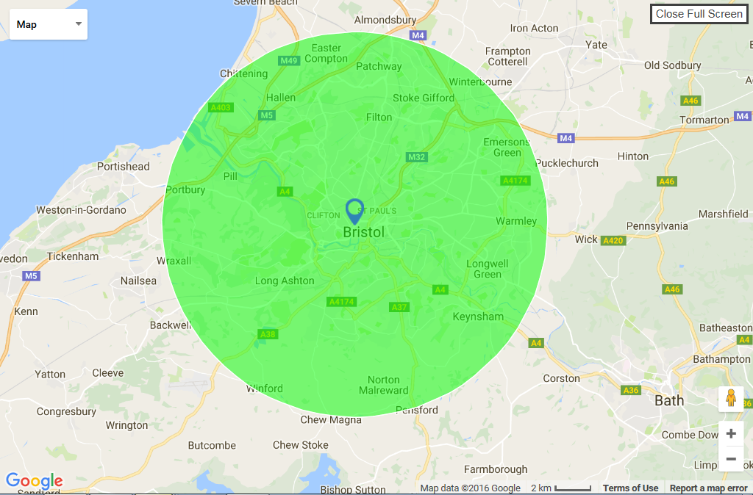

Question B1b. Provide a copy of your constitution document: This is a Pass/Fail question. Your constitution document must demonstrate that it allows you to do the work you are proposing and that your organisation meets the Eligibility Criteria Checklist. Please submit a copy of your constitution with your application

Question B1c. Provide a list of your current Trustees, their names, addresses, This is a Pass/Fail question. We will check that there are at least 3 trustees/directors, that they are not related or living together, are not paid shareholders and if any are residents of the Bristol.

Question B1d.: Your organisation bank account: This is a Pass/Fail question.

Questions B1e. If you don’t have a bank account in your organisation’s name you can approach an organisation which does qualify (it can answer yes to all the questions in B1 and yes to one of the organisation structure types in question B2)
If you have answered no to question B1d please provide the name of the accountable body that has agreed to hold your funding

Question B1f. Financial safeguards: This is a Pass/Fail question. Tell us if your cheques and other payments (of over £100) have to be authorised by two signatories who are not related and do not live together? We will only fund organisations that have this financial safeguard in place.

Send a copy of your most recent accounts with your application – this should be the accounts you share at your Annual General Meeting

Question B2. Organisational Structure: This is a Pass/Fail question. If your organisational structure does not fit within one of those in our Eligibility Criteria Checklist your application will not be taken forward.

Section C: Priorities:

It’s important that our grant money has the biggest impact it can therefore we have to prioritise who we give grants to. The questions in this section will help us decide if you meet our priorities for the funding.

C1. Smaller organisations with a regular turnover of under £250,000

Whilst there is no cut off for groups that have a regular turnover of higher than £250,000 we wish to maximise the impact of our small grants by prioritising smaller organisations who may have never had funding. There is a weighting of 1 point for organisations with under £250,000 regular turnover

C2. Are the majority of your trustees, senior management, staff and volunteers ‘of’ the community you are working with? This question helps us to decide whether you are an Organisation 'of' your community- That is organisations who are led by and controlled by a majority of people who have direct relevant experience in the context of the proposal. Tick ‘yes’ only if the majority of your trustees, senior management, staff and volunteers ‘of’ the community you are working with.
There is a weighting of 2 points for organisations which are ‘of’ their community

C3. BIF Small Grants will fund Place-based and equalities- based work

A) Place based organisations - Wards

•focused on the 20% most deprived neighbourhoods in the city’s wards.
•The Small grants round will also specifically prioritise wards that contain areas in the top 1%-10% of deprivation and were under-represented in the medium to large round of BIF2 grants these are:

•Henbury and Brentry
•Frome Vale
•Hillfields
•Brislington West
•Stockwood
•Hengrove and Whitchurch Park

Please tick the wards that your organisation will be working in. We have highlighted the wards that are in the 20% most deprived neighbourhoods
There is a weighting of 1 point in total for organisations which are working in any or all of these wards

For applications which are focused on where people live we will prioritise areas of greatest inequality – we are open to evidence but our starting point will be areas in the top 20% most deprived, which include areas in the following wards: Ashley, Avonmouth and Lawrence Weston, Bishopworth, Brislington East, Brislington West, Central, Easton, Eastville, Filwood, Frome Vale, Hartcliffe and Withywood, Henbury and Brentry, Hengrove and Whitchurch Park, Hillfields, Horfield, Knowle, Lawrence Hill, Lockleaze, Southmead, Southville, Stoke Bishop, St George Central, St George West, Stockwood and Windmill Hill.

Please see this map for further information on priority areas that experience the greatest inequality in the city:
2019+IMD+map+with+ward+and+area+committee+boundaries (bristol.gov.uk)

B) Equalities based organisations

•Organisations that are led by equalities communities or from communities that have identified themselves as experiencing systemic inequality.

•In particular applications will be encouraged from and working with equalities communities under-represented in BIF2 medium to large grant allocations, including:

•Gypsy, Roma and traveller people
•Young people
•Lesbian Gay Bisexual and Transgender (LGBT+)people

There is a weighting of 1 point in total for organisations which are doing focused work with any or all of these priority groups

Please tick all equalities group that your proposal intends to l deliver focused work with. We’ve also set out some other specific groups that experience inequality which may help you focus on particular groups of people

Section D - Quality

About your proposal

D1. Give your proposal a short, clear name. Not scored

D2 Tell us how much grant are you asking for. Not scored

D3. – provide a short description of what you will do if funded – 50 words maximum. This section summarises your proposal. Not scored

D4. Your Community-identified priority: Tell us the priority issue you want to work on with this grant – 25 word maximum. Not scored
Please note:
•Video applications will be accepted for Questions D5- E2 (the scored sections of the application)
•Please indicate on the application form which questions you have chosen to answer this way.
•Video Applications will be scored using the same criteria as written answers
•Video applications should stick to the same word count indicated for questions in the application
•To submit a video application WhatsApp your video to 07385950631
•Stating:
- The name of your organisation
- The name of your application

D5. Tell us why the issue you want to address is important to your community and what your organisation already does to support your community and this issue.
This question is scored

D6. The BIF 2 Thematic Priorities: We’ve set out the 4 priorities which BIF 2 wants to support which come from the research which Black South West Network, along with Voscur and Locality, conducted to identify pressing issues made worse within communities because of the Covid-19 pandemic. Tell us if your Community Priority fits within any of these four pre-set priorities. This is for information only – there is no special advantage or loss to your application if your Community-identifed priority does or does not fit in these priorities. Not scored

D7. What work will you do over the 18 months of the grant to make an impact within your community?: This question is your chance to tell us about your proposed work plan, what you want to achieve, what you’ll do to achieve it, how you’ve involved people in shaping the work, how what you do will fit with other organisations and work in your community and how you’ll work together with other organisations. This question is scored

D8. How will you work in your community to bring people together to grow skills, confidence and stronger relationships between people? This question asks how you’ll support the BIF 2 Ways of Working in how you deliver your project (see BIF 2 Overview). In particular we want you to tell us how you’ll be inclusive of people from different communities in your work and how you’ll link people you work with up with others to build their connections and to support them to take action in their community. This question is scored

Section E: Impact

This section is important because we want the BIF Small Grants to help you make a real difference to the Community Priority you are working on AND to the longer-term strength of your organisation. the heart of the application. The questions take you through the Making an Impact model (see the Overview, page 12) for your proposal. This section is scored in our appraisal process.

The goal of this second Bristol Impact Fund is to grow the power of those communities in the city which experience the greatest inequality.

The diagrams below set out two contrasted illustrations of some of the characteristics of, on the one hand, a more active powerful community rooted in a strong foundation of community action and getting things done with the support of local agencies (diagram a); on the other, where local people are disconnected from top down decision making (diagram b). The left diagram (a) shows characteristics of community life where power is shared with many more people rather than the few.

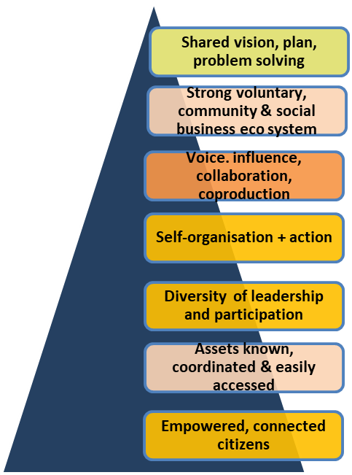
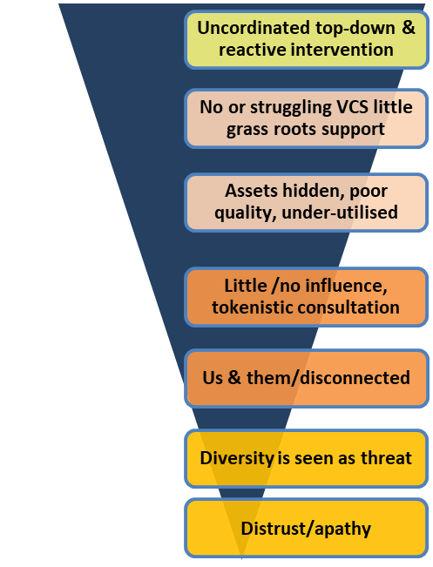

a.

P
O
S
I
T
I
V
E

A
C
T
I
O
N

This second Bristol Impact Fund is looking to support Community and Voluntary organisations, rooted in communities, to work in ways which intentionally support their communities to develop towards the state shown in diagram a.

The diagram below illustrates the direction of travel which the second Bristol impact Fund is looking to support:

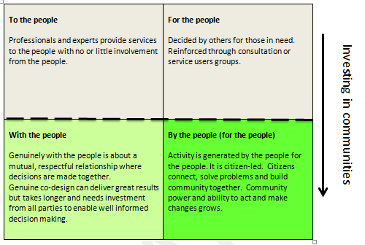

Bristol Impact Fund aims to support work which builds relationships based on the ‘with the people’ and ‘by the people’ approaches, rather than ‘to the people’ and ‘for the people’ approaches in order to strengthen the base of empowered, connected citizens within our communities.

E1: What improvements or positive difference for your community will your work achieve at the end of 18- month funding? Tell us about why you’ve planned your work in the way you have and why you think it will make a positive difference. You should use evidence that shows that your proposal will work and will be an effective way of having an impact on the chosen priorities. For example, this could be learning from your own work, learning from similar projects delivered by other organisations, results of consultation with your community or experts, evaluation of an existing service or of an activity, or it could be a combination of stories from your community or data from your community. Tell us what you expect to change for your community at the end of the 18-month grant period.
This question is scored

E2. : What improvements or positive difference for your organisation will your work achieve at the end of 18-month funding. We want the small grant to support smaller organisations to develop. Please tell us how you think the grant will support your organisation to develop. This question is scored

E3. Community Priority - Outcomes and indicators: What would you expect to see if your work is successful? Heritage Lottery describes outcomes in the following way:

Outcome:
• The output of cooking dinner is a plate of food. The outcome is a full and satisfied person.
• The output of a teacher is a certain number of lessons delivered in a year. The outcome is happier, wiser students who are more able to succeed.

Please set one outcome for your chosen Community Priority. Copy your Community Priority wording from your answer to D4. Then enter the Outcome which is the key one you want to use to show your 18-month project has succeeded. Set an outcome which describes positive changes or improvements and which is meaningful to your community and your organisation.

Indicators
An indicator is a measure or output you predict or expect to achieve which will show that you’re achieving your Outcome.

Please set two indicators for your proposal:

Indicator 1: this should be a number-based indicator – example: 20 BAME older people who say they feel more connected to their community (quantity or amount outputs you’ll deliver)

Indicator 2: This should be a set of stories or case studies that show the quality and experience of positive change which people you work with are likely to tell you about.

This question is scored

E4. Community Building Priority: BIF2 has already set a Community Building Priority which all Small Grant-funded projects must contribute to. You’ll see the Priority and the Outcome and the Indicators for this Priority already set out in the Application form:

Community Building Priority
Programme Priority (This is OUR Bristol Impact Fund priority):
To Strengthen the capacity of equalities-led communities, geographical communities and people experiencing the greatest inequality” (you must address this priority)

Outcome (This is the BIF Outcome your work must support)
People are supported to make people to people connections, and participate in community life making the best use of community assets
Indicators (these are our core BIF indicators you must contribute to):
Please fill in the number of people you expect to support to achieve these indicators over the course of your programme below:

- Number of people who have gained knowledge, skills and confidence (in a relevant area of their life or in making a change in their community)

- Number of people making new connections

E4. Help:
Indicators are the signs that change is happening, and they help you to see if what you are doing is working. Some people call them measures. Please tell us number of people you expect to achieve the two core BIF indicators we’ve set out above

Please enter the numbers of people you expect to support to achieve these two pre-set indicators into the application in the boxes provided

  - Number of people who have gained knowledge, skills and confidence (in a relevant area of their life or in making a change in their community)

- Number of people making new connections

This question is scored

E5. Please fill out the budget for your proposal. Use as many rows as you need. Please indicate how much funding you intend to use from BIF2 Small Grants and any other funding from other sources you will use in the project.

Not scored

Section F: Baseline Standards

F1. Please complete the Baseline Standards table to tell us:

- If your organisation has all the listed policies in place already
- If not, if you will commit to develop any missing policies in the first 6 months of receiving a Small Grant. Support will be available to you from Voscur and Black South West Network to achieve this
- Note: you must confirm that you will have a Safeguarding policy in place before the start of any Small Grant is you are working with Children and Young People or Vulnerable adults

F2. Please confirm you will use only accessible venues to deliver your work

F3. Please confirm that you will consider and act to minimise the environmental impact of how you delivery your proposed project

F4. Please confirm that you will obtain and provide evidence of the correct insurances at the minimum levels required before the start of your grant agreement

F5. Please confirm that you have permission from your organisation’s trustees to apply for this BIF 2 Small Grant; and that your organisation meets the Eligibility Criteria for a Small Grant.

Bristol Impact Fund 2 Small Grants Assessment

The section below sets out how we will assess your application and the scoring awarded for each element

- Eligibility for BIF 2 Small Grant funding:

We will assess your organisation’s eligibility to get BIF 2 Small Grants funding by looking at your answers to:

- Sections B1 & B2
- Your answers to our Baseline Standards questions: Sections F1; F2; F3 & F4

- BIF 2 Small Grant Priorities: Scoring your proposal: additional weighting

- Section C1: Small organisations

Organisations with a regular turnover of under £250,000: 1 additional point

- Section C2: Communities ‘of’

Organisations which are ‘of’ their community: 2 additional points

- Section C3a: Wards

Organisations which are working in the 10% most deprived areas of the following wards: 1 additional point (in total, not 1 point for each ward):

- Henbury and Brentry
- Frome Vale
- Hillfields
- Brislington West
- Stockwood
- Hengrove and Whitchurch Park

- Section C3b: Equality Groups

Organisations which are working with the following equalities groups: 1 additional point (in total, not 1 point for each group):

- Gypsy, Roma and traveller people
- Young people
- Lesbian Gay Bisexual and Transgender (LGBT+) people

- Scoring your proposal: Quality

- Section D5: Tell us why this issue is important to your community, and what your organisation already does to support your community and this issue.

Score | 1 | 2 | 3 | 4
Rationale | Poor: Not clearly answered or explained | Satisfactory: Answered partially or fully but we have moderate/minor reservations | Good: Answered and explained clearly | Excellent: – our factors have been addressed and exceeded
Additional information | If a proposal scores ‘1’ for any of the appraised factors it will not be considered as fundable.

- Section D7: What work will you do over the 18 months of the grant to make an impact within your community?

Score | 1 | 2 | 3 | 4
Rationale | Poor: Not clearly answered or explained | Satisfactory: Answered partially or fully but we have moderate/minor reservations | Good: Answered and explained clearly | Excellent: – our factors have been addressed and exceeded
Additional information | If a proposal scores ‘1’ for any of the appraised factors it will not be considered as fundable.

- Section D8: How will you work in your community to bring people together to grow skills, confidence and stronger relationships between people?

Score | 1 | 2 | 3 | 4
Rationale | Poor: Not clearly answered or explained | Satisfactory: Answered partially or fully but we have moderate/  minor reservations | Good: Answered and explained clearly | Excellent: – our factors have been addressed and exceeded
Additional information | If a proposal scores ‘1’ for any of the appraised factors it will not be considered as fundable.

- Scoring your proposal: Impact

  - Section E1: What improvements or positive difference for your community will your work achieve at the end of 18- month funding?

Score | 1 | 2 | 3 | 4
Rationale | Poor: Not clearly answered or explained | Satisfactory: Answered partially or fully but we have moderate/minor reservations | Good: Answered and explained clearly | Excellent: – our factors have been addressed and exceeded
Additional information | If a proposal scores ‘1’ for any of the appraised factors it will not be considered as fundable.

  - Section E2: What improvements or positive difference for your organisation will your work achieve at the end of 18-month funding

Score | 1 | 2 | 3 | 4
Rationale | Poor: Not clearly answered or explained | Satisfactory: Answered partially or fully but we have moderate/minor reservations | Good: Answered and explained clearly | Excellent: – our factors have been addressed and exceeded
Additional information | If a proposal scores ‘1’ for any of the appraised factors it will not be considered as fundable.

  - Section E3: Community Priority - Outcomes and indicators: What would you expect to see if your work is successful?

Score | 1 | 2 | 3 | 4
Rationale | Poor: Not clearly described or plausible | Satisfactory: clear and plausible but we have moderate/minor reservations | Good: clear & plausible | Excellent: – very clear, plausible and strong measure of impact
Additional information | If a proposal scores ‘1’ for any of the appraised factors it will not be considered as fundable.

  - Section E4: Community Building Priority -Indicators: Bristol Impact Fund has a Programme Priority and Outcome and Indicators that we have already set. We want you to tell us how your work will support these

Score | 1 | 2 | 3 | 4
Rationale | Poor: Not credible numbers or low impact | Satisfactory: acceptable numbers and impact but we have moderate/minor reservations | Good: c acceptable numbers and impact | Excellent: – strong proposed numbers and impact
Additional information | If a proposal scores ‘1’ for any of the appraised factors it will not be considered as fundable.

Small Grants Allocation Decisions

Assessment Stage | Activity
Stage 1 – Assessment | Applications will be assessed by neighbourhood and communities officers and public health practitioners to create a ‘long list’ of fundable applications
Stage 2 – Bristol Funders Network | Long list shared with partners in Bristol Funders Network to identify any that might be funded from non-BCC funding sources
Stage 3 – BCC Allocations panel | Panel of Key BCC staff make final recommendations for funding
Stage 4 – Officer Executive Decision | Final allocations approved and signed off by Officer Executive decision

Bristol Impact Fund Small Grants Timetable and Process

Applications open ​ | 8th March 2022 ​
Application Close ​ | 8th April 2022 ​
Assessment process ​ | 11th April – 29th April ​
Allocations panel ​ | Beginning of May ​
Officer Executive Decision​ | End of May ​
Grant decisions communicated to applicants ​ | End of May ​
New grant funding agreements starts ​ | 1st July ​

Supporting Documents

The following supporting documents are included in the application pack to help you put together your application:

- Bristol Impact Fund Overview
- Baseline Standards

Checklist

This checklist is to help you keep track of all the application documents needed

Checklist Don’t forget to include: | Included - tick
Copy of your governing rules or constitution
A List of names and addresses of your current trustees
A copy of your most recent accounts.

