

PERSONAL EDUCATION PLAN
Name of young person |  | Age
School/Post 16 provider |  | Year group
Date of PEP meeting

Documents/information you’ll need:
- Previous PEP form
- Attendance print out (attach to this PEP)
- Attainment data including full and interim reports (attach to this PEP)
- SIMS (or equivalent) data – positive and negative since last meeting (attach to this PEP)
- EAL action plan
- IEP/PSP where appropriate (attach to this PEP)
- One page profile or pupil passport (attach to this PEP)
- If the young person has an EHCP, outcomes from the EHCP
- Reports/comments from additional support/TA feedback (attach to this PEP)
- Exclusion information – internal and external (attach to this PEP)
- Any positive examples of work or achievements (attach to this PEP)

Monitoring the PEP
These people will be expected to monitor the PEP via the processes outlined to ensure that actions and activities recorded in the PEP are implemented without delay.

Headteacher –Pupil progress meetings
IRO – CiC Review
SIO – Core Visit
The HOPE Virtual School will monitor the quality of the PEP using Ofsted terms. The monitoring form will be returned to the designated teacher.
Reviewing the PEP
A full PEP meeting needs to be held within 28 calendar days of a young person coming into care, then at three months and then every six months.
The PEP needs to be reviewed each term (3 times a year). The review process should be timed so that an up to date version of the PEP is available in time for the statutory review of the young person’s care plan. Designated teachers can use The HOPE’s PEP review form to complete their review.
There should be a review meeting involving the SW, YP, carers and others, such as the VSH (The designated teacher for looked-after and previously looked-after children, DfE February 2018; para 34 page 19).

A copy of the PEP including all attachments/print outs and the PEP Essential Information Record must be sent securely to everyone at the meeting and the Independent Reviewing Officer. If you are completing the PEP form via the Establishment Portal, it will be received by the young person’s social worker and The HOPE, along with the attachments.
Section 1: People at this PEP meeting
Name | Role | Contact details (CHECK: DO ANY NEED TO BE KEPT CONFIDENTIAL?)

Section 2: Discussion of Last PEP’s Actions
Actions not completed from last PEP (write N/A below if this is the first PEP or ‘All completed’ if there are no actions to carry forward. Add actions to be carried forward to the S.M.A.R.T action plan)

Action | Revised timescale | Lead person

What are the significant actions from the last meeting that have had the greatest impact?

Section 3: The Young Person’s Voice
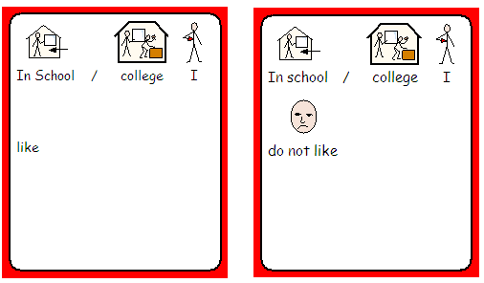

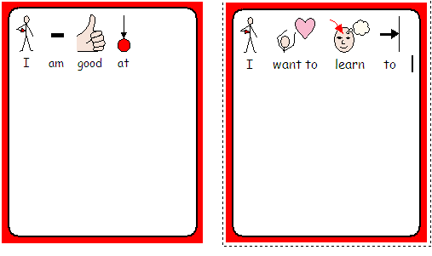

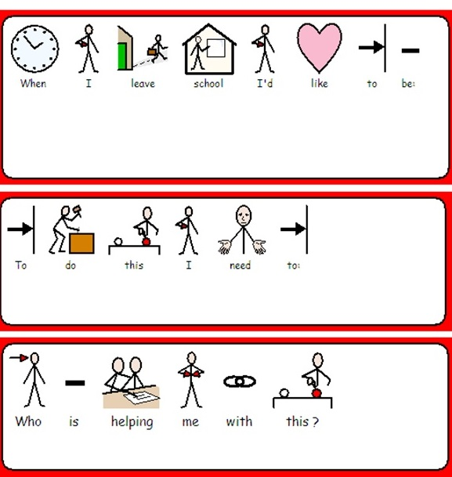

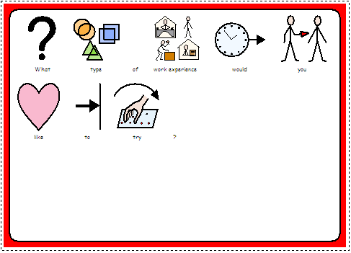

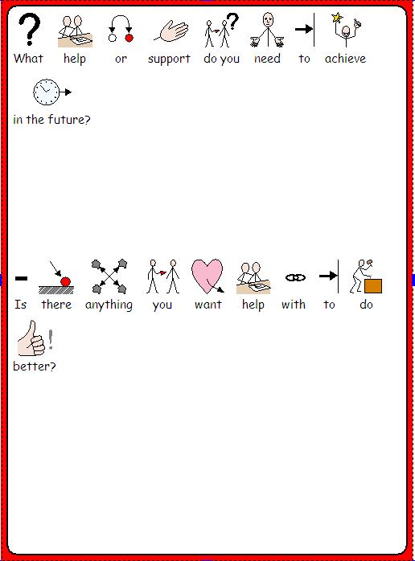

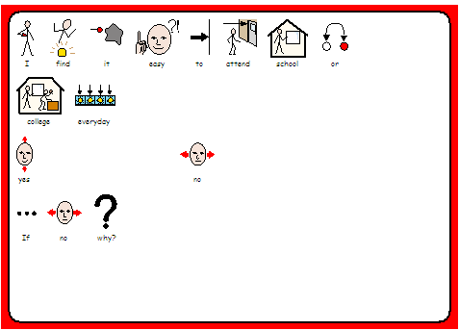

Resilience (the ability to get back on track and be yourself even when things don’t go to plan)
What helps me and what do I want to do more of to:
- keep positive relationships with others?
- manage my emotions and let people know how I am feeling?
- be more independent?
- participate in activities at school and outside of school?

Did the young person attend the meeting? Yes ☐ No ☐
If not, please give reasons.

Who will let the young person know what was discussed?

Evidence of listening to the young person’s voice
Action/s to carry forward to the S.M.A.R.T. action plan
Section 4: Setting’s Contribution - Support
Please indicate the primary need of the EHCP below:  CI ☐ CL ☐ SEMH ☐ SPN ☐  CI – Communication and interaction CL – Cognition and learning  SEMH – Social, emotional and mental health SPN – Sensory and/or physical needs | Banding level:
Date of last Annual Review meeting (if applicable):

Details of support in the setting
What support is accessed within the core offer from the setting?
Graduated approach Please write what is in place
Whole class work, Small group work, Individual work, Any other support e.g. counselling

School Strength and difficulties questionnaire (SDQ)
School SDQ Total Difficulties Score
Date SDQ completed
Name of person/s who completed the SDQ

If the young person or an adult who knows them has identified any mental health needs, please provide information below. Include the score/s from the young person’s and/or carer’s Strengths and Difficulties questionnaire (SDQ), if used, and any support that is required or ongoing from mental health specialist support services.
Support from other services (please upload relevant reports with the PEP)
Organisation and role | Name | Nature of the support | Start date

Section 5: Setting’s Contribution - Achievement and Attainment
Please complete either the relevant table below for the key stage the young person is in, or the SEND (specialist provision) information for the relevant key stage

Please fill in the table below if the young person is in KS3 and one of the two following tables, as relevant
KS2
 | Reading | Writing | Maths
TA
Scaled Score/Level

Key Stage 3
KEY STAGE 3 | Attainment Bands  - 789 – 456 - 123  - A*AB – ABC – DEFG - U  - EL1,2,3  - FS1,2  - Pre key stage | Current Attainment | EoYT | Progress  - Progress being made above this band  - Progress being made within this band  - Progress being made below this band
English
Maths
Science
If the above table is not relevant to the young person’s progress and attainment at KS3, please complete the table below instead.
SEND (Specialist provision)
 | Attainment Bands | Current Attainment | EoYT | Progress  - More than expected progress  - Expected progress  - Less than expected progress
Communication (English) | N/A SEND
Cognition (Maths) | N/A SEND

Key Stage 4
Subject | Level  0,1,2 or 3  e.g. GCSE- level 2 | Exam board | Current Attainment Grade  9-1 or A*-U for GCSE subjects  Distinction  Merit  Pass  EL1,2,3  FS1,2 | End of KS4 Target  As Current Attainment Grade options (see column to left) | Progress  - Progress being made above this grade  - Progress being made within this grade  - Progress being made below this grade | Teacher Predicted Grade  9-1 or A*-U for GCSE subjects  Distinction  Merit  Pass  EL1,2,3  FS1,2 | Mock Results  English Lang, English Lit and Maths only | Actual Attainment  For Y11 outcomes only
English Lang
English Lit
Maths
EBacc 1 Science
EBacc 2 Humanities
EBacc 3 Foreign Languages
Other EBacc Options
Other Qualification

If the above table is not relevant to the young person’s progress and attainment at KS4, please complete the table below instead.
SEND (Specialist provision)
 | Current Attainment Grade | End of KS4 target | Progress  - More than expected progress  - Expected progress  - Less than expected progress | Teacher Predicted Grade | Mock Results  (if applicable) | Actual Attainment  For Y11 outcomes only
Communication (English)
Cognition (Maths)

Key Stage 5/Post 16
Please list all qualifications and achievements including English and Maths from previous years e.g. GCSE’s and any Post 16 qualifications
Qualification  A level  ASDAN  BTEC  BTEC Diploma  BTEC Extended Diploma  City & Guilds  Degree  Extended Project  Functional Skills  GCSE  Global Research Project  Masters Degree  Music  Other (please state)  Prince’s Trust  RSA | Subject | Level  Pre-entry  Entry 1 to 3  Level 1 to 7  Other (please state) | EoYT | Result/Grade | Date Achieved | Progress  More than expected progress (MEP)  Expected progress (EP)  Less than expected progress (LEP)

If you wish to attach your current school report for the relevant reporting period in addition to the above information, please do so.

Other assessment information e.g. CATs, reading age, standardised scores
Date | Assessment type | Outcome

Current Education, Employment and Training
Please complete the relevant section below according to whether the young person is at FE college; 6th form; training/work based learning; or other employment or training
Current Provision and Progress
Name of course/training
Qualification
Level
Start and end dates
- Please complete the following with feedback from individual tutors/trainers/employers to discuss at the PEP
Subject/course/training | Tutor/Trainer/Employer comments and update on progress |  | Target | On track?
Discussion on progress

Section 6: Setting’s Contribution - Report from English and Maths teachers/tutors
Discussion/Explanation/Narrative on Progress

English

Maths

Other (please ensure feedback from 1:1 tuition)

English as an additional language
Learner who has English as an additional language (EAL)?  Yes ☐ No ☐  First language: | Is the young person able to read in his/her first language? Yes ☐ No ☐  If yes, to what standard? (Basic, More advanced, Fluent)  Is the young person able to write in his/her first language? Yes ☐ No ☐  If yes, to what standard? (Basic, More advanced, Fluent)
Please specify EAL assessment being used e.g. Solihull, NASSEA etc.
Additional languages spoken (list which and to what standard in reading and writing)

Section 7: Setting’s Contribution - Transitions
What changes or transitions are coming up that we need to plan for? (e.g. new teacher, change of key stage/school/care placement, moving on to FE, employment or training. What information, advice and guidance [careers advice] has been given for FE, employment or training? If applicable, has planning for independence been discussed e.g. living arrangements?)

Section 8: Setting’s Contribution – Behaviour and Attendance

Available Sessions | Sessions Attended | Authorised Absence (Sessions) | Unauthorised absence (Sessions) | Sessions excluded | No. of exclusions | Attendance Percentage

Is there a Pastoral Support Plan in place? Yes ☐ No ☐

Behaviour and Attendance – contextual information and any interventions made

Action/s relating to support, attainment, progress, transitions and/or attendance to carry forward to the S.M.A.R.T. action plan

Section 9: Additional Contributions
Social worker’s views on the young person’s attainment, progress and resilience
Carer’s/parent’s views on the young person’s attainment, progress and resilience
Other adults* at the meeting views on the young person’s attainment, progress and resilience
To include HOPE staff, if present

Action/s from additional contributions to carry forward to the S.M.A.R.T. action plan (e.g. how school will support the carer to help the young person’s learning at home and how the young person is supported to build resilience)

Section 10: CiC Pupil Premium/Bursary (80% of CiC Pupil Premium spend should be on improving outcomes in communication and learning. CiC Pupil Premium can only be allocated to students up to and including Year 11 if there are specific needs which have not been met via the young person’s EHCP. These needs must be clearly identified and costs provided.)

Review of previous spend since last PEP
Area of curriculum identified for support | Agreed intervention | Cost | Impact of intervention
English reading | Dancing Bears 2 x week 30mins | £525
 |  | Total £

Forecast of spend before next PEP
Area of curriculum identified for support | Agreed intervention | Cost | Expected impact of intervention
English reading | Dancing Bears 2 x week 30mins | £525
 |  | Total £

16-19 Bursary
Has the 16-19 Bursary been applied for? Yes ☐ No ☐
Please give details of how the Bursary will be allocated to the pupil:

If there is any additional support that the student needs in reference to the Bursary, what is needed?

Action/s from Pupil Premium/Bursary to carry forward to the S.M.A.R.T. action plan

Section 11: S.M.A.R.T. Action Plan
Specific actions to improve progress and attainment (and attendance, if necessary)
Bring together all the actions discussed today, including any carried forward from discussion of the last PEP’s actions, and record them below.
 | Action to be taken | By who? | By when? | Impact
What supports the pupil’s learning?
This is an essential target as evidenced by the CiC Pupil Premium information. It should have clear indications of expected attainment and planned intervention to ensure appropriate use and access to Pupil Premium funding.
What supports social opportunities/leisure interests?
(e.g. after school clubs, hobbies, clubs, teams)
What supports emotional wellbeing and resilience?
(e.g. assertiveness training/life story work, nurture groups etc.)
What supports positive behaviour?
(e.g. school rewards, time-out cards, key worker sessions, rewards)
What supports good health?
(e.g. glasses, hearing, speech, language. Attach medical plan as appropriate)
How are the longer term plans for educational targets and aspirations being supported?

Section 12: PEP Essential Information Record
School History (School to complete before the meeting. Speak to social worker if information not known)
Name and address of school | Date  started | Date left | Reason for leaving | Attendance % | No. of FTEs

Corporate parents who support this young person’s education
(Social worker to complete before the meeting. If any of the details are confidential do not include, but make sure the designated teacher has the information.)

Who? | Name | Address | Phone number & email
Carer the young person lives with |  | Check if confidential before completing | Check if confidential before completing
Parent/s |  | Check if confidential before completing | Check if confidential before completing
Designated teacher

Class teacher

Social worker

Supervising social worker
Independent Reviewing Officer |  | Independent Reviewing Officers  Children & Families Services(CH)  PO Box 3399  Bristol BS1 9NE | 0117 352 5059
The HOPE Virtual School |  | The HOPE Virtual School for Children in Care (CH)  PO Box 3399  Bristol BS1 9NE | 0117 903 6282
Others

Information for corporate parents
(Social worker to complete before the meeting)
Please fill in the information below for the young person before coming into care (for first PEP only)
Number of school changes | Attendance record (choose one of options below)  95%+ /92-95% /Below 92% | Exclusions record  Permanent/more than 3 fixed term/1-2 fixed term/none

Care status (choose 1) | ☐ Care Order  ☐ Interim Care Order  ☐ Section 20  ☐ Placement Order | Ethnic background
Level of delegated authority held by carer |  | The person who will come to parents’/carers’ evenings
The person school needs to call in an emergency |  | The person responsible for health issues (vaccination/permission/medical emergencies)
The person who will sign to say the young person can go on school trips |  | What information must be kept confidential?
School should send letters and reports to |  | Who else should receive copies of the young person’s school report?
Is it permitted to take photos of the young person? |  | The person who will sign to say if the young person can be in photos
Who is not allowed to contact the young person? |  | Who is allowed to pick the young person up from school?
Family members who can have contact with the young person |  | How does the young person get to school?

Date of next PEP meeting |  | Venue
Meeting time |  | Date of next CiC Review meeting
Date for PEP review meeting

