Early Years Foundation Stage PEP form No:
My Personal Education Plan

My name
My birthday
My age
My year group

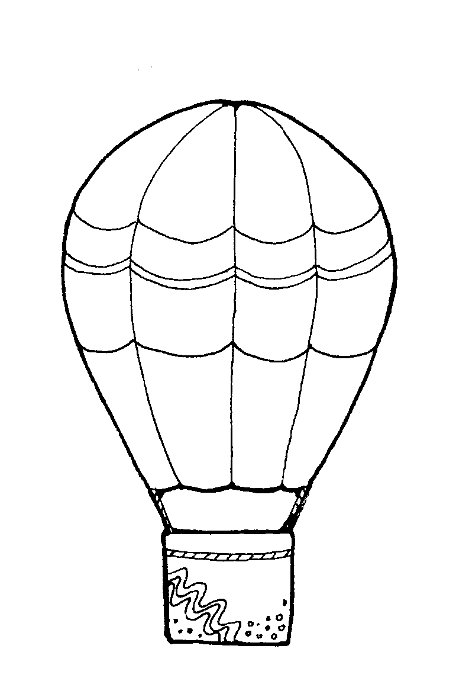

My school/setting
Date of my PEP meeting




Before the PEP meeting
Helpful Documents/information:

Previous PEP form
Learning Diary/Journal
Please mark ☒ if included in paperwork
☐ Attendance information
☐ Attainment/assessment information – AcE; 2 year check; other assessments
☐ EAL action plan - where appropriate
☐ ISP/PSP/IEP - where appropriate /comments from additional support/TA feedback
☐ If the child has an EHCP, outcomes from the EHCP
☐ Any examples of work or achievements

Monitoring the PEP
The PEP will be monitored to ensure that actions and activities recorded in the PEP are implemented without delay by:
- The IRO [Independent Reviewing Officer] – CiC review
- In a school: Headteacher –Pupil progress meetings
The HOPE Virtual School will monitor the quality of the PEP using Ofsted terms. The monitoring form will be returned to the designated teacher/person.

Reviewing the PEP
A full PEP meeting needs to be held within 28 calendar days of a child coming into care, then at three months and then every six months.
The current PEP needs to be reviewed each term (3 times a year). The review process should be timed so that an up to date version of the PEP is available in time for the statutory review of the child’s care plan. Designated teachers can use The HOPE’s PEP review form to complete their review.
There should be a review of the PEP involving the SW, YP, carers and others, such as the VSH (The designated teacher for looked-after and previously looked-after children, DfE February 2018; para 34 page 19).

A copy of the PEP including all attachments/print outs and the PEP Essential Information Record must be sent securely to everyone at the meeting and the Independent Reviewing Officer. If you are completing the PEP form via the Establishment Portal, it will be received by the child’s social worker and The HOPE, along with any attachments.

If you do not have access to the Establishment Portal, please email the completed form by secure email to anne.mortimore@bristol.gov.uk

My voice: About me ……

I like playing with

I am good at/enjoy

My friends are

I am happy when

I am sad when

I like to be called

I am a boy/girl

My important/special people are

This is me….. (a record of my mark making)

What the adults say -1

What makes me unique and special? (a simple, positive statement about me)

My parent/carer says

My social worker says

My key person says

Has anyone celebrated what makes me special?

How?

What the adults say -2

What do I enjoy doing with my carer?

At home and
out & about

Who do I share books with?

What is my favourite story?

Carer’s view of setting and how the child has settled:

How do I learn?

By playing and exploring-engagement
- Finding out and exploring
- Using what I know in my play
- Being willing to have a go

Through active learning-motivation
- Being involved and concentrating
- Keeping trying
- Enjoying achieving what I set out to do

By creating and thinking critically-thinking
- Having my own ideas
- Using what I already know to learn new things
- Choosing ways to do things and finding new ways

What the adults say – 3

My progress – summary of learning and development
Summary statements and comment on progress:

Prime Areas: Personal, Social and Emotional Development, Physical Development and Communication and Language

Specific areas: Literacy, Mathematics, Understanding the World, Expressive Arts and Design

English as an additional language [EAL]  Yes ☐ No ☐  First language: | Is the child able to read in his/her first language? Yes ☐ No ☐  If yes, to what standard? (Basic, More advanced, Fluent)  Is the child able to write in his/her first language? Yes ☐ No ☐  If yes, to what standard? (Basic, More advanced, Fluent)
Additional languages spoken (list which and to what standard in reading and writing)

Outcome of the ECAT  Early Language Child Monitoring Tool (CMT) | Current Assessment – Date:  (Please enclose completed copy with PEP paperwork)
Area | Development Band | At risk of delay? Comment:
Listening & attention |  | Yes |  | No
Understanding |  | Yes |  | No
Talking |  | Yes |  | No
Social Communication |  | Yes |  | No

What the adults say – 4
Detailed attainment information is attached to the PEP document yes/no
If no – this information will be sent by [date]

Development & Learning (Assessment)
Please choose: Birth to Five Matters / Development Matters / OP&L*/ DEYO**/ Other:
* Observation of Play & Learning
**Differentiated Early Years Outcomes

Area of learning  Child’s age in months at time of assessment: | Age-related milestones or ranges  met/not yet  Progress:  Less/Expected/More than expected progress |  | Comment on areas for development
Personal, Social & Emotional Development | met/not yet | L/E/M
Communication & Language | met/not yet | L/E/M
Physical Development | met/not yet | L/E/M
Literacy | met/not yet | L/E/M
Mathematics | met/not yet | L/E/M
Understanding the World | met/not yet | L/E/M
Expressive Arts | met/not yet | L/E/M

For children transferring from Reception to Y1 ONLY.
Please complete the final Early Learning Goals.
Please enter:  1= Emerging  2= Expected | Communication & Language |  |  |  | Physical development |  | Personal, social and emotional development
Please enter:  1= Emerging  2= Expected | ELG01 |  | ELG02 |  | ELG03 | ELG04 | ELG05 |  | ELG06 | ELG07
Please enter:  1= Emerging  2= Expected | Literacy |  |  | Mathematics |  | Understanding the world |  |  | Expressive arts & design
Please enter:  1= Emerging  2= Expected | ELG08 | ELG09 | ELG10 | ELG11 | ELG12 | ELG13 | ELG14 | ELG15 | ELG 16 | ELG17
Date: | Did the child achieve a good level of development overall? Yes ☐ No ☐

What the adults say - 5

My additional needs
If I have anything in the list below, please tick the box and make sure a copy is with this plan (including a provision map if applicable):

No SEND ☐

School/Early Years Support ☐ |  | Inclusion Support Plan ☐
Bristol SEND Support Plan ☐ |  | Other LA SEND Support Plan ☐
Pastoral Support Plan ☐ |  | Integrated Review/2yr check ☐ Date
EHCP ☐  Date of Annual Review |  | EYs Inclusion fund or Top Up? ☐  Comment:
(if yes, please tick my primary need below)
CI ☐ CL ☐ SEMH ☐ SPN ☐
CI – Communication and interaction CL – Cognition and learning SEMH – Social, emotional and mental health SPN – Sensory and/or physical needs
We have shared the above document/s and discussed the young person’s provision at this meeting ☐
Date of last Annual Review (if applicable):

Education Setting’s 2-4 years Strengths and difficulties questionnaire (SDQ)
School SDQ Total Difficulties Score | Date SDQ completed | Name of person/s who completed the SDQ
Comment:

If the child or an adult who knows them has identified any mental health needs, please provide information below. Include the score/s from the child’s and/or carer’s Strengths and Difficulties questionnaire (SDQ), if used, and any support that is required or ongoing from mental health specialist support services.

How am I being helped?
For children in RECEPTION CLASS: What support is accessed within the core offer from school?

Graduated approach | What is in place?
Whole class work
Small group work
Individual work:
(e.g. 1-1 support, Speech & Language intervention programme, etc.)
Any other support [eg: at unstructured times]

At home?

Other adults are involved with me? (e.g. Health Visitor, Speech and Language, CAMHS, Occupational Therapist, Educational Psychologist etc.)

What changes or transitions do I have coming up that we need to plan for?
Education:

Care:

Discussion of Last PEP’s Actions
Actions from last PEP (write N/A below if this is the first PEP.
Add the actions to be carried forward to the new action plan with the revised timescale)

Action | Completed?  yes/no | Comment

What are the significant actions from the last meeting that have had the greatest impact?

My next steps in learning

What will I do?  Identified next step | Who will help me? | How will they help me?  Specific action

Pupil Premium expenditure - Am I entitled to Pupil Premium?

Yes ☐ Reception: CiC Pupil Premium [4-5 year old] please include provision map if available.
Yes ☐ EYPP: Early Years Pupil Premium [3-4 year old]
Not yet ☐ Free Early Education Entitlement [2-3 year old] / EYEP [under 2YO]
Date used? | What on? Identified need & targeted objective | Cost? | Impact? How will you know it is achieved? Actual Outcomes:

If I am entitled to the Pupil Premium and it has not yet been used, please add this to my action plan below.

My action plan (including any remaining actions from my last PEP meeting, my needs as discussed at this meeting, any transitions and what school/setting will do to support my carer to help me with my school work)

What? Specific actions/interventions planned | Who?  Who will support? | When? Frequency of sessions Start/Finish date:

We have all agreed this plan. School/setting representative’s name: Signature:

Essential PEP Information Record

Name of school/setting
Date of admission
Sessions attended | Monday | a.m. ☐ | p.m. ☐
 | Tuesday | a.m. ☐ | p.m. ☐
 | Wednesday | a.m. ☐ | p.m. ☐
 | Thursday | a.m. ☐ | p.m. ☐
 | Friday | a.m. ☐ | p.m. ☐
Attendance % so far this academic year:

People at this PEP meeting: If any of the details are confidential do not include, but make sure the designated person has the information.)

Name | Title | Contact details  (if not on next page) | X if need copy of PEP | Invite to next PEP?
 |  |  | ☐ | Yes ☐ No ☐
 |  |  | ☐ | Yes ☐ No ☐
 |  |  | ☐ | Yes ☐ No ☐
 |  |  | ☐ | Yes ☐ No ☐
 |  |  | ☐ | Yes ☐ No ☐
 |  |  | ☐ | Yes ☐ No ☐
 |  |  | ☐ | Yes ☐ No ☐
 |  |  | ☐ | Yes ☐ No ☐

Date of next PEP meeting |  | Date of PEP review  Who will be involved?
Meeting time & Venue |  | Date of next CiC Review meeting

School/Setting History (School/setting to complete before the meeting).

Name and address of school/setting | Date  started | Date left | Reason for leaving | Attendance % | No. of FTEs

Adults involved with the child (Social worker to complete before the meeting)
CHECK: is this information confidential?

Who? | Name | Address  Write confidential here if appropriate | Phone & email  Write confidential here if appropriate
Carer the young person lives with
Parent/s

Designated teacher

Class teacher

Social worker

Independent Reviewing Officer |  | Independent Reviewing Officers  Children & Families Services (CH)  PO Box 3399  Bristol BS1 9NE | 0117 352 5059
The HOPE | Anne Mortimore | The HOPE Virtual School for Children in Care (CH)  PO Box 3399  Bristol  BS1 9NE | Tel: 0117 903 6282  anne.mortimore@bristol.gov.uk
Others

Things those adults need to know (Social worker to complete before the meeting)

Please fill in the information below for the child before coming into care
Number of school changes | Attendance record  Excellent/Good/Average/Very low | Exclusions record  Permanent/more than 3 fixed term/1-2 fixed term/none

Care status (choose)  ☐ Care Order  ☐ Interim Care Order  ☐ Section 20  ☐ Placement Order | Ethnic background

The contact arrangements (who, days, times)
Level of delegated authority held by carer | The person who will come to parents’/carers’ evenings
The person school needs to call in an emergency | The person responsible for health issues (vaccination/permission/medical emergencies)
The person who will sign to say the child can go on school trips | What information must be kept confidential?
School should send letters and reports to | Who else should receive copies of the child’s school report?
Is it permitted to take photos of the child? | The person who will sign to say if the child can be in photos
Who is not allowed to contact the child? | Who is allowed to pick the child up from school?
Family members who can have contact with the child | How does the child get to school?

