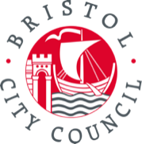
All about me

Name:
Date of Birth:
Current Setting:

It is important that your views are included in your Education, Health and Care Assessment.

You do not need to fill in this form by yourself, so please ask other people to help if you would like them to. Whatever is written on this form will be shared with other people who are involved in your assessment.

If your parent, carer, or another adult is helping to fill in this form, please ask them to write your views exactly as you would like them written.

There are some example questions on the next page with space for you to include your views.

You might want to be more creative in representing your views; perhaps you would like to draw them or make a video! If so, please ask someone to write down some key points in the boxes below to send in with your creative views. This information will be used to support your Education, Health and Care Assessment.

Here and Now
Did anyone help to fill this in?

Thinking about the Here and Now
In this section, you can tell us all about you. It will be helpful to know about the things and people that are important to you as well as the things that you find a bit tricky. This is your space to show what is important to you, at the moment.
The questions here are ideas. You may have other things you would like to say.

- Who are the important people in my life? Who do I trust and talk to about things that worry me?
- What is important to me (things that make me feel happy, contented, and fulfilled, and things I look forward to enjoying)?
- What is important for me (the help and support I need to stay healthy, safe, and well)?
- What am I proud of? What do I find tricky or challenging?
- What would my worst day at school/college be like?
- What would my best day at school/college be like?

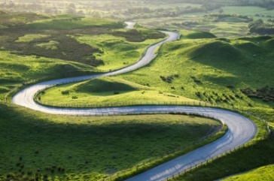
Hopes and Dreams
Did anyone help to fill this in?

Your Hopes and Dreams for the Future
We would like you to think about your hopes and dreams for the future. Imagine what life could be like and tell us about what you see yourself doing.
As before, these questions are just some ideas. Please say whatever is important to you and your hopes and dreams for the future.

When I am older…
- What will be important to me?
- What might be some of the challenges I face?
- What sort of job might I like?

