Setting logo |  | My name is
Setting logo |  | This is my plan to support me.  Current setting:  Age:
Setting logo
  Next steps: We have decided to…Circle as appropriate
  Continue to use BSSP as overview of need and provision | Apply for top up funding | Request an EHC needs assessment
What’s in this plan?
Information, Advice and Support 4
Contact details 5
Parent(s) / carer(s) contact details 5
Important Information 7
People who helped write this plan 7
How I participated in the development of my plan 8
The story of me and my family 8
I can understand you if (communication methods…………………………………………………………………………………………………………………………………………………………………………………………….6
My views, interests and aspirations (Section 1)…………………………………………………………………………………………………………………………………………………………………………………………………7
Growing up………………………………………………………………………………………………………………………………………………………………………………………………………………………………………………………..8
My strengths, needs, outcomes and provision (Section 2) 11
My strengths, needs, outcomes and provision - Communication & Interaction 12
My strengths, needs, outcomes and provision - Cognition and Learning 13
My strengths, needs, outcomes and provision - Social, Emotional and Mental Health 14
My strengths, needs, outcomes and provision - Physical and/or Sensory 15
Additional Health information (Section 3) 16
Additional Care information (Section 4) 16
When this plan will be reviewed 17
Reports that helped us write this plan (Appendix 1) 17
Individual provision map…………………………………………………………………………………………………………………………………………………………………………………………………………………………….16-18
My agreement to this plan 18

Information, Advice and Support

Bristol SEND Support Plans are for children and young people with identified special educational needs or a disability. They are non-statutory plans and should be used for children and young people who are on SEN Support in their educational setting. These plans are used to request a statutory needs assessment / apply for top up funding where applicable.

A child or young person has special educational needs if he or she has a learning difficulty or disability which calls for special educational provision to be made for him or her. Special educational provision is usually resources or support that is additional to and different from what practitioner / teachers and settings would be able to provide for the majority of pupils in the setting.

Find out more about special educational needs in education from www.bristol.gov.uk/localoffer
 | Bristol’s Local Offer - www.bristol.gov.uk/localoffer  A website full of information for parents, carers and young people with special educational needs and disabilities in Bristol, up to the age of 25. It has information on what services are available, events that are happening in the local area, where you can get support and advice and how you can feedback on the services you use.
   | Supportive Parents - www.supportiveparents.org.uk  "Supportive Parents provides the statutory SENDIAS Service in Bristol, North Somerset and South Gloucestershire. It provides free, impartial, confidential, information, advice and support to children, young people from 0-25 and their parents about any type of special educational need or disability. They offer information from the first concern right through the process of seeking statutory support to improve education experience. Supportive Parents are an independent charity and company limited by guarantee."  You may be eligible for certain benefits or grants if your child or young person has special educational needs. You can find out more from www.gov.uk/browse/benefits/disability.  All information is stored in accordance with Bristol local authority data protection policy  www.bristol.gov.uk/data-protection-foi/data-protection-policy

My contact details
My first name is |  |  | My last name is
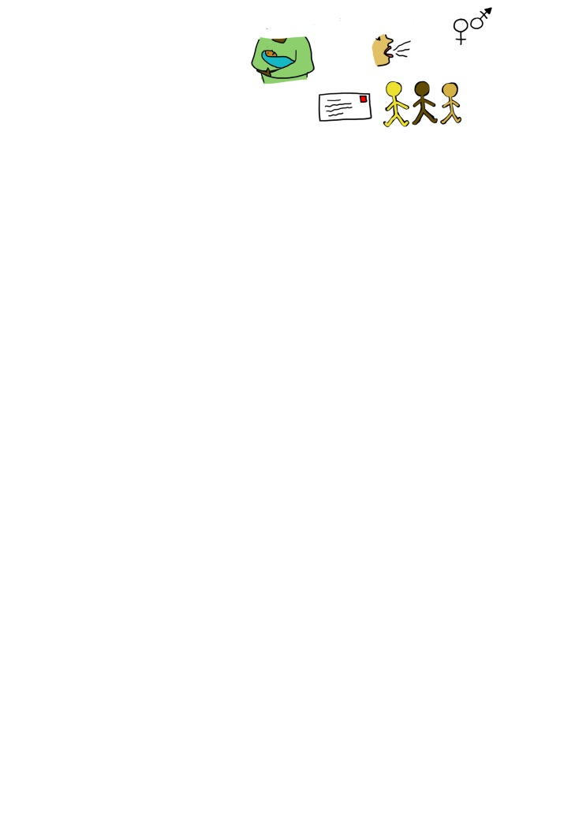 | I was born on (Date of birth) |  |  | My number is  (telephone number)
 | I live at  (Home address & Postcode) |  |  | My Email address is
 |  |  |  | At home I speak (Home language)

My parent(s) / carer(s) contact details | First | Second
Surname, Other name/s
Relationship to child/young person
Home address & Postcode
(if different from above)

Telephone/mobile number
Email address
Do you have any communication needs (e.g. you speak another language)

Important Information
The name of the place where I go to learn is
(School, college or setting)
My key adult’s name is
(Name of teacher/practitioner/mentor/tutor)
NHS number |  |  |  |  |  | Social Care Status/ Ref
UPN / ULN / EY ref number |  |  |  |  |  | Pupil premium |  | Y/N

The people who helped me write this plan
Name | Role |  |  | Contact detail (number / email address) |  |  | They work in: |  |  |  | Report attached:
 |  |  |  |  |  |  | ☒Education  ☐Health |  |  | ☐Social Care  ☐Other | Date of report
 |  |  |  |  |  |  | ☐Education  ☐Health |  |  | ☐Social Care  ☐Other
 |  |  |  |  |  |  | ☐Education  ☐Health |  |  | ☐Social Care  ☐Other
 |  |  |  |  |  |  | ☐Education  ☐Health |  |  | ☐Social Care  ☐Other
 |  |  |  |  |  |  | ☐Education  ☐Health |  |  | ☐Social Care  ☐Other
 |  |  |  |  |  |  | ☐Education  ☐Health |  |  | ☐Social Care  ☐Other
 |  |  |  |  |  |  | ☐Education  ☐Health |  |  | ☐Social Care  ☐Other

How I participated in the development of my plan
Summary of how views and aspirations were gathered and when (written/ adapted or adjusted forms of contributions, attendance at review)

How my parents/ carers participated in the development of my plan (if appropriate)
Summary of how views and aspirations were gathered and when (e.g. when gathered or written/adapted)

The story of me
In young persons words
I was born with …..
I have a diagnosis of Epilepsy which is controlled by medication.
I live with ……. And have x sisters etc
I also spend time with….

The best way to communicate with me is
Verbally/ non-verbally using Makaton/ British Sign Language/ AAC
First/ Second language
A summary of how I communicate and engage in decision-making. E.g. I actively engage in decision making when…..

My views, interests and aspirations (Section 1)
What people like about me/ I am good at… |  | What is important to me/ my main interests…..
Positive qualities, strengths, personal achievements and talents  - Extra curricular  - Domestic – eg, cooking, looking after siblings  - Creative – dance, drama, art, other languages, music  - Physical – any sport/specific activities  - Games – board/computer  - Social – making friends/supporting others |  | Important routines, favourite activities/ lessons and things that are important  preferred hobbies and leisure activities at the educational setting, at home and in the wider community
What I find difficult….. |  | Strategies to support me…..
Daily challenges  least favourite activities/ lessons  things to be avoided  - Curriculum  - Learning behaviours – sitting on a chair, following instruction, distraction of self or others  - Sensory over/under stimulation – audio, tactile, visual  - Transitions – between home & school, between classes, between playground & classroom  - Personal needs – hygiene, personal space, bathroom needs, overheating,  hunger and thirst  - Language – understanding instruction, using language appropriate to the situation and audience, ability to make feelings known  - Safety – risk taking behaviours, safety of others in their presence, play and interaction with others |  | Let me sit at the front of the class so I can see my teachers face and hands  Use my personalised visual timetable and my now and next board/ choice box  Let me wear my noise reducing headphones when I need them  Use a timer and visuals to let me know how long I have to do something  Get my attention before speaking to me  Give me time to process instructions and repeat if necessary  Give me clear simple instructions  Let me have time with an adult one to one so that I understand tasks and can learn at my own pace and sustain attention  Break my learning into small chunks that I can achieve one at a time.  Using visual and practical resources to help me understand concepts  Give me something appropriate to fiddle with and a sensory cushion to sit on  Give me movement/ sensory breaks throughout the day
These people are important to me….
Important people in my life including family, pets, friendships, staff etc

Preparing for adulthood – There are things we all need to learn as we grow older if want to have good health, be independent, feel part of my community and have a job or meaningful activity.

The things that help me to have good health are…  I think I would have better health if… |  | Being independent in my life means I can…  Things I would like to be able to do for myself are…
Going to gymnastics on Fridays  Eating breakfast every day  learning to swim  getting more sleep  To do my daily physio to help my fine and gross motor skills  To self-administer my own medication daily and understand |  | Dressing myself  Learning to my own shoelaces  Go to the shop on my own  Get the bus to and from college independently
I feel part of my community when…  I would feel more part of my community if… |  | In the future I want to be able to have a job doing / or be able to…  I would like to learn to…
I could play with friends in the park  I could use my wheelchair independently on the pavements (people didn’t park on the pavement)  I would manage my behaviours and have conversations which are appropriate for social groups/ clubs  I would remember my own personal details (full name, address, postcode, telephone number) and list three key people to contact in an emergency  I would develop self-regulation strategies to reduce my anxiety and help me feel calm when coping with change. |  | Short term aspirations and long-term aspirations including paid employment/ purposeful activity, independent living and community participation  Go to college to study……  To become a …….  To live on my own  To develop my English and maths skills to be more independent  To be able to do my own washing, cleaning and cook my own meals for supported or independent living

https://www.preparingforadulthood.org.uk/SiteAssets/Downloads/yeded5wb636481748062535810.pdf

Progress I have made…..
QUANTATIVE OUTCOMES FOR PUPIL
Area / subject | Date/ age
Attendance

Progress Summary to date (using standardised measures)

XXX made +4 months in reading using …… assessment etc
Other measurable data – Attendance has…
This enabled XXX to access learning that was adapted to his level alongside his peers

QUALITATIVE OUTCOMES FOR PUPIL
Independence/ confidence / attitude to learning
XXX needs constant support to stay focused on at activity be that academic work, playing alongside a peer or eating his lunch as he very easily gets distracted.
He wants to learn and responds well to positive encouragement. He loves praise and showing his achievements to adults. He cannot complete a task without adult support
Social skills / relationships
XXX takes a while to form trusting relationships with adults and often his peers give him a wide berth as they are wary of his unpredictable behaviour.
He is beginning to show willingness to be friends and play appropriately with others for short periods of time- this has to be closely monitored
He is able to interact appropriately with his peers when in directed small groups
Behaviour / ability to make well informed choices
When XXX has 1:1 support his behaviour is more manageable as he is so keen to please and he likes the security of someone supporting him to make the right choices
He is running out of the classroom less and able to make the right choice when given the option to eg “sit on the carpet or at your workstation”
Enrichment activities
Since XXX has been on medication his seizures seem to be better controlled and this has improved his attendance.
Mum is fully engaged with the school and works well with outside agencies

Date | Timeline of provision/support
Date | Meeting with professionals, parents and SENCo  Placed on SEN register  Meeting with parents  Further assessment of need  Additional intervention identified and put in place  Staff training  Referred to paediatrician / EP ….  Individual provision plan  Apply for Early Years SEN Panel Funding

My strengths, needs, outcomes and provision (Section 2)
This part of the plan has information on:
- Strengths - What you’re good at
- Needs – What you need help with
- Outcomes – What you want to be able to achieve in the future
- Provision – What support or resources you need to be able to achieve the outcomes you want.
This plan should make sure all needs have been identified.
This section looks at strengths, needs, outcomes and provision to help you live your life:
Communication and Interaction – Support needed to help you communicate effectively.
Cognition and Learning – Support needed to help with learning.
Social, Emotional and Mental Health – Support needed for my wellbeing, to ensure positive interactions and to keep safe.
Sensory and/or Physical – Support needed to access your learning.

Top Tips |  | Specific  Measurable Achievable Realistic  Time limited
When writing this section should….  - Refer to views, aspirations and interests in section 1  - Add Health or Social Care provision, which supports education.  - Make sure the outcomes are SMART |  | Specific  Measurable Achievable Realistic  Time limited

My strengths, needs, outcomes and provision - Communication & Interaction
My strengths are…
Summarise strengths refer to professional reports if appropriate
Refer to attainment in relation to communication & interaction if these have been assessed/ measured
e.g. I can…
I am able to…
My needs are…
Education or training that is in addition to, or different from that made generally for others of the same chronological age in settings
Speech and language needs
E.g. I communicates mainly through physical actions (pointing, gestures, nodding, flexing fingers and flapping arms)
I become visibly upset when I am unhappy, uncomfortable, tired, uncertain or anxious.
Listening and attention needs
I find it hard to concentrate for longer than 10 minutes and need brain breaks
Social communication needs
I find it hard to understand how other people are feeling and this makes me feel stressed
What I want to do in the future… (inc. long term outcomes)…. | What I want to achieve (and by when) | My Provision/ Support  Strategy or intervention? | Delivery and monitoring  Who, when, frequency | What difference did it make….  Was the outcome achieve
I would like to go to …. | To have a part time job …..(by …)  To point to an emotions card to show if I am happy or sad (by…) | Daily ….. programme delivered by …. across all areas of learning, (as recommended by my speech and language therapist) to help me use my listening and memory strategies. | Be specific. E.g.  - Class teacher/ Form tutor/ teacher  - LSA/ TA/ Learning Mentor  - Speech and Language Therapist  - Family members  Daily for for the first 10 minutes of each lesson | I have been answering my name with a ‘yes’ for 4 weeks

My strengths, needs, outcomes and provision - Cognition and Learning

My strengths are…
Summarise strengths refer to professional reports if appropriate
Refer to attainment in relation to cognition and learning if these have been assessed/ measured
e.g. I can…
I am able to…
My needs are…
Education or training that is in addition to, or different from that made generally for others of the same chronological age in settings
Cognitive functioning
I find it hard to do the same work as everyone else so I need……
I have dyslexia so find reading and writing hard
Concentration and focus needs
I find it hard to concentrate for more than 10 minutes especially if I am in a bad mood/ tired. I can get very anxious and upset if I am asked to do something, which I don’t want to do or is too difficult for me.
I find it hard to read the board unless…..
What I want to do in the future… (inc. long term outcomes)…. | What I want to achieve (and by when) | My Provision/ Support  Strategy or intervention? | Delivery and monitoring  Who, when, frequency | What difference did it make….  Was the outcome achieve
I want to go to college to…..  I want to be able to ….. | To read a level ….. book by the end of year 3 | Daily use of Dyslexia-specific resources and strategies across all sessions to develop my word reading skills and short term auditory memory E.g. Nessy, Wordshark, tracking exercises etc. | Be specific. E.g.  dyslexia qualified/ trained staff  - Class teacher/ teacher  - LSA/ TA/ Learning Mentor  - SENDCo  - Family members  Daily and….. | I can now read level …. Books  I feel more confident in….

My strengths, needs, outcomes and provision - Social, Emotional and Mental Health
My strengths are…
Summarise strengths refer to professional reports if appropriate
Refer to attainment in relation to cognition and learning if these have been assessed/ measured
e.g. I can…
I am able to…
My needs are…
Education or training that is in addition to, or different from that made generally for others of the same chronological age in settings
Social welfare needs
Emotional well-being needs
Mental health needs
E.g. I like familiar routines, as they give me reassurance about what is happening now and in the near future.
I find change difficult and this can lead to me feeling anxious and running around the school.
At times of change, I show obsessive and repetitive behaviours . This stops me from leaving home and participating in community activities.
What I want to do in the future… (inc. long term outcomes)…. | What I want to achieve (and by when) | My Provision/ Support  Strategy or intervention? | Delivery and monitoring  Who, when, frequency | What difference did it make….  Was the outcome achieve
To manage change and my anxieties so that I do not need to self-harm | To be able to get to school on time every day | Use a visual Anxiety Five Point Scale to develop self-regulation and emotional resilience skills and reduce and independently manage anxiety or stress at different points on the scale in different community contexts (as advised by….)  Mrs X to help me to clarify subtle signs of anxiety escalation (behaviour, physical indicators etc. | Be specific. E.g.  - Class teacher/ Form tutor/ teacher  - LSA/ TA/ Learning Mentor  - Family members  Daily and…… | I have had only 6 lates in term 3 which has reduced from 23 in term 2

My strengths, needs, outcomes and provision - Physical and/or Sensory
My strengths are…
Summarise strengths refer to professional reports if appropriate
Refer to attainment in relation to cognition and learning if these have been assessed/ measured
e.g. I can…
I am able to…
My needs are…
Education or training that is in addition to, or different from that made generally for others of the same chronological age in settings
Sensory needs
I find busy, noisy places overwhelming
Physical needs – Gross motor
E.g. I have Cerebral Palsy which affects my right side. I can walk unaided with confidence, but I experiences difficulty when trying to move quickly. When in busy environments I can find it difficult to move round small places.
Physical needs – Fine motor
I find it hard to hold a pencil and need to type/ communicate by….
What I want to do in the future… (inc. long term outcomes)…. | What I want to achieve (and by when) | My Provision/ Support  Strategy or intervention? | Delivery and monitoring  Who, when, frequency | What difference did it make….  Was the outcome achieve
To manage busy noisy places e.g. the mall | To independently go to assembly 3 x a week. | Use visual checklist (progressing to a printed checklist) to ensure physical and sensory needs are addressed, prior to going to assembly. E.g. I have had a drink, I have used the bathroom, I have the resources I need. Teacher/ LSA to initially assist me to check-off my list and work towards independent use | Be specific. E.g.  - Class teacher/ Form tutor/ teacher  - LSA/ TA/ Learning Mentor  - Physiotherapist  - Family members  3 x a week | I have managed to attend assembly 3x week for 4 weeks and am using my checklist independently.

Additional Health information (Section 3) - You should add information about health needs like on-going health care needs and personal care needs.
Strengths | Needs
I have developed a good sleeping pattern and I sleep for 7 hours without waking.  I can swallow my tablets without them being crushed up anymore.  I can use the toilet independently and am dry at night | Summarise all health needs gathered from all professional reports. …..  E.g. As well as Cerebral Palsy I have a visual field difficulty - homonymous hemianopia - which means that the left side of my vision is severely reduced. This affects my ability to navigate safely in unfamiliar or busy environments  E.g. Diabetes, Epilepsy, hearing loss that is moderate in both ears at mid to low frequencies and profound in both ears at high frequencies, Asthma etc.  Add in any relevant detail reported by the health professionals in relation to the health need identified. E.g. My Asthma is worse in winter I also am more vulnerable to chest infections at this time of year.  I attend appointments at the hospital every eight weeks where ……..is monitored by my consultant. My care plan is shared with everyone who helps me.

Additional Care information (Section 4) – You should include any social care information and links to other plans and/or personalised support plans.
Strengths | Needs
I have settled well into my new foster placement and am getting on well with the family  I am developing adult independence skills. I understand how to use public transport and am learning how to manage my money and maintain personal safety while using the bus. | Summarise all social care needs gathered from all professional reports – e.g. SAF, CIN, CP Plan, PEP (Inclusion of this information MUST be with the consent of the young person/family/ primary carer/ legal guardian)  E.g. My behaviour at home means that there are times when my personal safety and that of my sibling can be at risk.  E.g. I have extremely limited mobility. This means that I face significant challenges in joining in with social activities including family outings and holidays.  My home is adapted to give me:  a self-contained bedroom with walk in shower; and has storage space for the equipment I use on a daily basis.

When this plan will be reviewed
The day the plan will be reviewed | DD/MM/YYYY
The person who will arrange the review
Key working lead
Their contact details
Telephone and email

Important dates and transitions | Date
The date I will change school/setting or change key stage  For example Nursery to Primary school or year 9 to year 10, or year 11 onwards | DD/MM/YYYY

Reports that helped us write this plan (Appendix 1)
Name of the report | Name of the person that wrote the report | Their position / role | Date they wrote the report / gave advice

Post 16 aged Individual Costed Provision Map
Refer to Bristol Graduated Guidance
Number of pupils in class/ group: |  | Number of Support Staff/ TAs allocated to class/group:

Place (CORE SCHOOL BASED) Universal provision - what is available for all- Quality First Teaching | Cost  £4,000

Funded via pupil premium/ enhanced pupil premium (delete as necessary) | £
E.G. Payment for school trips, Support/ help with planning for CT from Reading recovery teacher/ additional support at lunchtime, fine motor group with teacher, interpreter for meetings.

Needs, outcomes and provision – provision in additional to and different from universal provision.
Area of need | Provision /support to meet need | Cost & time
SEMH | TA to meet parent in quiet space – links with home eg: share news, games, toys etc.  Share feelings for start of day.  Go through visual timetable. | 5x 10 mins p/w =  0.85hrs x £13.88 x 45.5 weeks  = £536.81

Place (UNIVERAL) provision Element 1 | £4,000
Plus (ADDITIONAL) provision Element 2 and 3 (- £6,000 notional SEN) | £
Element 3 requested | £

My agreement to this plan
I agree that….
- People listened to my views and aspirations when we were writing this plan.
- I am happy with what is written about me in this plan and support identified.
- I am happy for this plan to be shared with other professionals if it will help me to achieve it.
Next steps: We have decided to……
i.e. request a full needs assessment, apply for top up funding etc…

My signature | Date
My parent(s) / carer(s) signature | Date

Professionals Agreement We agree to support you to achieving the outcomes in this plan by delivering the provision we agreed and to help you review your progress when it is due. We agree that we will protect your information in line with our organisations data protection policies
Signed by key working lead  (on behalf of all the people who helped write this plan) | Date
Head teacher/ setting lead signature | Date

Signed off by Service Director for Education, Learning and Skills 21st March 2019

