XXX’s New School
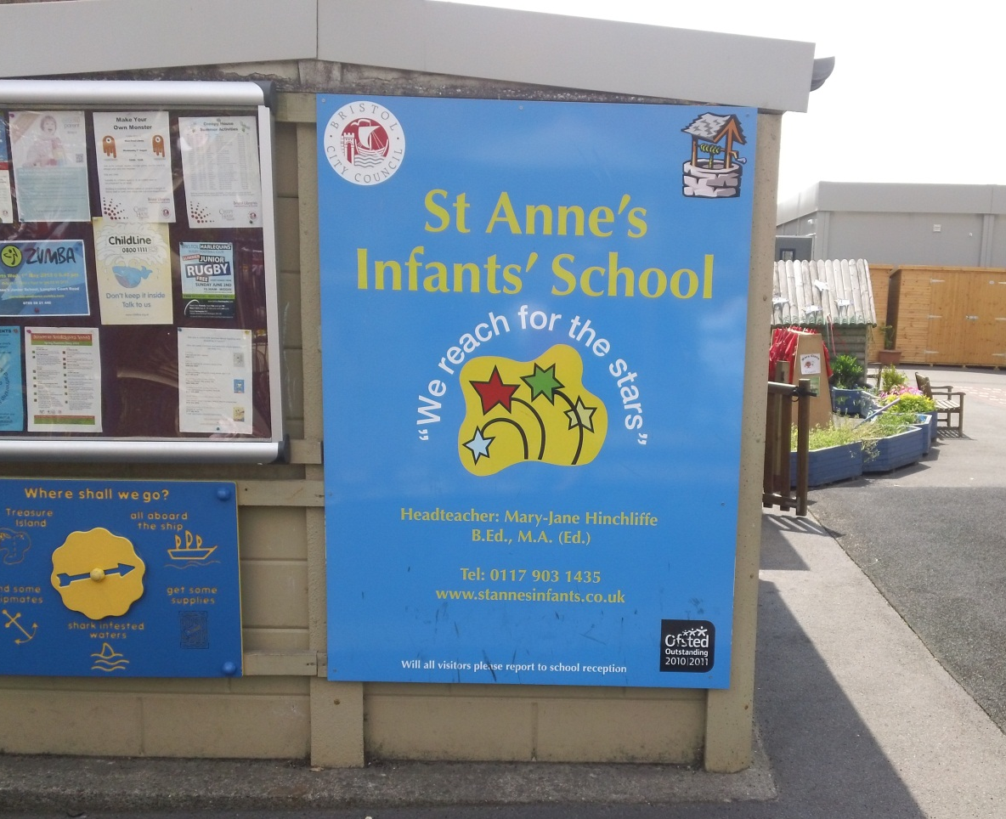
XXX’s new school is St Anne’s Infant School
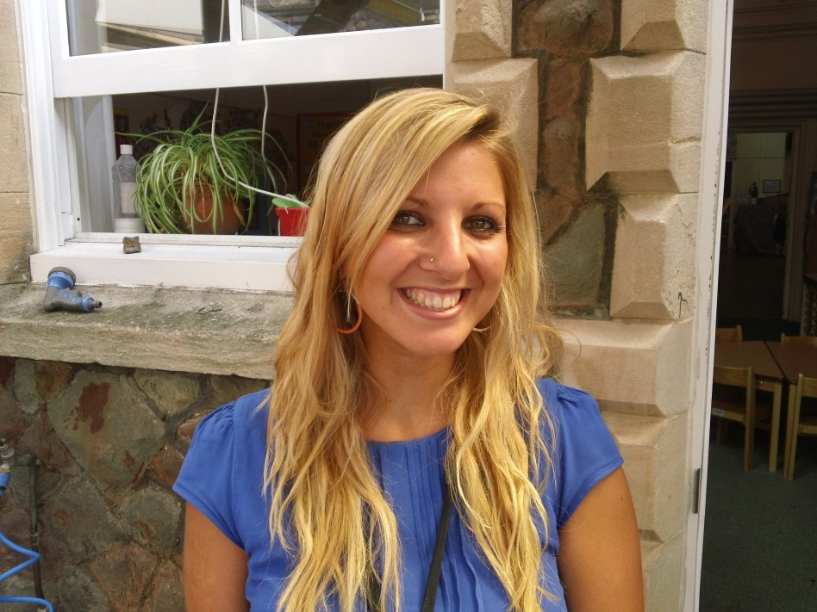 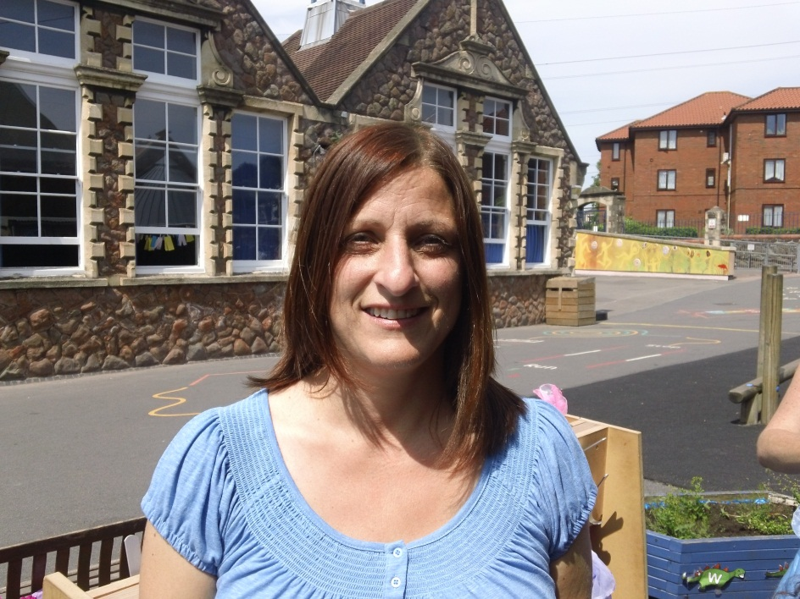 Miss XX will be XXX’s Class Mrs X will also help XXX in his
Teacher. new class.

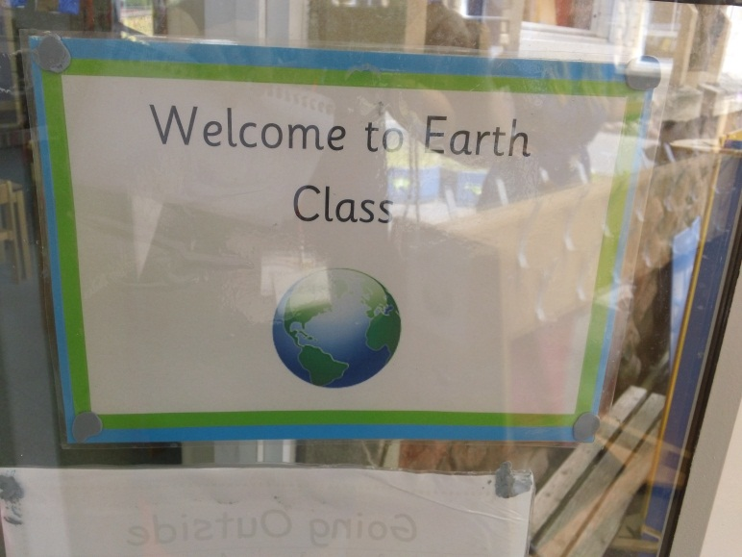
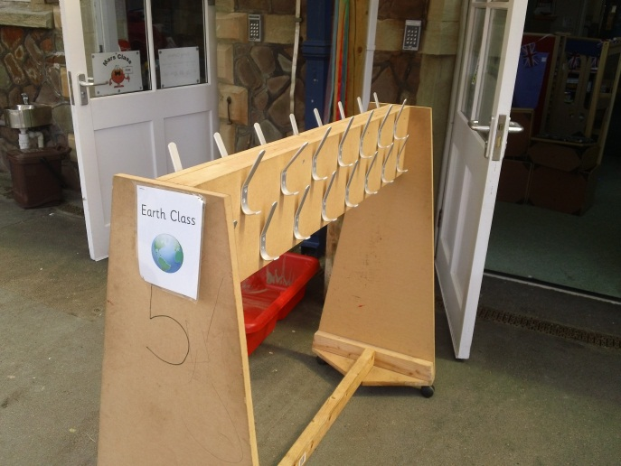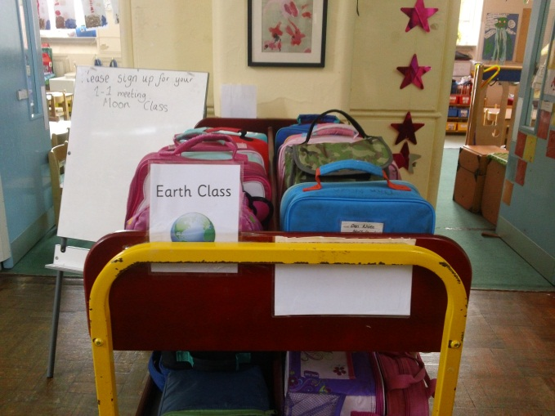
XXX will be in Earth Class. Earth Class has pegs to hang up the coats and a trolley for the lunch boxes.

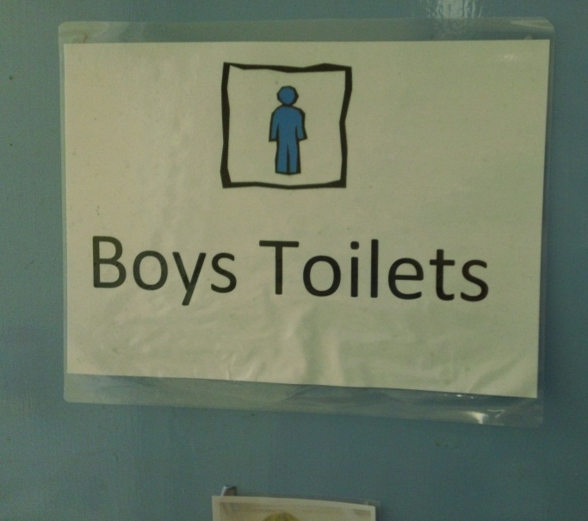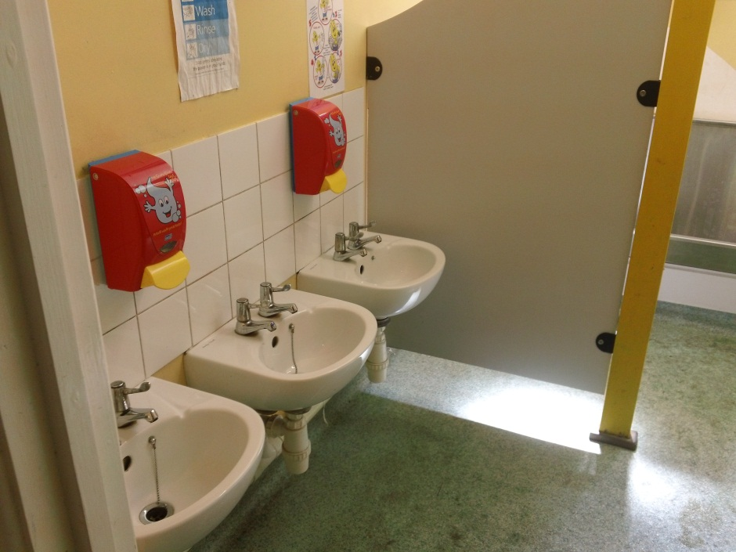
The boys’ toilets have a sign on the door and are close to the classroom.

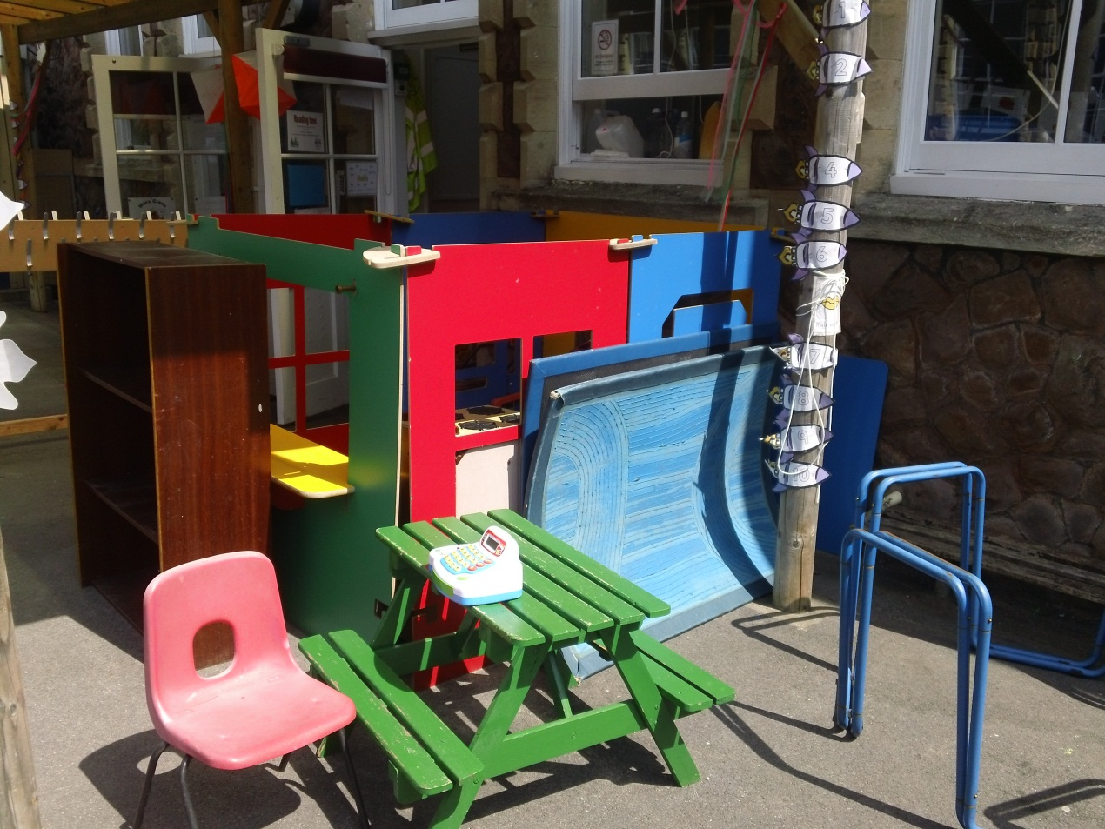
XXX will be able to play outside and inside the classroom.
XXX will have fun playing and learning in his new school.

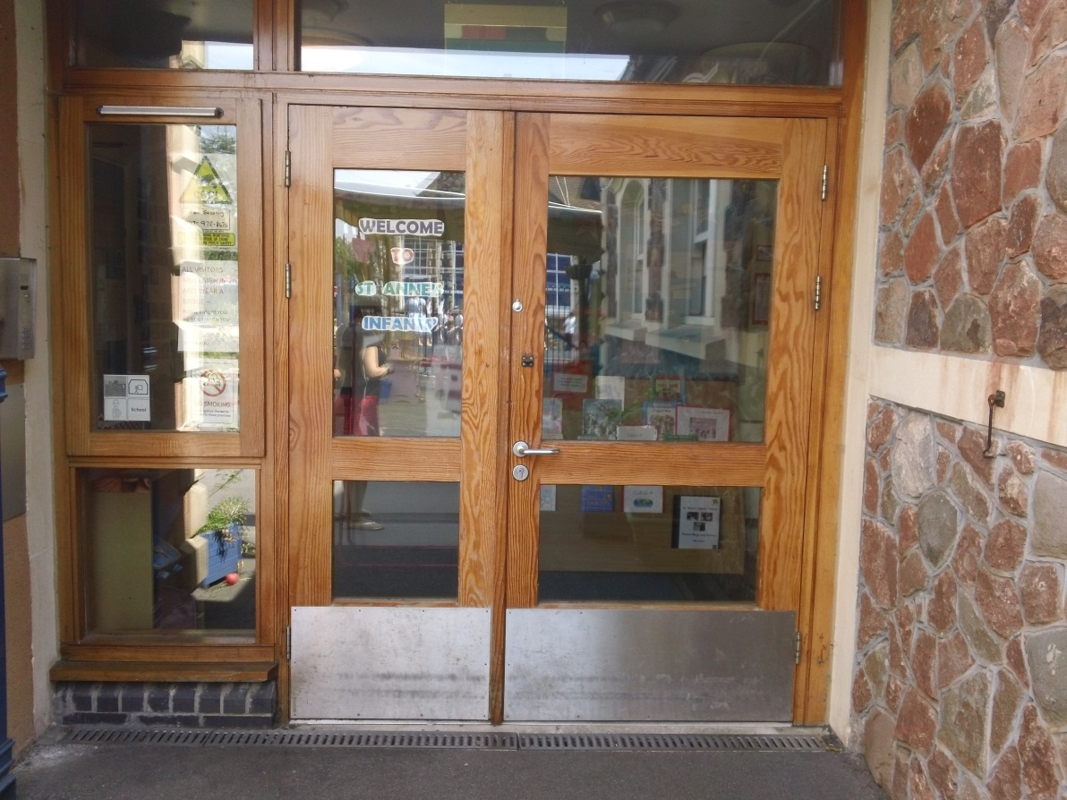
This is the door XXX will walk through to go to Earth Class.
XXXX New School
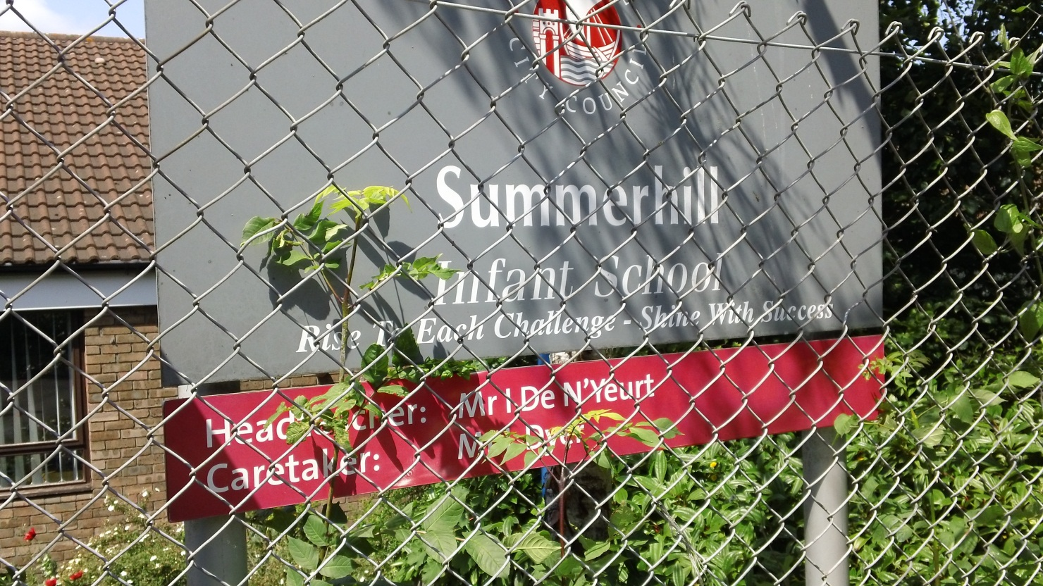
XXX is going to Summerhill Infant’s School

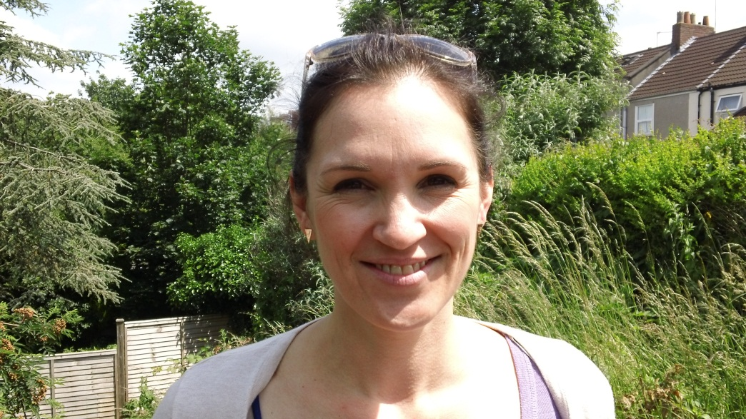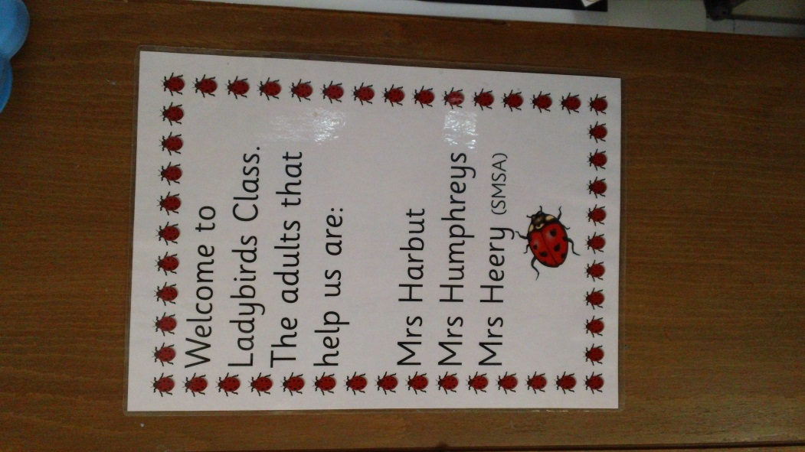

Mrs XXXX will be XXX’s teacher. XXX will be in Ladybird Class.
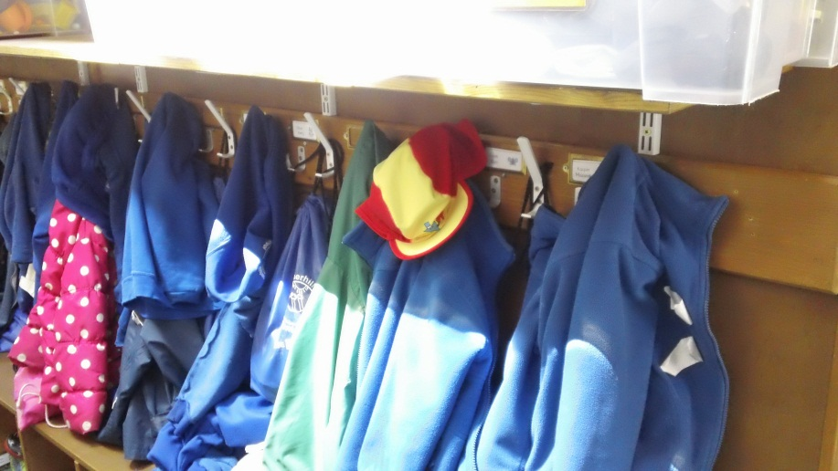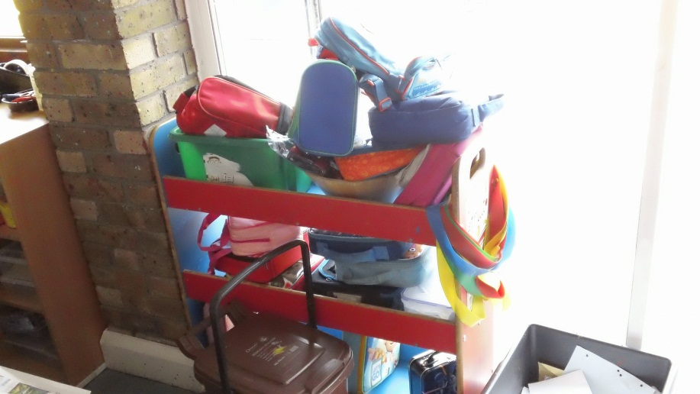

Ladybird coat pegs. XXX can hang his Ladybird packed lunch boxes.
Coat here. XXX can put his lunchbox here.

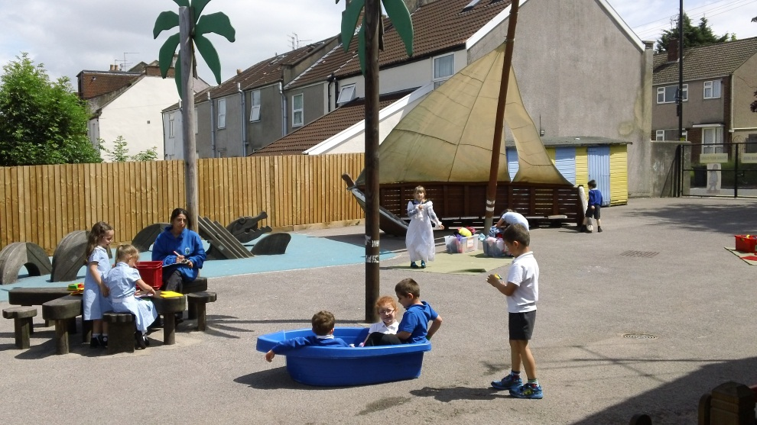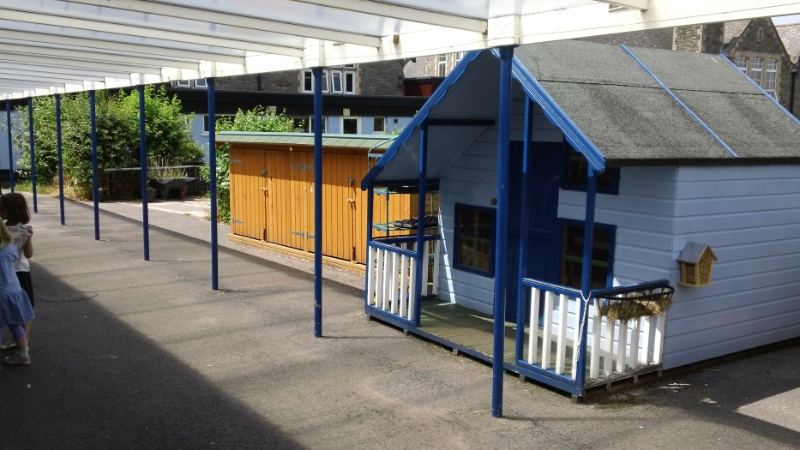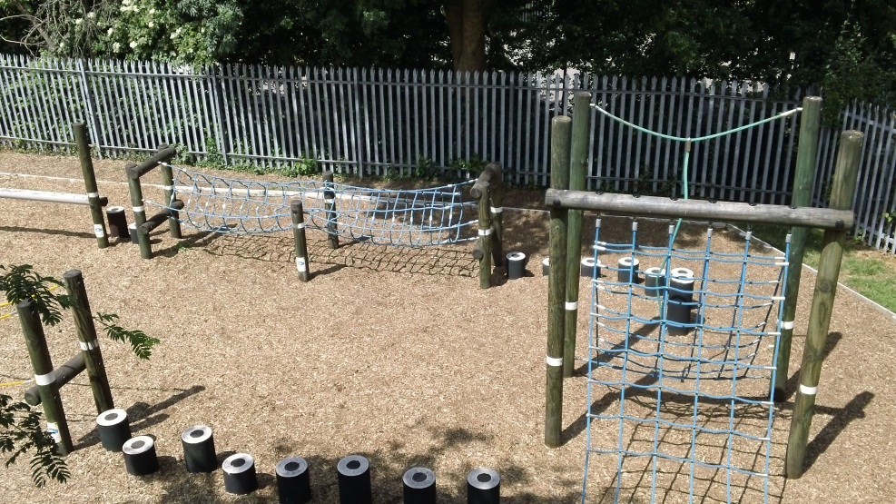
Outside play
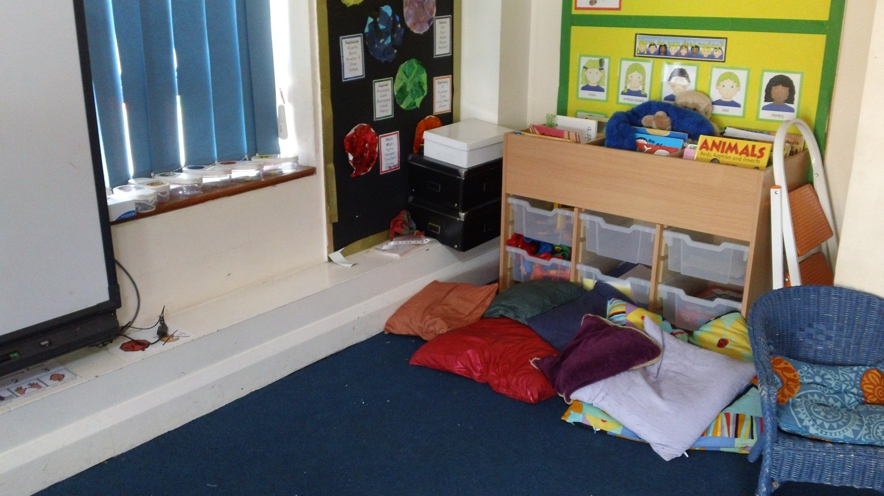
Inside the classroom.
XXX will have fun in his new school.

