Tom is a friendly, placid gentle natured boy. He is very intelligent, enthusiastic, and hard working in all subject areas.
His interests are mathematics, computers and jokes. A brief description of Tom’s strengths and difficulties related to his Autism are:-

Pupils Photo
Sensory

- Tom is sensitive to noise. He needs pre warning of a fire alarm practice bell.
- Tom dislikes getting his hands messy which impacts on his experiences in certain areas of the curriculum e.g. art and cookery.
- Tom does not like to wear new clothes. This may impact on drama.

Social Communication

- Tom does not always respond to whole- class instructions
- He can sometimes appear a little abrupt/impatient in speech and gesture.
- Tom’s understanding is very good. He will always ask quietly if he is wants any instruction clarified.
- Tom is very precise and concise in his speech.
- He has an expressive voice and delights in word-play and puns.
- Toms’ conversation tends to be brief and to the point unless talking about something in which he is particularly interested e.g. calculators.
- He is not at ease with social chit chat and tends to prefer discussion with clear focus and structure.
- Tom converses well with adults in comparison to his conversation with his peers.

Social Interaction

- Social interaction with his peers, particularly in an unstructured situation presents a challenge for Tom.
- Tom may isolate himself without some structure or adult/peer intervention.
- Tom has made progress developing friendship skills but there are still social skills to learn. He often chooses to talk to adults about his favourite subjects rather than seek out friends.
- During unstructured times of the day e.g. break time Tom attempts to interact with certain pupils when they are playing a predictable game that he understands. If the rules suddenly change, he retreats to the periphery of the playground and walks around alone or seeks out adult company.

Inflexible thinking/behaviour

- Tom may interpret information literally.
- Tom has a fairly narrow range of interests.
- Tom likes to know the schedule for the day.
- Tom finds it difficult to accept another pupils opinion

Example of a One Page Profile

Insert Pupils
photo
My name is Peter Jones

I am in year 7. My Tutor is Mrs Brown.

I have High Functioning Autism.

Things I want you to know about me

I Don’t Like

Changing for PE
Being touched
Loud noises
Crowded places



I Like

Computers
Maths
Reading
Making films

Things I find difficult
Changes of routine Working in large groups

Getting started with work Listening for a long time

Asking for help I can get distracted easily

Things that help me

- Try and let me know when things are going to be different

- Work in a small group with people I know and who know me

- Check that I know what I have to do and go through it with me

- Make sure I have written down and understood the homework

Sometimes I get ‘stressed’ and may start banging things. I am allowed to use my pass card and then go to the LS to ‘chill out’

My special friends are Sarah and John. I like to go with them when the bell rings.

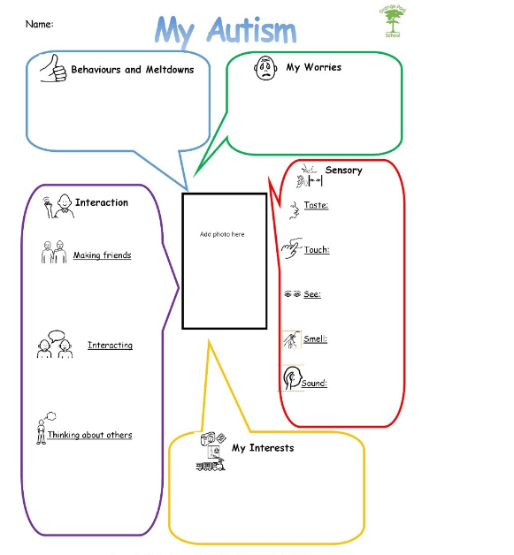

Passport for:

My full name is ____________________  Please call me ____________________  Signed: Pupil  Signed: Parent  Signed: Teacher/tutor | Dinner Time Arrangements  Signed: Lunchtime  supervisor
Key adults for me at school | Where I can find them
Things you should know  - I like  - I like  - I like | Things you should know  - I don’t like  - I don’t like  - I don’t like
How I communicate | How you should communicate with me

Strategies to help me in lessons

Strategies to help me move around the building | Helpful strategies at break times and dinner times

Date: _______________________________

Review date: _________________________

