Spellings Book (insert photo of book)
All teachers in my new school give children spellings to learn.
I have different spellings to learn each week.
 I write my spelling in my spellings book so that I can remember which words I have to learn.

It is important to be able to spell words correctly so that other people can read them.

If words are not spelt correctly, we cannot always work out what they say.

I take my spelling book home so that I can practise my spellings every day. This will help me to remember how to spell them.

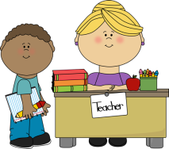
I bring my spelling book back into school so that my teacher can look at it and see that I have been practising.

On (insert appropriate day) we have a spelling test so that our teacher can see if we can remember how to spell the words.
If I have practised my spellings at home every day then I will get a good score in the test, and I will spell those words correctly in my writing.
This means that other people will be able to read what I have written.
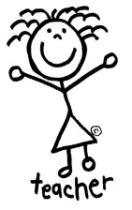
My teacher will be pleased and give me a (insert appropriate reward).

My parents will be proud of me. I will feel proud that I learned my spellings.
Answering questions in class

Sometimes we all sit on the carpet and our
teacher talks to us to help us learn.

I must listen to my teacher when she is
talking because it will help me learn.

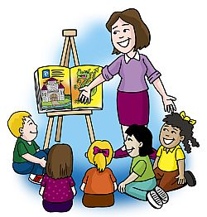
Sometimes the teacher asks the class a question. My teacher can see me and all the other children at the same time, but she can only listen to one voice. We put our hands up to show the teacher that we know the answer to her question. She can see all the children who know the answer, but she can only listen to one child saying their answer out loud.


Sometimes I know the answer to a question that my
teacher has asked the class.

If I put my hand up the teacher will see that I know the answer. Sometimes the teacher will pick me to say my answer out loud. She will be pleased that I joined in.
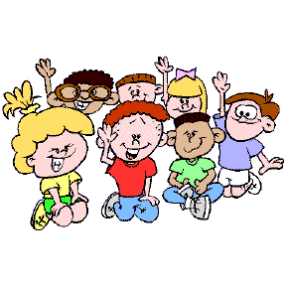
Sometimes other children also want to answer the teacher’s question, so they put their hands up as well as me.

There is not time for my teacher to pick all the children,
so that means she will not always pick me to say my
answer out loud. She will still be pleased that I joined in.


Putting my hand up is a signal to the teacher that I know the answer to her question. Even if she does not ask me to say my answer out loud, she has seen my signal and she is pleased that I know the answer.

