Expected Learning Behaviours social story

In school all students need to follow the school rules, this makes everyone feel safe and happy.
- I must listen to the teacher and not interrupt.
- I will talk respectfully and will not swear.
- I must not disrupt or distract others e.g. sharing jokes (I can write these down in my note book and share them at an appropriate time e.g. break or end of the lesson)
- I will use my flow chart for time out if I am anxious.
- I will follow my task checklist and ask for help if I need it (verbally or using my RAG cards)
- I will not use my phone in school.

Should I forget staff will give me one reminder to follow the expected school rules.
If I follow the key expected behaviours in each lesson I will receive a tick on my reward chart.
Getting changed for PE social story

At secondary school we all get changed for PE.
This stops our school uniform from becoming smelly and dirty.
When I change for PE I need to take off my school uniform but leave on my underwear.
I need to put all my school uniform together so I can find it after PE
I will then need to put on my PE kit and go to join the teacher and the rest of my class.
Once I have finished PE the teacher will tell us to go and get changed.
I need to walk back to the changing room and take off my PE kit leaving on my underwear.
I need to put my school uniform back on and put my dirty PE clothes in my PE bag.
I am now ready to go to my next activity. Teachers and my parents will be happy if I follow the changing room rules.


School uniform social story


White Shirt Polo Shirt
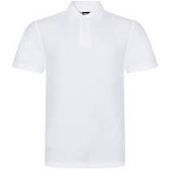
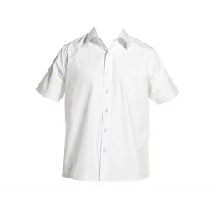

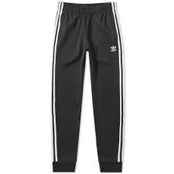
Plain Black Jogging Trousers Shiny branded Jogging Trousers
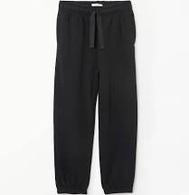

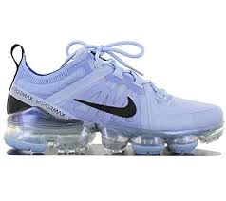
Plain Black Leather Trainers Branded fashion Trainers
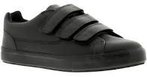

School Blazer Hoody
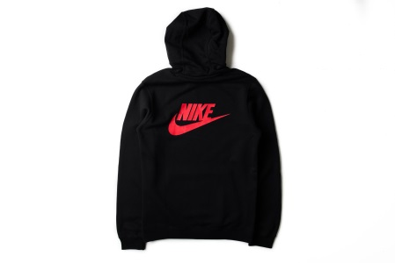
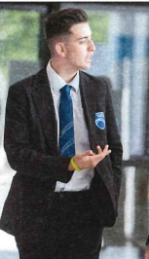
Why should I wear school uniform?

When I go to secondary school all my friends wear school uniform.

We all have to wear a shirt, plain black trousers, our house tie, blazer and smart black shoes.

It helps makes us all look smart and ready to learn.

We all feel the same and this makes us feel happy.

My friends will look at me and feel I am part of their group and friend if I look the same.

I know I can ask to take off my blazer in class if I feel too hot and this is ok.

My friends may look at me and think I don’t like them or don’t want to be the same if I don’t wear my uniform.

Everyone will be happy if I wear my school uniform

What do I need today in school?

 | Do I need it today? | Have I packed it?
Pencil Case (Pen x 2, Pencil x 2, Rubber, Pencil sharpener, ruler)
Calculator
Exercise books
Text Books
PE kit
Lunch Box
Drinking Bottle (if containing squash must not be see thorough)
Picture of family (if wanted to keep in wallet)
Mobile Phone

What will be the same and what will be different at Secondary School?

What will be the same?
• A Teacher who knows me well – this person is called my Tutor or could be a keyworker from the SEN base.
• I will still have a playtime – this is now called ‘Break’ at secondary school, I will be able to chat and hang out with my friends.
• I will have lunch time – the dining hall might be bigger, I will still need to line up to choose and collect my food.
• I will learn lots of new things in each subject
• I will have school rules I have to follow.
• I might see children I know from Primary School in class or at break
• Like primary school there are lots of children of different ages in school, we call these ‘year groups’
• There will be toilets in school but just more of them in different places around the building.

What will be different?
• I will not stay in one class for the day. I will be moving to a different class each lesson.
• I will have a different teacher for each subject – they know lots about what they teach and will be able to answer my questions.
• I will need to carry in my bag all my books and equipment I need for that day.
• Teachers take a register at the start of each class

What will I receive ticks for on my Report Card?
- I will get a tick on my chart if I show at least 3 behaviours from the green list.
- For each tick on my chart I will get 5 minutes reward time at home
- If I get x ticks I can once a week choose a friend to play a game in the SEN base for 15 minutes.
These are the learning behaviours that will gain me a tick on my chart.
- Line up with my peers without touching or pushing them.
- Enter the classroom and sit down getting my belongings out
- Get my equipment and books out of my bag without touching peers with my hands or books or equipment
- I use my RAG cards to indicate if I am stuck or need help
- I listen to adult instructions and do my work and not interrupt lessons. When talking to my teacher and friends to speak nicely and tell them if I don’t understand.

If I show these behaviours I will not receive a tick on my reward chart.
- Touching or pushing my peers when lining up.
- Not entering the classroom and getting ready for the lesson.
- Pushing my bag, books and equipment towards peers or hitting them with them.
- Not using my RAG cards to tell the teacher I am stuck or need help.
- Not listening toadult instructions and interrupting lessons. Not talking to my teacher or friends nicely and beign rude to them when I don’t understand.

I must put my hand and wait until the teacher asks me to share my thoughts or when the peer has finished talking.
YES
NO
I can share my idea in my calm quiet voice with the teacher or a peer.
When I want to talk in class or ask the teacher a question
- I need to pause and look around
- Is the teacher or a peer talking?
- Are we watching a video or looking at a presentation on the board?

