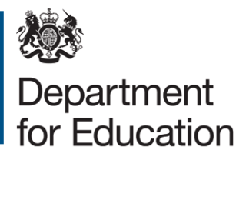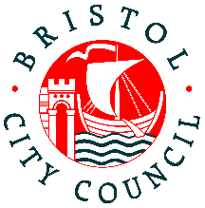

Application form for free early education for two-year-olds from families with no recourse to public funds (NRPF)
Please complete this application form if you are a family with No Recourse to Public Funds and would like to apply for up to 15 hours a week of free early education for two-year-olds.
Applicants should complete all sections. When completed, please ensure the declaration at the end of the application is also signed.

Child’s details
Surname of child
First name(s) of child
Date of birth of child (dd/mm/yy)
Sex of child | Female Male
Address of child

Name and Address of preferred setting

Parent/carer’s details
Surname of parent/carer
First name(s) of parent/carer
Parent/carer’s date of birth
Relationship to child
Email address and/or phone number for parent/carer | Email:  Telephone:
Do you have recourse to public funds? | Yes  No
Does your partner have recourse to public funds? | Yes Not Applicable  No
If you have a Share Code please provide it.

Evidence of income
To be eligible for free early education for two-year-olds place, your family’s annual household income must be no higher than the following:
- £26,500 for families outside of London with one child
- £30,600 for families outside of London with two or more children
This includes any wider income or support you or your partner (if you have one) may be receiving in addition to any earnings from employment. Where possible, please also provide a document to show this for you and your partner – this could be a bank statement, a pay slip or an employment contract in you or your partner’s name.
Are you employed? | Yes  No
If you have a partner, are they employed? | Yes  No
Is your annual household income less than the maximum income thresholds listed above? | Yes  No

Declaration of applicant
I .............................................. of .........................................................................................
confirm that the information I have provided above is accurate and true.
I agree that the information I have provided can be shared with the Department for Education for the purposes of assessing eligibility for a free early education for two-year-olds.

Parent/Carer/Guardian with legal responsibility for care of the child
Signed
Print name
Date
© Crown copyright 2022

