


NAME
Education, Health and Care Plan

You can put a picture of yourself or something that is important to you.  You can leave this blank if you want to. | Name:
 | Date of Birth:
 | Current Setting:

This Education, Health and Care Plan sets out NAME needs and the provisions to meet them. NAME and his parent/carer’s views are in Part A, and they have been used alongside the professional assessments and recommendations to identify the provision they need for their education.
In accordance with the Children and Families Act 2014, the following Education, Health & Care Plan is maintained by Bristol City Council (‘the education and social care authority’) and the Bristol NHS Clinical Commissioning Group (‘the health authority’). These authorities have a legal responsibility to make sure the provision is delivered.
The plan should be reviewed on a yearly basis by NAME school SENDCo. Any concerns about the plan should be raised with the SENDCo and NAME’s SEN Caseworker (sen.caseworker@bristol.gov.uk ). If help is needed with this please contact SEND and You as the impartial, confidential SEND Information, Advice and Support Service: https://www.sendandyou.org.uk/

Date of this Final EHC Plan: DATE
Scheduled review date: DATE

Contents

NAME Personal Details (blue) 3
NAME Parent/ Carer Contact Details (blue) 4
All About Me - NAME views, interests and aspirations (Section A – purple) 5
Family’s Views and Aspirations for NAME (Section A- purple) 6
What did others say? (Section A- purple) 8
Outcomes, Special Educational Needs & Provision (Sections E, B & F- green) 9
Health Needs, Outcomes and Provision (Sections C & G- red) 12
Social Care Needs and Provision (Sections D, H1 & H2- orange) 14
Place of Education (Section I- dark blue) 16
Personal Budget (Section J- light green) 16
Appendices (Section K – pink) 17

NAME Personal Details (blue)
  Name: |  |   Preferred pronoun (they/she/he):
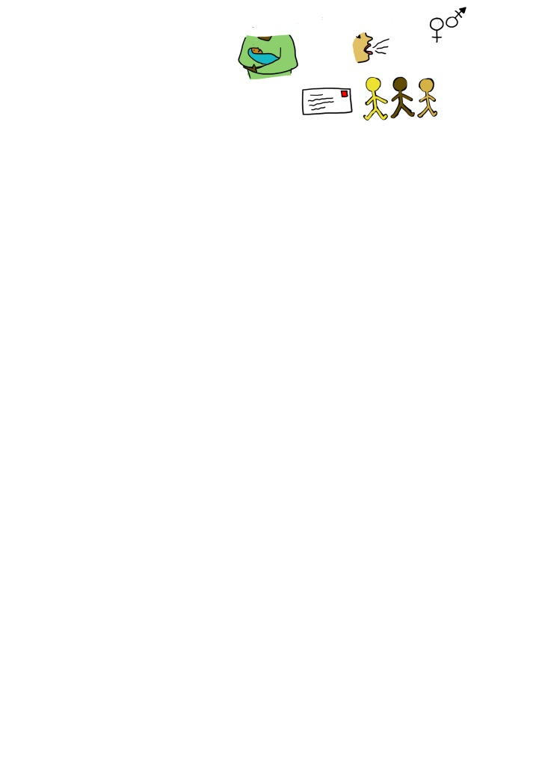  Date of birth: |  | Home address:
  NAME’s telephone number:  (as applicable) |  |   NAME’s email address:  (as applicable)
  Home language: |  |   Interpreter required?
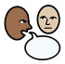  NAME’s preferred way to communicate: |  |   Unique Pupil Number:
  NHS Number: |  |   Social Care Reference:
  Is NAME a child in care? |  | If so, Full Care Order, Interim Care Order, Section 20 or other?
  Primary need: |  | Secondary need:

NAME Parent/Carer Contact Details (blue)
Parent/Carer 1 |  | Parent/Carer 2
Name: |  | Name:
  Relationship to NAME: |  | Relationship to NAME:
Home address: |  | Home address:
Telephone number: |  | Telephone number:
Email address: |  | Email address:
Home language: |  | Home language:
  Interpreter required? |  |   Interpreter required?
  Additional support  needed: |  | Additional support needed:


All about me

NAME views, interests, and aspirations (Section A - purple)
If the child or young person has contributed their views in any other format, please insert them here. For example;
- PATH meeting graphic
- A drawing
- A photo
- Other.

NAME, how did you contribute your views? |  | Who helped put together ‘All About Me’?
 | Poster or PowerPoint |  | NAME
 | Drawing |  | Parents / Carers
 | Mind Map |  | School / Early Years Setting / College
 | Video / Audio Clip |  | Educational Psychologist
 | One Page Profile |  | Bristol Autism Team
 | Other |  | Other

Here and Now
What is important at the moment for NAME?

Hopes and Dreams
What is important in the future for NAME?
I

Family’s views and aspirations for NAME (Section A - purple)
Summary of key events in NAME’s history and how these impact on him now:

Are there any other views and aspirations you would like to add which are not included above?
Are there family, friends or others who are important to NAME?

What are NAME’s strengths?

What did others say? (Section A - purple)
What strengths did professionals identify?
What did the professionals who know you say about you?

Outcomes, Special Educational Needs & Provision (Sections E, B & F - green)
Outcomes (E):  www.bristol.gov.uk/web/bristol-local-offer/children-and-young-people-s-outcomes-framework | Which Child and Young Person Outcomes Framework theme is the outcome working towards?
Outcome 1:
Outcome 2:
Outcome 3:
Outcome 4:
Outcome 5:
Outcome 6:

SEN Category | Need (B) | Impact  and how does this affect NAME?

Specific Provision (F) | How Often | Group Size | By Whom | Is provision above core service? | Which SEN Category will this provision meet? | Which Outcomes Framework theme is this provision working towards?
Additional Specific Strategies  These are over and above those which should be ordinarily available within educational settings  https://www.bristol.gov.uk/web/bristol-local-offer/professionals/ordinarily-available-provision |  |  |  |  |  | By Whom

Health Needs & Provision (Sections C & G - red)

Diagnosis/presentation:

Is there medication that needs to be given at school for which you’d expect an Individual Healthcare Plan? Yes/No

SEN Category | Health Needs which relate to NAME’s Special Educational Needs (C) | Impact  and how does this affect NAME?

Specific Health Provision (G) | How Often | Group Size | By Whom | Is provision above core service? | Which SEN Category will this provision meet? | Which Outcomes Framework theme is this provision working towards?

Social Care Needs & Provision (Sections D, H1 & H2 - orange)
We have gone through the Chronically Sick and Disabled Persons Act with the family and we have identified the needs which the family are currently meeting. For the detailed information please refer to the Social Care Contribution Appendix.
Were there any social care needs that relate to special educational needs identified during the assessment?
SEN Category |  | Social Care Needs which relate to NAME’s Special Educational Needs (D) |  |  |  | Impact  and how does this affect NAME?
Social Care Needs that do not relate to Special Educational Needs |  |  |  |  |  | Impact  and how does this affect NAME?
 | Specific Social Care Provision (H1)  Any Social Care provision which must be made for a child or young person under 18 resulting from Section 2 of the Chronically Sick and Disabled Persons Act 1970, e.g., short breaks, adaptations through disabled facilities grants, provision from a Personal Social Care Budget. |  | How Often | Group Size | By Whom |  | Which SEN Category will this provision meet? | Which Outcomes Framework theme is this provision working towards?
 | Specific Social Care Provision (H2)  Any other Social Care Provision reasonable required by the learning difficulty or disability which result in the child/young person having SEN. H2 provision must only include services which are not provided under Section 2 of the Chronically Sick and Disabled Persons Act (CSDPA) 1970. |  | How Often | Group Size | By Whom |  | Which SEN Category will this provision meet? | Which Outcomes Framework theme is this provision working towards?

Place of Education (Section I – dark blue)
Statutory requirements state that the type of setting or name of a school/other setting recorded here in the Final EHC Plan, with all the provisions needed agreed.
Name of Education Setting: | Type of Education Setting: | Dates from/to:

Next Key Transition Points
Key Transition: | Date:

Personal Budget (Section J – light green)

Source | How will the personal budget be used? | Which outcome will this support? | Amount
Education |  |  | £
Health |  |  | £
Social Care |  |  | £
Total Amount: |  |  | £

Appendices (Section K - pink)
Advice and information received from contributors to the EHC Assessment and Plan
Who provided the advice and information for the EHC Plan?

Person/professional: | Name: | Email address: | Other contact details: | Date of report:

Signature of SEND Case Worker
Signature:

Duty Authorised Officer
Signature:

