

The Parks Service

Pack A

Health and Safety support pack for practical activities carried out by volunteer groups.

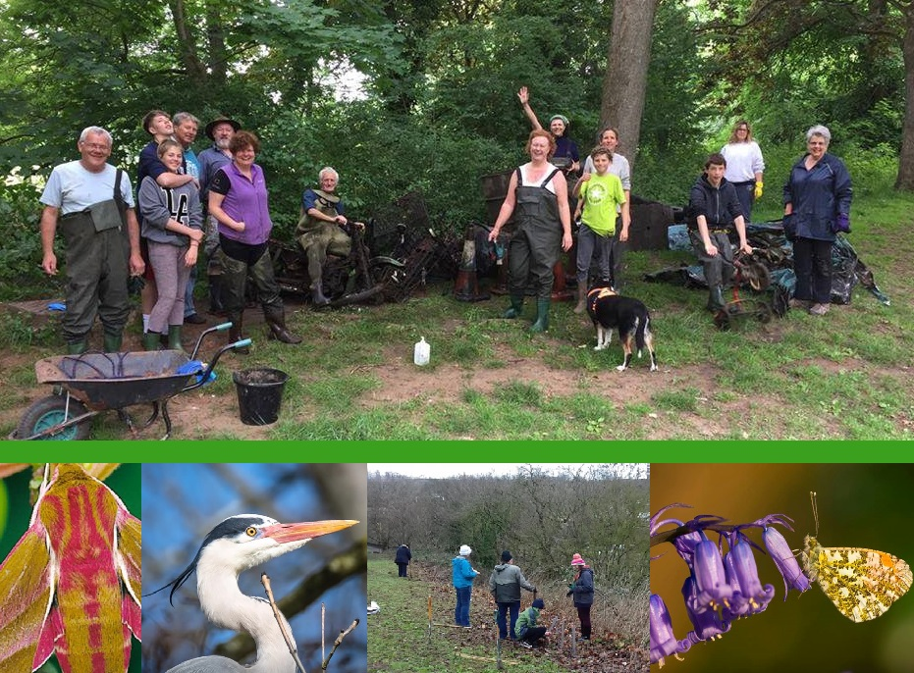

Oct 2023
Copyright of Bristol City Council

Introduction | 3
Training outline | 4
Insurance cover | 4
Risk assessment | 5
Site risk assessment example | 8
Safe use of tools | 9
Personal Protective Equipment (PPE) | 9
Advice on First Aid | 10
Useful Contacts | 10
Accident Report Form | 11
Hazardous plants list | 13
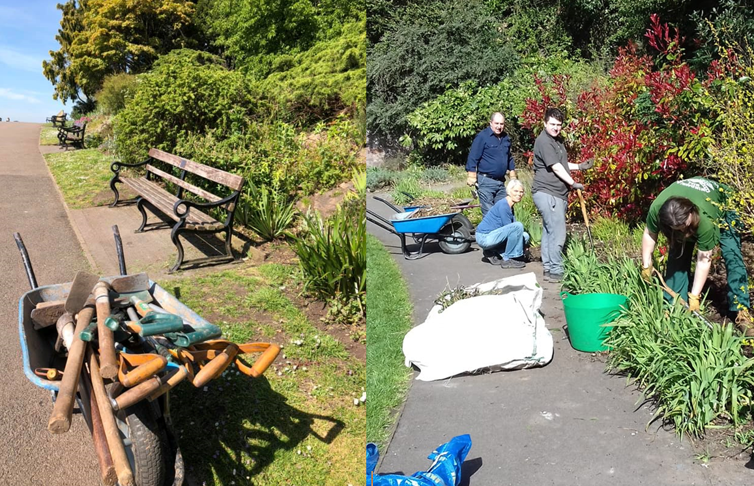

Introduction

Thank you for attending this training course as a volunteer leader.

Bristol is fortunate to have fantastic Parks and Open Spaces. These spaces provide opportunities for residents, community groups and local businesses to volunteer, gain skills and reduce social isolation. Volunteering also complements the wider management of parks and open spaces, making them better for both residents and wildlife.

It is important to us that you are protected along with other park users and work safely.

It is Bristol City Council policy that anyone working as a volunteer on land owned by the Council is considered as an employee whilst volunteering. This affords volunteers access to the same level of training, support and protection that a Council employee would receive in order to carry out the same activity.

This document contains essential information on policy, insurance and risk assessments which will help you lead volunteer sessions safely. We also include tips on how you can engage volunteers in your community. Template risk assessments and other important forms are provided to minimize the work required prior to a volunteering session. These resources will enable volunteers to work independently and carry out a range of practical activities safely.

No activity is ‘safe’ but risks can be minimised if time and consideration is given to the hazards associated with a task.

Key Statements

As a volunteer lead it is mandatory to use the risk assessment models provided in this training and work to the procedures that are detailed.

This training is designed to cover all aspects needed to work safely outdoors in parks and green spaces managed by The Parks Service.

Any H&S training not provided by The Parks Service is not appropriate for those wishing to volunteer to work in green spaces owned by Parks.

Only activities that take place on land managed or owned by The Parks Service are affected by the guidelines in this document. This excludes land that is privately owned or owned by another department of the City Council. For confirmation on land ownership contact your Operations Coordinator.

For more complex activities or activities known to contain greater risks, The Parks Service can provide hands-on support through a member of staff. The staff member will then act as the competent person, responsible for producing risk assessments and leading the activity.

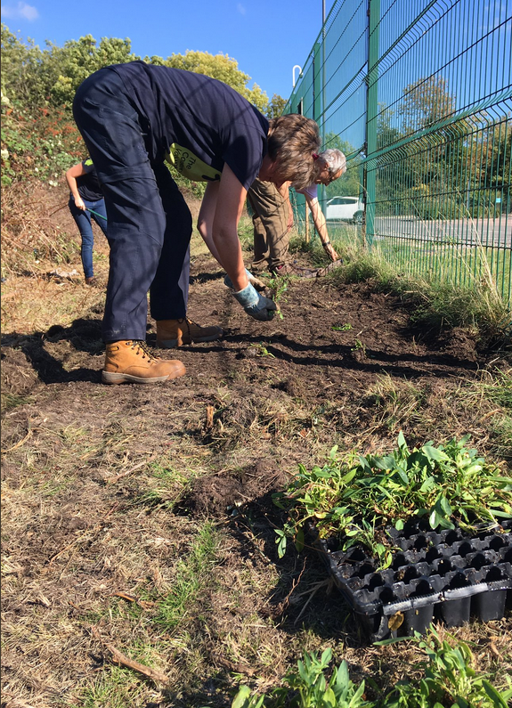
Training Outline
Today we will cover general guidance on Health and Safety (H&S) as well as specific guidance on the principles and practice of Risk Assessment. We give guidance on tool usage and delivering a ‘Tools Talk’ at the start of your activity.
This training will be followed up by a visit from a member of our Parks Team at one of your volunteering activities.
Insurance Cover
All volunteers working on Bristol City Council property are covered by the Council’s public liability insurance. This is providing they are working with prior approval from the Council.
All trained volunteers and those they supervise are also protected by personal accident insurance.
Volunteers under the age of 16 are covered, but must be accompanied by a parent or guardian. There is no upward age limit.
Personal accident insurance covers a range of permanent injuries. The amount paid to the injured person is dependent on the seriousness of the injury.

Risk Assessment (RA)
We will cover:
- What is a risk assessment?
- How to assess risks
- The 5 steps to risk assessment
- Capability and vulnerability of volunteers
- Calculating levels of risk

- What is risk assessment?
A risk assessment is a careful examination of an activity which could cause harm to people, property or the environment. It enables you to weigh up what control measures you need to take to prevent harm.
A risk assessment identifies hazards and risks.
Hazard means anything that can cause harm e.g. weather, landscape, chemicals, tools.
Risk is the chance, high to low, that somebody or something will be harmed by the hazard.
You need to decide whether a hazard is significant and whether satisfactory precautions are in place to minimize the risk.
- How to assess risks
Risk assessments (RAs) should be carried out by a competent trained person, i.e. yourself, using the RA models provided in this pack and ‘The 5 Steps to Risk Assessment’.
You will need to complete a blank site RA form and submit it to The Parks Service at least two weeks before the activity is due to take place. We will then ‘sign off’ the RA or contact you to discuss.
In all RAs there are three types of hazards to consider:
- Generic hazards – these will apply to any practical activity taking place outdoors with groups of people, e.g. manual handling, lifting, weather
- Activity hazards – these are specific to the activity taking place, e.g. scrub clearance
- Site hazards – these are specific to the location that the activity is taking place, e.g. Castle Park
This pack provides complete model RA for both generic and activity hazards. It does not provide models for site hazards as each site will have its own unique hazards which may be subject to daily change, e.g. due to weather conditions or maintenance work being carried out.
To support you with assessing site hazards we include information sheets at the end of this document. These cover:
- Recognition of hazardous and/or poisonous plants
- Hazards from micro-organisms (disease and bacteria)
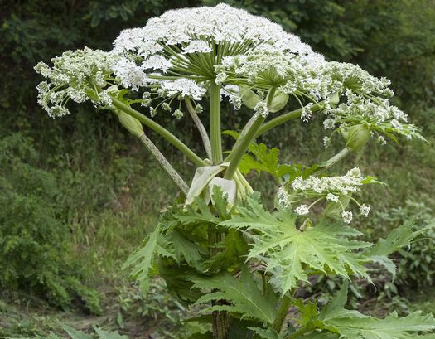

Common Hazards to consider in your RA:
- Derelict sites may contain unsafe structures
- Underground services such as gas and sewer pipes, electricity cables and water mains. Contact your Operations Coordinator or Allotments Officer for a service map of the site
- Overhead services (pylons, phone lines)
- Ground conditions:
    - Slopes at work site
    - Standing water or waterlogged surface
    - Cracks in the surface
    - Trip hazards
    - Mud/Ice
- Water (deep water, drainage ditches)
- Adjacent roads, traffic, waterways, railways or industries
- Public highway works
- Barbed wire
- Overgrown shrubbery and branches
- Hazardous and poisonous plants

- The 5 Steps to Risk Assessment adapted from ‘five steps to Risk Assessment’ (H&S Executive 2000)
Step 1: Look for the three types of hazards – Generic, Activity and Site
Step 2: Decide who or what might be harmed:
- Volunteers, the general public, or both?
- Vulnerable volunteers, e.g. children and young people, disabled people, older people, pregnant women?
- The wider environment/wildlife
Think about how the accidents could happen
Step 3: Using the table and formula on the next page, evaluate the risks and decide whether control measures are required to reduce the level of risk.
If any activity is classed as high, the activity must not go ahead unless control measures can be taken to reduce the risk.
Final risk levels will be the ones which apply after control measures are identified.
Step 4: Record your findings - Complete your blank RA form, including reference to the model RAs provides in this pack.
Step 5: Review your RA and revise it if necessary
Never use a site RA twice. Something will always be different, even if you are carrying out the same activity (activity and generic RAs can be used more than once if the activity is taking place multiple times over a 12 month period).
- Review your RA on the day of the activity. Has anything changed? Is there anything you need to add (e.g. weather)?
If volunteers are completing the same activity in the same location several times a year you don’t need to re-submit the forms every time.
Do complete a proper review on the day.

- Welcoming All Volunteers: Capability and vulnerability
Consider how you advise and protect volunteers with protected characteristics below: (identified groups in the Equalities Act, 2010)
- Age
- Disability
- Gender reassignment
- Marriage and civil partnership
- Pregnancy and maternity
- Race
- Religion or belief
- Sex
- Sexual orientation
If your activity is not covered by the RA models provided in this pack, contact your Client Officer.
- Calculating levels of risk
It is common practice for risk levels to be calculated using a Risk Matrix (see below). All necessary control measures must be taken to reduce the level of risk if possible.
If the level of risk cannot be reduced from HIGH (6 or above), the activity must not go ahead:
Risk level = Likelihood X Severity
High likelihood = Occurs repeatedly/to be expected
Medium likelihood = Occurs/could occur sometimes
Low likelihood = Unlikely / probability close to zero
Likelihood
High (3) | 9 | 6 | 3
Medium (2) | 6 | 4 | 2
Low (1) | 3 | 2 | 1
Severity | Fatal/Major injury (3) | Serious injury (2) | Minor injury (1)

Fatal/Major injury = Death, major injury or ill health causing long term disability or absence from work
Serious injury = Injuries or ill health causing short term disability or absence from work (over 3 days)
Minor injury = Minor knocks, scrapes, splinters, plant or insect stings
Risk Level = HIGH – activity must not go ahead
Risk Level = MEDIUM – activity can go ahead with caution
Risk Level = LOW – activity can be carried out as usual

Site Risk Assessment Form – Completed Example
Prepared by: Tom Penn Date of Assessment: 1st June 2019
Hazards are appropriate to the site on which the activity is taking place. Consider volunteers’ abilities and refer to Risk Assessment matrix
Hazard | Possible outcome | Persons at risk | Control measures | Risk Level after control | Who is responsible?
Busy local road by main entrance  EXAMPLE | Road traffic accident while accessing site and/or carrying tools to work area | Volunteers and public | 1. Designate volunteer as a ‘traffic watch’ while crossing and moving tools  2. Raise awareness of pelican crossing / safe place to cross close by | Medium | Tom Penn and other competent persons (e.g. trained volunteers)
Dogs not on leads | May distract tool users, cause a fall or bite volunteers | Volunteers and public | Dog owners to be asked to control dog and to take it away from work area  If dog appears vicious or engages in any attack with another dog, withdraw from the vicinity as quickly as possible | Medium
Steep slopes, grassy slopes, wooden steps on route leading to work areas | Slips, trips and falls | Volunteers | Briefing to anyone not familiar with the site. Verbal warnings to be passed back from leader as steps are approached if steps are wet or frosty | Medium
Working in a public area (tools/debris on ground) | Public entering work area may be at risk from cut material, slips trips and falls | Public | Use of signage or barriers is impracticable - volunteers will keep a look out for members of the public entering the area and guide them to a safe area. Paths will be kept clear or tools and debris. Tools to lie face down. | Low
Falling branches | Injury if hit | Volunteers and public | In woodland check for loose hanging branches above work area and do not work in areas at risk from these falling | Low
All hazards must be reassessed on the day of the activity in case of change. Generic Risk Assessment forms applicable:
- General manual handling
- Tool use

Safe Use of Tools

All hand tools used for the management, maintenance and enhancement of The Parks Service open spaces are subject to the legal requirements of the Provision and Use of Work Equipment Regulations 1998 (PUWER).

Under PUWER, The Parks Service is required to ensure tools provided are:

• Suitable for use, and for the purpose and conditions in which it is used

• Maintained in a safe condition for use so that people’s H&S is not at risk

• Inspected in certain circumstances to ensure that it is, and continues to be, safe for use. Any inspection should be carried out by a competent person and a record kept until the next inspection.

If volunteers’ own tools are being used on The Parks Service land, they are subject to the requirements of PUWER. Once trained, you will need to ensure they are safe to use.

- Only use the right tools for the job – e.g. spades not shovels.

- Use only tools in good condition. Reject tools with damaged handles, burred or broken heads or cutting edges.

- Keep cutting tools sharp and store and transport them with sharp edges covered. Wear gloves when handling tools with sharp edges.

4. Never use a tool in a way that you or someone else will be injured if it slips.

5. You must provide clear instruction in safe tools use at the beginning of every session and monitor use throughout.

Volunteers must not use power tools on land owned by Bristol City Council unless they have received Power Tool Training from an appropriate member of Parks Staff.

Personal Protective Equipment (PPE)
All practical activities will require some form of PPE. The exact nature of what items should be made available or worn should be made clear in the Risk Assessment of an activity. PPE must be available to persons who require it and will be provided by Bristol Parks if sufficient notice is given. Some items have a usable shelf life (e.g. safety helmets) and will always be provided by Bristol Parks.
Work must not take place is the required PPE is not available.
Examples of PPE can include:
Gloves – required for almost all activities
Safety Goggles – worn when using sledge hammers, picks, crowbars, chisels, chemicals or any circumstance where harmful/sharp substances may enter the eyes.
Safety Helmets – worn when work is taking place above head height or when sledgehammers are used
Hi-Viz – should be worn whenever working near a road or cycle route. Also used when marshalling at events or to allow First Aiders and/or supervisors to be identified.
Sturdy Footwear – should always be used during practical work. When moving heavy objects or there is danger to the feet, steel toe-capped boots should be worn.
Ear defenders – to protect against noise

Advice on First Aid

People carrying out an activity can suffer injuries or fall ill. Whatever the cause of the injury or illness, it is important is that the individual receives immediate first aid and that an ambulance is called in serious cases. ‘First Aid’ covers the arrangements you must make to ensure this happens. It can save lives and prevent minor injuries becoming major ones.

First Aid guidelines for working on The Parks Service Land

The Parks Service do not insist that there must be a First Aider present during volunteer activity on its land. However, we recognise that this would be good practice and help reduce risk.

The Health and Safety Executive (HSE)’s guidelines for First Aid at Work suggest that for higher risk activity involving five or more people, at least one should be a Qualified First Aider.

First Aid Kits

The HSE advice for the contents of a First Aid Kit is that it depends on the activity being carried out and the number of people carrying out any particular activity.

Welfare Kits

Welfare kits can be provided by volunteers on practical work days. It can support wellbeing and overall volunteer experience if these things area available:

- Hand sanitizer
- Scissors & safety pins
- Needle & thread
- Pencil and paper
- Sanitary towels
- Whistle
- Toilet roll
- Cotton wool

Useful Contacts

In an Emergency

Tel: 999 or 112 from a landline or mobile for:

• Fire brigade
• Ambulance
• Police
• Coastguard
• Mountain rescue
• Cave rescue

Western Power Distribution (South West) plc:
- Emergency number: 0800 6783 105
- Health and Safety Executive (HSE) info line: 0345 300 9923

Environment Agency:
- Floodline: 0345 988 1188
- Incident Hotline: 0800 80 70 60

Bristol City Council contacts

General volunteer activity enquiries: Contact your Operations Coordinator

Emergencies: Mon- Fri 8.30am to 6pm: 0117 922 2100
Out of Hours 6pm to 8.30am: 0117 922 2050.

Report a problem in the park

Bristol Harbour Master
Tel: 0117 903 1484
Accident Report Form – In the event of an accident, injury or near miss, the following form must be completed and handed in to your relevant Operations Coordinator within The Parks Service. This is vital for insurance purposes and our H&S reporting.
BRISTOL PARKS VOLUNTEERS | Injury Report Form Number:
Group name: | Section C – Other details
Section A – Personal details of affected person | Medical attention given?  First Aid / Doctor / Hospital / None
Surname | Was the injured person taken directly to hospital from scene of the incident?  Yes ❏ No ❏
First Name | Was the injured person kept in hospital for more than 24 hours?  Yes ❏ No ❏
Address | Has next of kind been notified?  Yes ❏ No ❏ N/A ❏
Date of Birth (DD/MM/YY) | Any other relevant details/circumstances
Male ❏ Female ❏ | Any other relevant details/circumstances
Employee of Bristol City Council Y ❏ N ❏ | Any other relevant details/circumstances
Section B – Incident details | Details of witnesses:
Date of incident (DD/MM/YY) | Details of witnesses:
Time am/pm | Details of witnesses:
Where did the incident occur? | Details of witnesses:
What activity was happening at the time?

Description of how the incident occurred

Did injury occur? Y ❏ N ❏ | Volunteer group leader:  Name …………………………………………………….  Signature ……………………………………………….  Date ………………………………………………………  Telephone number ……………………………….
If Yes, please specify
Type of injury:

Part of body affected:
Left ❏ Right ❏
To be completed by Bristol Parks Client Officer
Investigation form completed ❏ to follow ❏ N/A❏
Name:…………………………………… Signature:…………………………………….. Date:………………………………….

Common Hazardous Plants

Giant Hogweed

Giant Hogweed is originally from Asia and was introduced as an ornamental. It is similar in appearance to our Hogweed, only it is much larger (2-5 metres tall). They have huge stems and short hairs on the under surface of the leaf (about .25 mm long). Flower heads (June – July) are 20-50cm across.

The plant exudes a clear watery sap that sensitises the skin to ultraviolet radiation. This can result in severe burns to the affected areas resulting in severe blistering and painful dermatitis. These blisters can develop into purplish or blackened scars.

Wild Parsnip and Wild Angelica

Wild Parsnip and Wild Angelica also can cause burns to the skin by sensitising it to ultraviolet radiation. If the plant juices come into contact with skin in the presence of sunlight, a rash and/or blistering can occur, as well as skin discoloration that may last several months.

Wild parsnip is rough and hairy, growing to 30-150cm tall with numerous yellow, flat headed flowers. Its toothed leaves smell strongly of parsnip when bruised.

Angelica is hairless, often purple-tinged with chunky, purplish stems growing to 50-200cm tall. The flowers (June – Sept) are white or pinkish and in numerous domed heads 5-15cm across. Angelica prefers damp or marshy ground.

Precautions:
•Protect with gloves and long sleeves
• If make contact with sap, wash affected skin immediately with warm water.
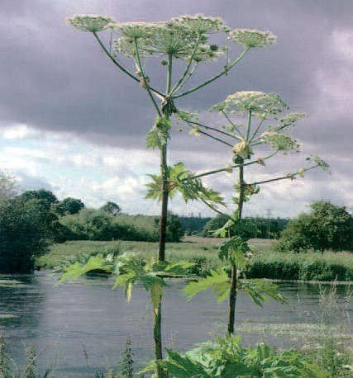
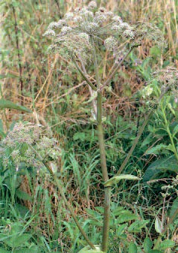
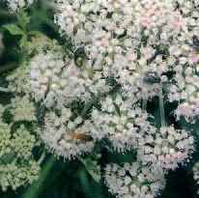
(Giant Hogweed)

(Wild Angelica)

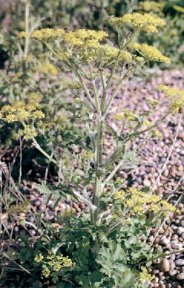

(Wild Parsnip)

Blue Green Algae

The growth of Blue Green Algae is encouraged in water during hot weather and in conditions where the water has become nutrient-rich. The algal blooms that result can be toxic if they come into contact with the skin.

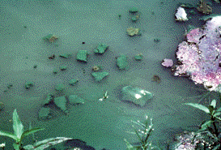

Precautions:

Avoid close working with algal blooms and wash them off immediately if they come into contact with skin. If contact cannot be avoided ensure protective clothing is worn and hand washing facilities are close by.

Bracken

Bracken can be toxic if cut late in the summer after particularly warm, wet weather, when spores are released. There is evidence that the spores can be harmful if inhaled, as can the spores of fungi associated with Bracken.
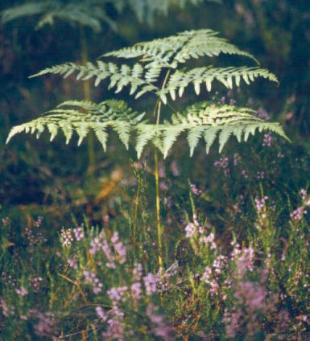
Precautions:

- Protect skin against contact with sap with gloves and long sleeved clothing

- Avoid prolonged working in bracken particularly during the late summer season from August to September

- Mechanical cutting of bracken would require a COSHH assessment, and further PPE being required

- If you have bracken on your site, contact your Area Coordinator to arrange safe methods of management

Thorns and Brambles

These can cause cuts and abrasions that can become infected. Blackthorn thorns (shown here) are prone to carry infectious material. Each thorn has a rough texture and can easily break under the skin.

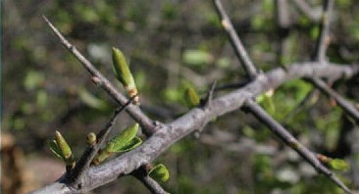

Precautions:

• Wear gloves and appropriate footwear if working with thorny plants

• Deal with splinters promptly

• Go and see a doctor immediately if there is any serious pain or swelling

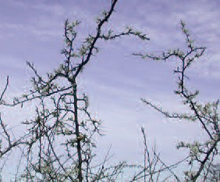

Common Hazardous Micro Organisms

Leptospirosis – Weil’s Disease

What are the symptoms? The disease starts with a flu-like illness with persistent and severe headache.

Who is at risk? Anyone who is exposed to rat’s urine e.g. workers in contact with canal and river water.

How might I catch it? The bacteria can get into your body through cuts and scratches and through the lining of the mouth, throat and eyes after contact with contaminated water such as sewers, ditches, ponds and slow-flowing rivers.

How can I prevent it? 1. Cover all cuts and broken skin with waterproof plasters before and during work.

2. Wear protective clothing.

3. Wash hands after handling possibly contaminated material and always before eating, drinking or smoking.

Lyme disease

What are the symptoms? Begins with a skin rash, often associated with flu-like illness.
Later cardiac, arthritic and/or neurological diseases may develop.

Who is at risk? Anyone who is exposed to grasses and shrubs where animals are likely to have been.

How might I catch it? Via the bite of infected ticks which are often found on the tips of vegetation waiting for a host to pass. Both domestic farm animals and wild animals e.g. deer can carry infected ticks.

How can I prevent it? Wear protective clothing.

Tetanus

What are the symptoms? Exaggerated reflexes, muscle rigidity and uncontrolled muscle spasms – lockjaw.

Who is at risk? Anyone working in contact with soil – especially if carrying a skin cut.

How might I catch it? The bacterium enters via breaks in the skin.

How can I prevent it? 1) Wear protective clothing.

2) Make sure all skin cuts are properly dressed before and during work.

3) Wash hands after handling possibly contaminated material and always before eating, drinking or smoking.

4) If you have not completed the NHS childhood vaccination programme which includes tetanus, consider contacting your GP for immunisation if you are going to regularly take part in gardening or outdoor conservation work. Your GP should be able to tell you if you have been immunised.

Toxocara canis

What are the symptoms? Following ingestion of the eggs, these hatch and the larvae migrate to the liver, lungs, eyes and brain.

Who is at risk? Anyone working in areas likely to harbour dog faeces.

How might I catch it? Hand-to-mouth contact with dog faeces or contaminated objects.

How can I prevent it?
1) Wear protective clothing.
2) Wash hands after handling possibly contaminated

This and all other H&S forms can be downloaded at on our parks pages. Follow the links from "Volunteering in Parks" then "Start and run a Friends Park Group". Scroll down to the forms you require.

These forms are also available directly from the Volunteer Database: https://app.betterimpact.com/Login

