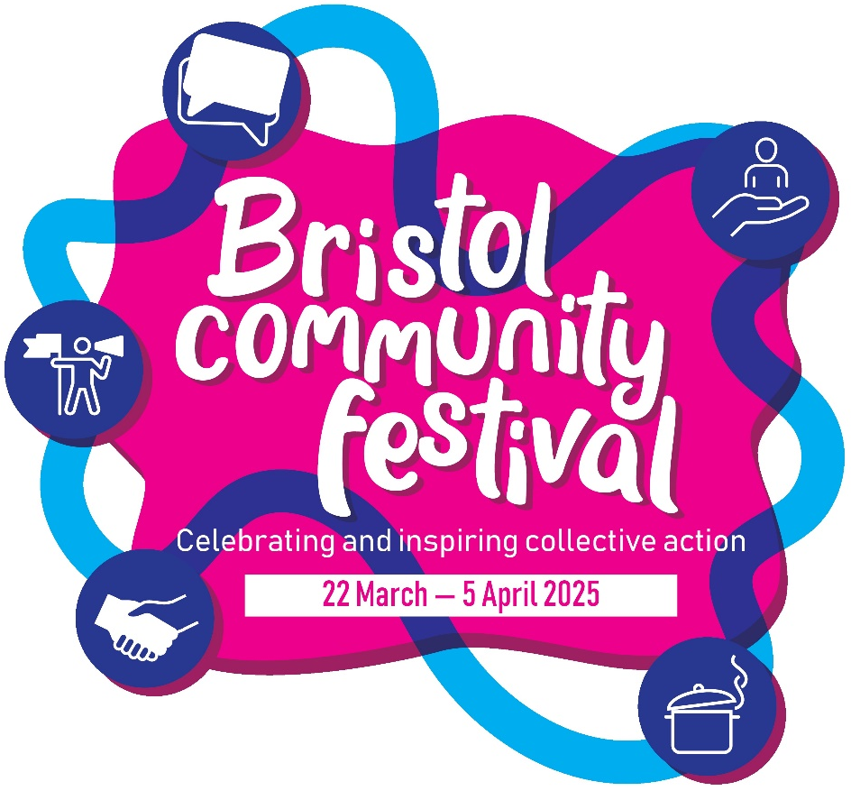

What is this marketing toolkit for?

From 22nd March – 5th April 2025, Bristol City Council will be partnering with organisations across the city to host Bristol Community Festival; a multi day event celebrating people in Bristol who come together to make positive change in their communities, and connecting and inspiring those that want to get involved. The festival aims to:
- ​It will celebrate citizen-led activities in Bristol, and the knowledge and experience of those that make them happen.
- It will share experiences of citizens making their voices heard or influencing decision making.
- It will share best practice and learning from projects and activities which were co-designed and co-produced with/by communities.
- It will connect citizens with opportunities to come together and make a positive change in their community.
- It will inspire upskill and connect people to enable them to take action on things that are important to them.
We’re inviting applications from resident-led groups and voluntary organisations to apply to organise an event about community action during the festival. Events could be…
- An information session about a project that was co-designed or co-produced with residents
- A taster session for a community activity i.e. community cooking, community gardening
- A screening of a film which was made by/with residents
- A live podcast recorded by/with residents
- An art exhibition showcasing work by residents Grants of up to £3,000 are available to groups working in or with one or more of top 30% most deprived areas in Bristol, or working with citywide equalities communities.
Groups/organisations that don’t need or are not awarded funding to organise an event or are not based in or work with people in a priority area or equalities groups can still apply.
We want to reach a wide range of different groups who might be interested in organising their own event to tell their story and share their experience of community action.
This document contains brand guidance, suggested newsletter content and social media posts and accessibility advice to help you to promote this opportunity. Please share with your networks to help us spread the word!

Suggested newsletter / blog copy

From 22nd March – 5th April 2025, Bristol City Council will be partnering with voluntary organisations and community groups across the city to host Bristol Community Festival; a multi-day event celebrating those that come together to make positive change in their communities and connecting and inspiring residents across Bristol. The council is looking for groups who want to get involved.
If you’re keen to organise an event for the festival, applications from resident-led groups and voluntary organisations are now open!
Grants to organise an event of up to £3,000 are available for groups working in priority areas and with city-wide equalities communities, but you don’t need a grant to be able to organise an event.
Events could be things like:
- Activity taster sessions
- Film screenings
- Art exhibitions
- Information sharing about a project
Find out more and apply www.bristol.gov.uk/bcf
If you’re not sure you want to organise an event, or you’d like to get involved in another way, or if you have another great idea, please complete this short form.

Keep up with festival news, announcements and information about how you can get involved with the festival by visiting Can Do Bristol.

Suggested social media posts

Facebook
Are you part of a community group or voluntary organisation? Are you involved in a project that has made a difference to your community?
Bristol City Council are inviting resident-led groups and voluntary organisations to apply to organise an event about community action during Bristol Community Festival next Spring.
Grants to organise an event of up to £3,000 are available for groups working in priority areas and with city-wide equalities communities, but you don’t need a grant to be able to organise an event. The festival will be about celebrating those that bring people together, inspire people to get involved in their community and connect those who don’t know where to start.
Events could be things like:
- Activity taster sessions
- Film screenings
- Art exhibitions
- Information sharing about a project
Applications are open until 9am Monday 21 October Find out more and apply www.bristol.gov.uk/bcf
X (formerly known as Twitter)
(280 characters)
Do you have an idea for an an event about community action? @BristolCouncil are calling on resident-led groups and voluntary organisations to apply to organise an event during Bristol Community Festival next Spring. Applications are open until 21 October. Find out more and apply www.bristol.gov.uk/bcf

Bristol Community Festival flyers

- English BCF events flyer
- Arabic BCF events flyer
- Bengali BCF events flyer
- Polish BCF events flyer
- Romanian BCF events flyer
- Somali BCF events flyer
- Simplified Chinese & traditional Chinese BCF event flyer

Design assets to use in your own communications

- BCF logo with strapline and transparent version
- BCF logo without strapline and transparent version
- Wiggle icon

Using the Bristol Community Festival graphics

The Bristol Community Festival logo has been designed for the following uses:
- Graphic to go at the top of a flyer/poster/letter/document
- Social media
- Transparent graphic – for use over coloured backgrounds

If you want to link the colours from the Bristol Community Festival graphic to use on your own documents please see below:

Colours: (cmyk & RGB)

Magenta: 0/100/0/0 & 236/0/140
Light blue: 100/0/0/0 & 0/174/239
Dark Blue: 100/95/5/0 & 43/57/144
Shadow: 35/100/35/10 & 158/51/99

How to use the Bristol City Council logo

Please include the Bristol City Council logo on any of the documents/products that you are creating. We recommend that the logo is placed in bottom right-hand corner of communications where possible.

The logo must:
- Be reproduced in full – including with the ‘Bristol City Council’ text
- Be reproduced in the correct colours or black/white
- Never be distorted or stretched
- Used correctly on dark or busy background
- Never ‘boxed in’ or used within a circle

Size of the logo:
- On an A4 publication, the recommended size of the logo is 35mm
- On an A5 publication, the logo should be 25mm
- The logo should never be reproduced at a size smaller than 20mm

Using the BCF and BCC logo on documents

If you are using the BCF graphic to create your own poster etc, please make sure you add both the BCF logo and the BCC logo.

Accessibility guidelines

Communications must be as accessible as possible to people with a visual impairment.

- The minimum font size that should be used is 12pt. Where possible 14pt or larger should be used
- To make text as clear as possible, communications should not use ‘serif’ typefaces, such as ‘Times’
- Text should not be underlined or in italics, unless used for emphasis. Blocks of text produced in capitals should be avoided
- Ensure you add alt-text onto your social media posts. Alt-text describes an image so that visually impaired users using screen readers will be able to understand what the image is

- The recommendation is that you do not upload posters/flyers to social media as this will not be accessible. Instead use the image provided and add the Bristol City Council website where full details are available
- When designing posters etc do not put text over busy images as it will be too hard for people to read

