Downloadable Payment for Involvement Documents

Contents
1. Information Pack for Payment for Involvement (Template) 2
2. Payment for Involvement Form (Template) 8
3. Evidence Letter (Template) 11
4. Expenses Policy (Template) 14
5. How To – Open Collective Payment (Template) 16



Information Pack for Payment for Involvement (Template)
- This will need to be provided to the participants at the start of the project. Participants may decide after reading this not to be involved.

Payment for Involvement Guidance
These guidelines have been developed by Bristol City Council for anyone involved in the [INSERT PROJECT NAME]. It sets out who we can offer payment for involvement to, in what circumstances, rates and methods of payment, and information about expenses.

We cannot provide individual advice about payment for involvement and how this might impact on your personal financial situation, but this document brings together helpful information and signposts further resources and support. It is each person’s individual responsibility to understand the impacts of receiving payment for involvement.

This guidance applies to people aged 16 and over.

Why do we offer payment for involvement?
We want to give greater power to communities to make decisions that affect them. We value diversity of knowledge and experience. We want to remove barriers to participation. Payment for involvement removes financial barriers which might stop people taking part. It means a broader range of people may be able to take part.

By offering payment for involvement, we are showing that we value and recognise everyone’s time and experience. Nobody is expected to contribute for free (although some people may choose to do this).

People with Lived Expertise Involvement and Participation vs Employment
Bristol City Council do not view people with lived expertise involvement and participation to be the same as paid employment. People involved are not staff and do not work for the organisation. There is no contract of employment between the participant and the Council, and we do not consider participation to be a means to assess capability for work.

What will we offer payment for involvement for?
We offer payment for involvement in the [INSERT PROJECT NAME] and the preparation that goes along with these. This is because taking part requires significant time and commitment and we will make use of your experience and knowledge. You’ll be working as a team to make decisions.

How much will I receive?
All members of the decision-making groups will be given money or vouchers for each meeting they attend, in recognition of their time.

Payment of £[INSERT RATE OF PAY] per hour will be made following each meeting. There is currently [INSERT PLANNED PROJECT LENGTH TIME] planned although this number may increase. Each of these sessions so far are expected to be [INSERT EXPECTED TIMINGS] in length. This might be adjusted if the length of the meeting is increased.

Meetings will take place every month until [INSERT EXPECTED PROJECT END DATE].

Participation involves:
- [INPUT PARTICIPATION EXPECTATIONS]

This is called payment for involvement or payment for participation and is not the same as work.

Reasonable expenses will be reimbursed in addition to this payment.

Who will receive payment for involvement?
We offer payment for involvement to anyone who takes part in [INSERT PROJECT NAME], who is doing so in their own time and not as part of a job they are already paid to do.

Accepting payment is optional.

How will I receive payment for involvement?

Payment for attending the meetings can be made in money, vouchers or a donation to a local charity of your choice. You can also choose not to be paid for your involvement.

Monetary payments
Money will be paid to participants by Social Change Nest, which is an organisation supporting Bristol City Council with the administration of payments via an online system called Open Collective.

Participants need to go onto a webpage and submit a claim/request for their time and any expenses, such as travel and/or childcare. You will need to upload receipts to this system as evidence of expenses. This video shows you how to submit your request for payment.

Requests will be approved by [INSERT NAMES OF OFFICERS WHO WILL BE APPROVING PAYMENTS] and then you will be paid by The Social Change Nest (this is the name that will appear in your account when you receive the money).

You can request this payment after each meeting. Payments will take a few days to arrive once approved.

Vouchers:
We will also offer vouchers, which will be given after each meeting. Vouchers will be sent electronically but if required, they can be printed for you.

Donation:
If you do not want to receive payment for involvement, we can donate the equivalent money to a local charity or community group of your choice, on your behalf.

To assist people who receive welfare benefits which have earnings limits, payment for involvement is voluntary so you can refuse it or ask to receive a lower rate. Please let us know if this applies to you.

Expenses
We will pay for the following reasonable expenses in addition to the payment for involvement: [ADD TO OR REMOVE AS APPLICABLE]
- Bus tickets;
- Parking costs when free parking is not available;
- Mileage costs at a rate of 45p per mile;
- Taxi (if this is the only option);
- Costs of a translator or interpreter;
- Costs of a personal assistant or support worker.

You will need to keep receipts for any expenses you incur to provide as evidence. You will then be reimbursed.

All expenses will be paid through the Open Collective online system.

We can reimburse you for expenses even if you do not wish to receive payment for involvement. Expenses are not considered the same as earnings or payment.

How might payment for involvement affect me?
Payment for involvement may affect your personal tax and benefits situation. Everyone’s financial circumstances are different and we cannot advise you on specific situations. We have gathered some guidance to explain the possible impacts. This helpful guide, produced for Disability Rights UK, explains how payment for involvement could affect your benefits and what you need to do before taking part.

We recommend seeking personal advice from whoever you normally speak to about benefits, for example, a Work Coach, Citizen’s Advice or the Jobcentre.

We also advise informing your Jobcentre, Work Coach, tax or benefits authorities of your participation. This is sometimes called “service user involvement” and is not the same as work.

We are happy to provide a letter explaining the nature of your participation and how it differs from work for you to give to your Work Coach/ Jobcentre. You could give this directly to your Work Coach/Jobcentre or send it to your Jobcentre via recorded delivery.

Participants will also be able to download evidence of payment from the Open Collective system, if they want a record of this.

We will be flexible with our approach to payment to try and meet your needs and work with you to find alternatives, if possible.

We recognise that your personal financial circumstances are private. We aim to find the balance between making sure you have the information and support you need, without asking you to share any information you may not wish to.

Please let us know if you are unsure about anything, have any questions or need more information. We are happy to help!

Further advice and support
Below is a list of organisations and resources where you may be able to find further advice and support relating to your specific financial circumstances.

Jobcentre Plus Offices
- 100 Temple Street, Redcliff, Bristol, BS1 6AG
- 382-386 Two Mile Hill, Kingswood, Bristol, BS15 1BZ
- 1-15 Monks Avenue, Horfield, Bristol, BS7 OUD
- 17-19 Kent Street, Bedminster, Bristol, BS13 7TE
- 59 Whitchurch Lane, Bishopsworth, Bristol, BS13 7TE
- 31 High Street, Shirehampton, Bristol, BS11 ODX
- Somerset Hall, Somerset Street, Bath, BA1 1TS
- 39 South Parade, Yate, South Glos, BS37 4BB
- 28 Old Street, Clevedon, BS21 6BY
- Regent House, High Street, W-S-M, North Somerset, BS23 1JF
- Brendan House, 3 Upper High Street, Taunton, TA1 3RL

Benefit Advice for service user involvement
We would advise you to contact organisations or visit their websites to book an appointment, or check drop-in times, as these could vary.

Organisations for support in Bristol
Citizens Advice Bureau
48 Fairfax Street, Bristol, BS1 3BL
Advice Line: 03444 111 444 Mon-Fri, 10:00am-1:00pm

North Bristol Advice Centre
2 Gainsborough Square, Lockleaze, Bristol, BS7 9XA
T: 0117 9515751
http://www.northbristoladvice.org.uk/get-advice

Talking Money
1 Hide Street, St Philips, Bristol, BS2 OBH
T: 0800 121 4511
mail@talkingmoney.org.uk

Kingswood Civic Centre
High Street, Kingswood, BS15 4AR
Thursday 9.30am-12.30pm

South Bristol Advice Services
Cover the following postcodes: BS3, BS4, BS13, BS14 & some parts of BS1
The Withywood Centre, Queens Road, BS13 8QA
T: 0117 985 1122
admin@southbristoladvice.org.uk

National organisations
HM Revenue and Customs
The HMRC website provides information about welfare benefits, income tax allowances and further forms of financial support

Citizens Advice Bureau (CAB)
You can find your local CAB on the Citizens Advice Bureau website which also gives lots of information to help you make financial decisions

NIHR guidance
NIHR’s guidance for members of the public includes a section with information on welfare benefits regulations

Disability Rights UK
Disability Rights UK website includes information and advice on benefits. You can contact 0330 995 0400 to access paper copies of their factsheets and publications

Turn2Us
Turn2Us is a charity providing financial information and support, including a benefits calculator, a ‘find an advisor’ tool, and free helpline: 0808 802 2000.

Local sources of support
Bristol City Council provides the Welfare Rights and Money Advice Service. Housing associations and community organisations may also offer similar services

Payment for Involvement Form (Template)
- This form will need to be completed by participants and returned to officers before the work begins.



Payment for Involvement Form

All information recorded on this page will only be looked at by the named officer: [insert officer name]. It will only be used to action the payment for involvement and will be kept in a password protected folder.

Name: ………………………………………………………………………………………………………………
Address: …………………………………………………………………………………………………………...
Telephone Number: ………………………………………………………………………………………….
Email address: …………………………………………………………………………………………………..

Please tick the option that you would prefer to be paid for your involvement:
☐ Money Payment
☐ Vouchers
If ticked, is the email address above the correct email address to send the vouchers to: ………………………………………………………………………………………………………
If ticked, please jump to question no. 3.
☐ Charity Donation
If ticked, please add name of charity: ………………………………………………………………..
If ticked, please jump to question no. 3.

☐ No Payment
If ticked, please jump to question no. 3.

- If you have ticked ‘Money Payment’, please answer these questions.

- Please tick the option of who you want to manage your payment for involvement:
☐ Myself
☐ Family, personal assistant, or someone you trust
If ticked, please add name of individual: …………………………………………………………..
☐ Bristol City Council Officer on behalf of you

- Do you give consent to named Bristol City Council Officer: [insert officer name]. to submit your payment requests on behalf of you?

You can withdraw your consent at any time and will need to make the Officer aware of this withdrawal.
Consent means permission for something to happen or agreement to do something.
☐ Yes
☐ No

- If you have ticked ‘Vouchers’, ‘Charity Donation’, ‘Money Payment’ or ‘No Payment’ please answer these questions.

- Have you read and/or talked through and understood the Payment for Involvement Working Group Guidance document?
☐ Yes
☐ No

Evidence Letter (Template)
- Once someone says they want to be involved, this needs to be filled in and given to participants to keep.
To |  |  | Reply to
Email |  |  | E-mail
 |  |  | Date

Dear [INSERT INDIVIDUAL VOLUNTEER NAME] and to whom it may concern,

Ref: Payment for Involvement

[INSERT INDIVIDUAL VOLUNTEER NAME] has been requested to assist Bristol City Council, as someone with lived expertise by [INSERT RESPONSIBILITIES AND PROJECT NAME]. We wish to ensure that the purpose of participation/ people with lived expertise involvement is understood and is not mistaken for work. We have supplied this letter to [INSERT INDIVIDUAL VOLUNTEER NAME] to be used as evidence of payment for involvement. This letter is signed by the [INPUT SIGNING OFFICER].
What is Bristol City Council?
Bristol City Council is the local authority of Bristol, England. This project, Co-Production Working group, is to [INSERT PROJECT AIM]. We want to give greater power to communities to make decisions that affect them. We value diversity of knowledge and experience. We want to remove barriers to participation and improve services.

What is people with lived expertise involvement?
People with lived expertise offer a perspective because of their personal experience of being part of communities represented in Adult Social Care and it is this experience and expertise that is requested to assist in our work.
People with lived expertise involvement can also be known as ‘service user involvement’. DWP have a full description of service users that applies to all benefits and can be found in Advice for Decision Makers Chapter H3: paragraph 3161.

The difference between people with lived expertise involvement and work
Involvement activities should not be mistaken for work, and recruitment for participation/ people with lived expertise involvement should not be confused with recruitment for employment. People are recruited because of their personal experience of being part of communities represented in Adult Social Care.
Participation/Service user involvement activities:
- are intermittent and people can withdraw at any time
- vary in length and in frequency, and usually last for a few hours (or less) in any one week
- are individual activities and do not imply future involvement
- may include attendance of quarterly or annual meetings
- may include contributing to intermittent meetings or telephone conferences
- may include helping to prepare for meetings, telephone conferences or events
- may include some follow-up activities after meetings or events.

Any payment that is offered for participation/ service user involvement is intended to cover preparation, attendance, and appropriate follow-up activities.

Support provided
Bristol City Council provides support measures that are appropriate for each individual, so that people can attend and contribute to our meetings and events.
Some people who we involve may be in receipt of benefits for mobility or care needs. Involvement in activities should not be interpreted as a reduction in the care or mobility needs of service users involved.
Support for care or mobility needs is offered as required by the participant/service user and may cover preparation, alternative transport options for travel to and from a venue, and personal individual support both during and after the activity. For example, support may include provision of a personal assistant or a support worker.

Payment for participation/ people with lived expertise involvement
Good practice guidance for participation/ people with lived expertise involvement recommends that members of the public should be offered payment for activities such as attending meetings and events, and that reasonable out-of-pocket expenses should be covered. Please note that:
- as involvement activities are often arranged on an ad hoc basis, organisations often pay service users monthly in arrears
- to assist service users who receive welfare benefits which have earnings limits or disregards, organisations offer involvement on a voluntary basis, or at a lesser amount, if requested
- On advice from the Avon, Somerset & Gloucestershire DWP branch, we have been advised that while the payments from this work would be classified as ‘unearned income’, these payments would be considered as “payments which would constitute a disproportionate administrative burden to take into account - for example, charitable income payments” and therefore would be an exception to the general rule and should not to be taken into account in a Universal Credit assessment
- Paper reference DEP2021-0349
- 160_Unearned_income_v11_0
- https://data.parliament.uk/DepositedPapers/Files/DEP2021-0349/160_Unearned_income_v11_0.pdf
- as the payment period may be over a month or more, we anticipate that Jobcentre Plus will treat these payments as averaged over the payment period. See DMG Chapter 48 paras 4080-81 and for a cycle of work para 48094.
- the Department for Work and Pensions legislation exempts ‘service users and carers’ from the application of notional earnings and treats reimbursed expenses for service user involvement as ignored (see ADM Chapter H3, paras 3160 and 3241)
- service users can withdraw from involvement activities at any time to attend ‘employment-related’ activities
- the Department for Work and Pensions legislation for persons who receive Employment and Support Allowance on exempt work now allows earnings at the higher level of Permitted work without time limit (see Memo DMG 7/17)
Please do not hesitate to contact me if you require further information.
Kind regards,

[INSERT SIGNING OFFICER]

Expenses Policy (Template)
- This is to be provided to the Social Change Nest – Open Collective.

What will we offer payment for involvement for?
We offer payment for involvement in the [INSERT PROJECT NAME] and the preparation that goes along with these. This is because taking part requires significant time and commitment and we will make use of your experience and knowledge. You’ll be working as a team to make decisions.

How much will I receive?
All members of the decision-making groups will be given money or vouchers for each meeting they attend, in recognition of their time.
Payment of £[INSERT RATE OF PAY] per hour will be made following each meeting. There is currently [INSERT PLANNED PROJECT LENGTH TIME] planned although this number may increase. Each of these sessions so far are expected to be [INSERT EXPECTED TIMINGS] in length. This might be adjusted if the length of the meeting is increased.

Meetings will take place every month until [INSERT EXPECTED PROJECT END DATE].

Participation involves:
• Attending each meeting where possible, either lasting two hours or one and a half hours each time.
• Working as a group, led by a facilitator, to discuss and make decisions about designing a co-production process.
• Reading or preparation at home before the meeting.

This is called payment for involvement or payment for participation and is not the same as work.

Who will receive payment for involvement?
We offer payment for involvement to anyone who takes part in the working group, who is doing so in their own time and not as part of a job they are already paid to do.

Accepting payment is optional.
Requests will be approved by Megan Belcher and Catherine Martin in the Transformation and Commissioning team in Adult Social Care at Bristol City Council and then you will be paid by The Social Change Nest (this is the name that will appear in your account when you receive the money).

You can request this payment for involvement after each meeting. Payments will take a few days to arrive once approved.

Expenses
We will pay for the following reasonable expenses in addition to the payment for involvement: [ADD TO OR REMOVE AS APPLICABLE]
• Bus tickets;
• Parking costs when free parking is not available;
• Mileage costs at a rate of 45p per mile;
• Taxi (if this is the only option);
• Costs of a translator or interpreter;
• Costs of a personal assistant or support worker.

You will need to keep receipts for any expenses you incur to provide as evidence. You will then be reimbursed.

All expenses will be paid through the Open Collective online system. Please submit expense claims separately to 'payment for involvement' requests.

We can reimburse you for expenses even if you do not wish to receive payment for involvement. Expenses are not considered the same as earnings or payment.

How To – Open Collective Payment (Template)
- If participants have selected monetary payment, give this information sheet to them so they can access Open Collective.


How to – Open Collective Payment

- Find the collective you are a part of: [INSERT LINK TO RELEVANT COLLECTIVE] (double click this link to open)
Once you are on the website, click the top right “Sign in” button
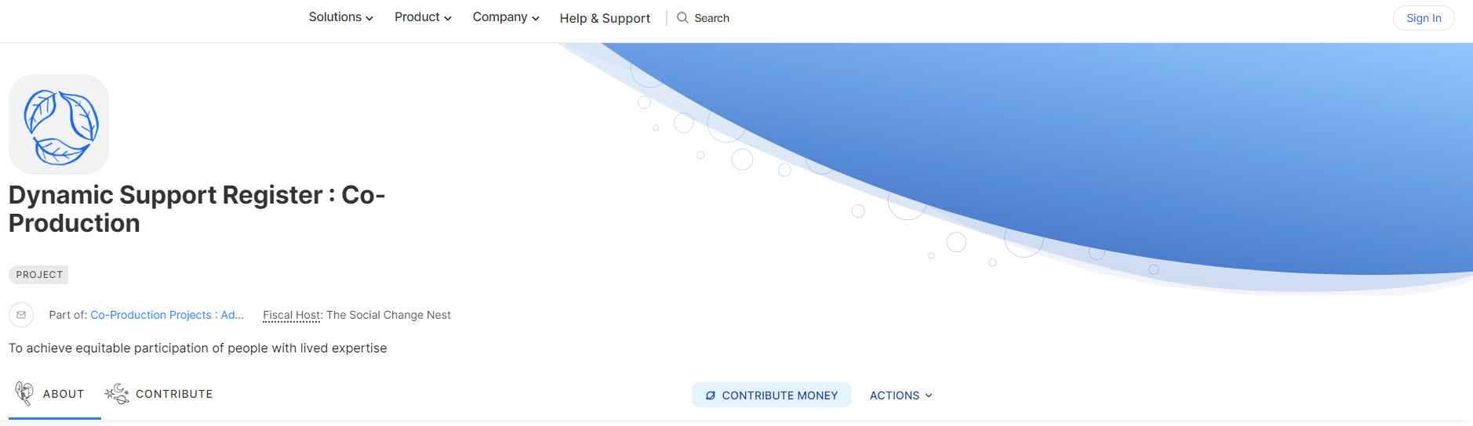
You will then be asked to log in or “create an account" if you don’t have one.
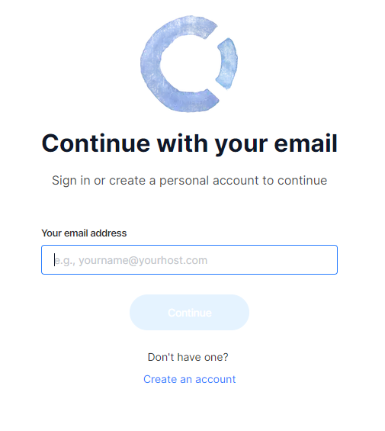
2. Click on “create an account”, now fill in the form with your name and email address.
Then tick the “I agree with the terms of service of Open Collective” box and then press the “Create Account and Continue” button.

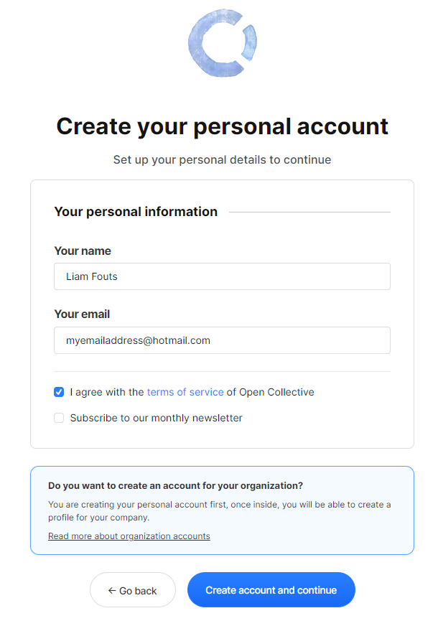
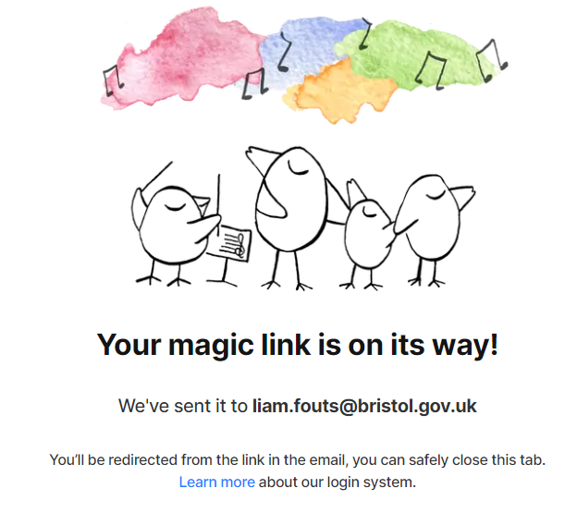
3. Now you’ve created your account, there will be a page telling you that they’ve sent you and email with a link to log in to Open Collective.

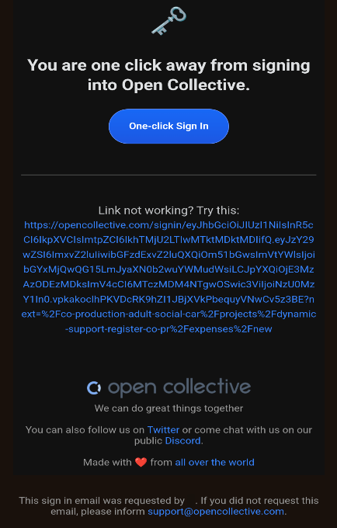

- When you receive the email from Open Collective, press the “One-click Sign in” button.

- Now go to the Collective you're submitting the expense to and click "Actions" and then click “Submit expense”.
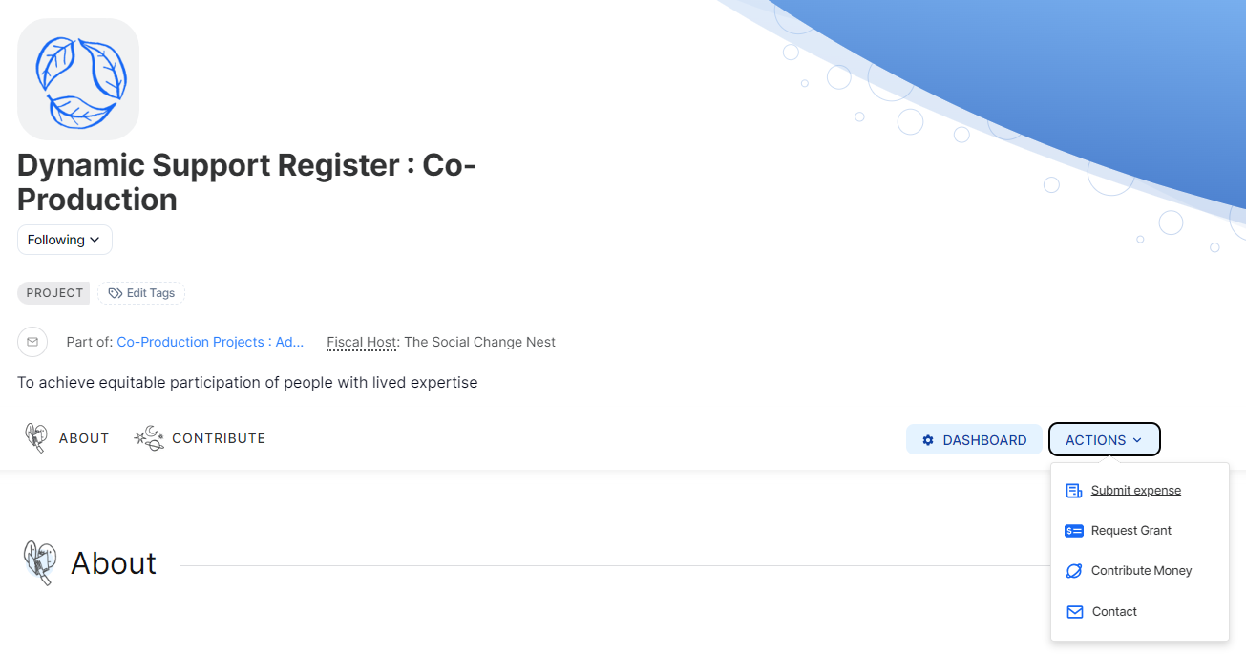
- On the Submit expense page, you can submit two types of expenses, reimbursements and invoices. On this page, you can also check the Collective balance, review expense policies and get the answers to a few of the most frequently asked questions.
Please continue to the next page for the Submit expense information.

- The screenshot below shows the information you need to fill out if you select Invoice and for the money to be transferred to your bank account.
If you need any support completing this, please contact [INSERT OFFICER CONTACT DETAILS] who will be able to support you in completing your expense submission.
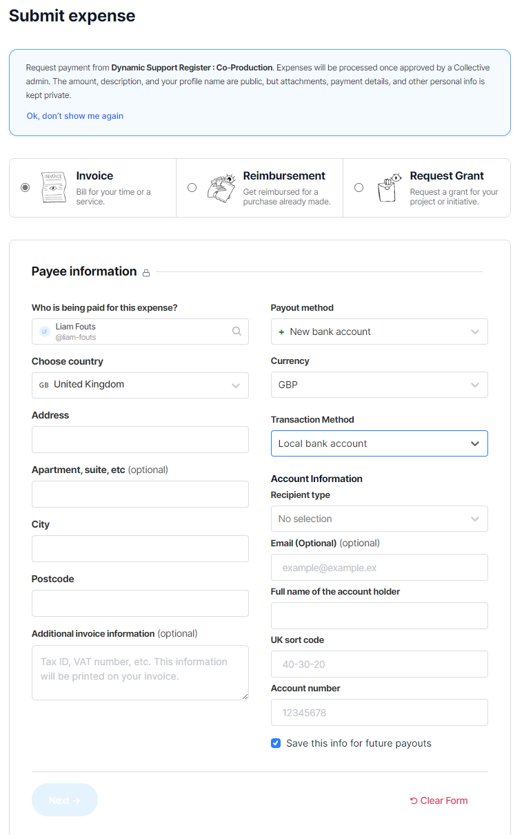
- Once you’ve filled out that form, you’ll see a page like below. Fill out the information include the “Expense title”, “Description”, “Date” and “Amount” in GBP (Great British Pounds!).
For every 1 hour you support the project, we pay you [INSERT AGREED AMOUNT]. You will need to total up the amount you are owed for your participation.
Once you are happy the information is correct, click the “Next” button.
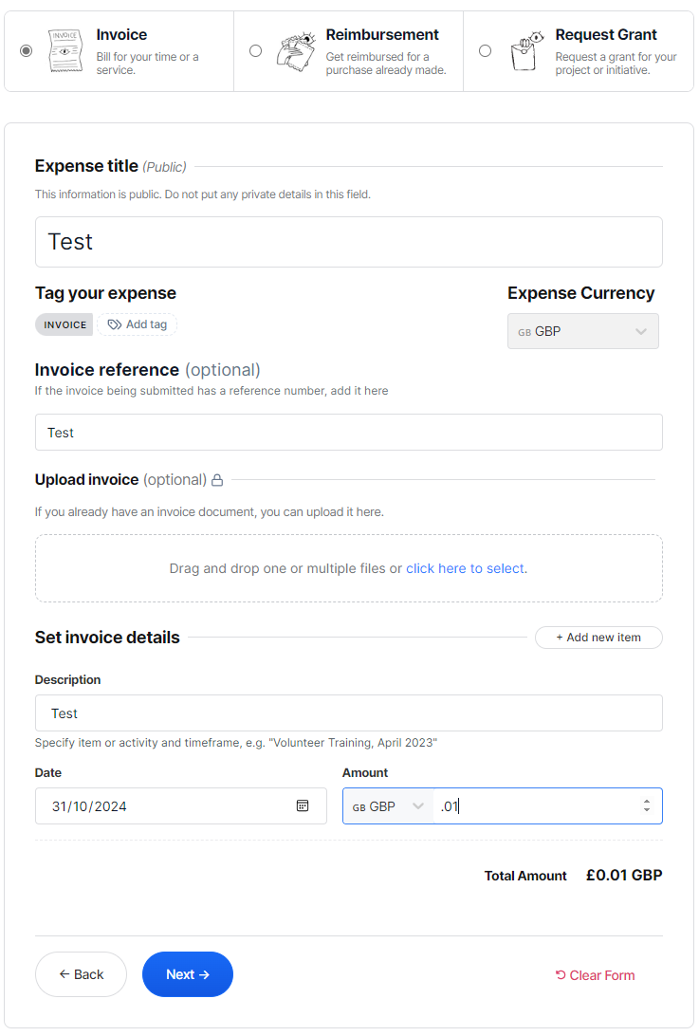
- You’ll now see a page like below. Once you have checked over your details such as the project, you’re requesting funding from, your personal details and bank account information. Press “Submit Expense”.
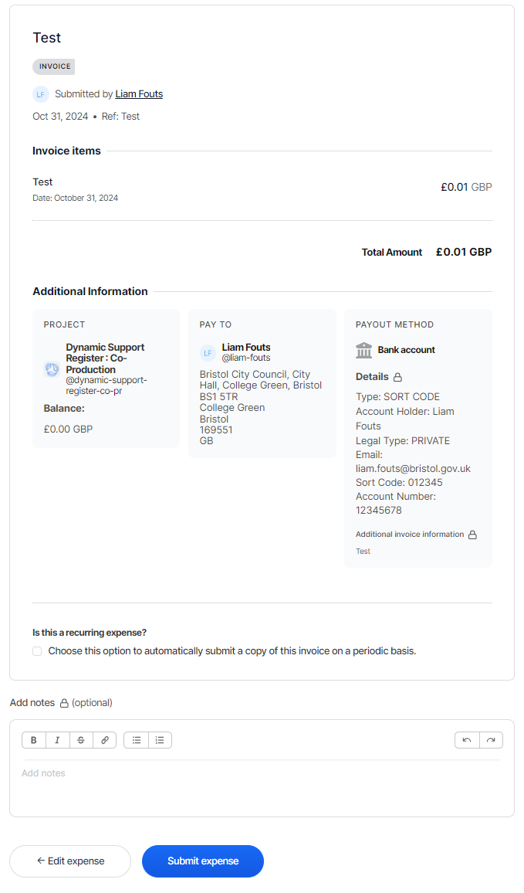
- Once this is submitted, the project managers will receive notifications on Open Collective to review and process your invoice, you should then receive payments within a few days after approval.

